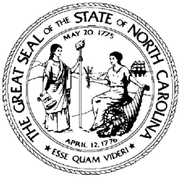

North Carolina Division of Workforce Solutions Operational Guidance N Guidance Number: OG 01-2022, Change 2

Date: March 20, 2026
Subject: NCWorks Tracking for Local Area Workforce Development Boards (WDBs)
From: Andrea L. DeSantis, Assistant Secretary for Workforce

Purpose:
To provide NCWorks Online (NCWO) reporting requirements for WDB-level grants.
This Operational Guidance (OG) rescinds OG 01-2022, Change 1. This update changes the expiration date of the OG to indefinite and reflects a change in the setup and maintenance from $2500 to $3000 annually. The procedures herein supersede all previous policies, procedures, and guidelines regarding NCWorks tracking for WDBs.

Background:
The Division of Workforce Solutions (DWS) administers the State Workforce Development data entry system, NCWorks Online, to collect and report all federal performance requirements for all Workforce Innovation and Opportunity Act (WIOA) and certain non-WIOA programs. The WDB may independently apply for and receive grants that DWS is not a party to and that have different reporting requirements than DWS programs. United States Department of Labor (USDOL), local funding sources, and national grants are among the various grants that WDBs receive outside of funding administered through the DWS. The WDBs may benefit from using NCWO to track data and for reporting. This Operational Guidance provides options for WDBs to utilize the existing NCWO system to capture and report data.

Action:
The WDB staff should share this Operational Guidance, as appropriate, to ensure all parties are aware of potential costs when submitting grant applications.

Effective Date:
Immediately

Expiration:
Indefinite
Contact:

DWS Information Technology Staff

Attachments:
- Guidelines for Using NCWorks Online to Track Board-Obtained Grants and Reports
- NCWorks Tracking Memorandum of Understanding for National Dislocated Worker Grant (NDWG) Template

