# State of North Carolina CDBG-DR Action Plan Non-Substantial Amendment 2

# CDBG-DR Grants under Public Law 114-223/254

# 

# April 9, 2018

# STATE OF NORTH CAROLINA DEPARTMENT OF COMMERCE

# North Carolina Department of Commerce

# CDBG-DR Action Plan

# Under

# Public Law 114-223/254 & PL 115-31

# History Form

Revision History: Action Plan

|  |  |  |  |
| --- | --- | --- | --- |
| Version | Date | Page | Description |
| #1 | 04.21.2017 |  | Initial Action Plan Submitted |
| #2 | 11.07.2017 |  | Substantial Amendment 1 |
| #3 | 04/09/2018 | 38 -46 | Non-substantial Amendment 2: Clarification of Method of Distribution |
|  |  |  |  |
|  |  |  |  |
|  |  |  |  |
|  |  |  |  |

State of North Carolina CDBG-DR Action Plan Non-Substantial Amendment 2 1

CDBG-DR Grants under Public Law 114-223/254 1

April 9, 2018 1

STATE OF NORTH CAROLINA DEPARTMENT OF COMMERCE 1

North Carolina Department of Commerce 2

CDBG-DR Action Plan 2

Under 2

Public Law 114-223/254 & PL 115-31 2

History Form 2

Introduction 5

Unmet Needs Assessment 6

Housing 7

Where did most of the damage occur? 8

Severely Impacted Communities 15

Repairing Owner-Occupied Homes 16

Rental Housing 17

Other Rental Housing 19

Housing Unmet Need Summary 22

Vulnerability of the Most Impacted Communities 23

Economic Recovery 32

Public Infrastructure and Facilities 33

Community and Supportive Facilities 35

Dams and Levees 35

Department of Transportation (DOT)/HUD/Federal Highway Association (FHWA) Transportation Facilities and Infrastructure 35

USDA / FSA Disaster Grant Programs 36

Environmental Protection Agency (EPA) - Drinking Water and Wastewater Repair and Mitigation 36

National Guard Facilities and Equipment 36

Planning, Coordination, and Community Outreach Needs 37

Nexus Between Unmet Need and Allocation of Resources 38

National Flood Insurance Restrictions 39

Method of Distribution 39

Non-Substantial Amendment #2 Method of Distribution 41

This Action Plan is being amended to provide additional clarification related to how the State of North Carolina determined the method of distribution among the four most impacted counties categorized as Tier 1 Counties and all other counties will be referred to as Tier II counties. 41

Recovery Programs 47

Program Name: Homeowner Recovery Program 47

Program Name: Homeowner Assistance Program 53

Program Name: Small Rental Repair Program 54

Program Name: Multi-Family Rental Housing 54

Program Name: Buyout and Acquisition Sub Program 55

Program Name: Public Housing Restoration Fund 57

Program Name: Supportive Housing and Services Grant 58

Program Name: Small Business Recovery Assistance 59

Program Name: Community Recovery Program 63

General Eligibility Requirements 65

Leveraging 66

Program Income 66

Schedule of Expenditures and Outcomes 67

Minimum Threshold for Substantial Amendment 69

State of North Carolina Green Building Standards for Construction and Contractor Oversight 69

Broadband 70

Monitoring Standards and Procedures 70

Contractor Performance Standards and Appeals Process 71

Citizen Participation Plan 73

Notice and Comment Period for Substantial Amendment 1 73

Appendix A – Substantial Amendment Public Meetings 75

Appendix B - Public Comments 76

# Introduction

Hurricane Matthew began as a Category 5 storm in the Caribbean, before hitting the coast of North Carolina (the State) on October 8, 2016. Fifty counties in North Carolina were declared federal disaster areas with historic communities in eastern North Carolina like Princeville, Kinston, Lumberton, Goldsboro, Fayetteville, and Fair Bluff experiencing catastrophic damages. Matthew lingered along the North Carolina coast for several days, causing rivers and their tributaries to swell and ultimately overflow into adjacent communities. Over a three-day period, central and eastern parts of North Carolina were inundated with rain, and 17 counties set new records for rain and flooding. Five river systems, the Tar, Cape Fear, Cashie, Lumber, and Neuse Rivers, flooded, remaining at flood levels for two weeks.

After Matthew passed, the State assessed the damage and documented that Matthew’s impact was devastating, significantly impacting residents in eastern and central North Carolina and causing catastrophic losses in the housing, business, public infrastructure, and agricultural sectors. More than 800,000 families lost power from Matthew, resulting in millions of dollars in food cost losses for families whose food needed to be frozen or refrigerated. 3,744 individuals needed to be moved to shelters, and 77,607 households applied for Federal Emergency Management Agency (FEMA) emergency assistance. When FEMA completed its analysis of impacts to housing stock, 34,284 households had evidence of flood damage and nearly 5,000 homes had major to severe damage, many of which were located in rural communities, where not only the home but the farm and livestock were impacted and/or lost. The State estimated that more than 300,000 businesses experienced physical and/or economic impacts from the storm, including many small “mom and pop” businesses located in small rural communities. Matthew’s impact on the agricultural industry was particularly hard hit, as the industry has a significant presence in driving the local economy in eastern North Carolina, where the State is among leaders in the nation in livestock and crop production. North Carolina’s farms, including many small multi-generational family farms, along with the firms that provide materials needed to grow livestock and produce crops and food producers that take these products to market, lost tremendous amounts of inventory, livestock, and crops, with millions of dollars of the losses not covered by United States Department of Agriculture (USDA) programs. The impact to communities was also catastrophic, with public buildings, parks, schools, roads, water and wastewater systems, and other public infrastructure heavily impacted. Portions of the interstate system closed in some cases for up to ten days. In total, the State estimated that Matthew’s total economic impact was roughly $2 billion.

# Unmet Needs Assessment

The Unmet Needs Assessment within this Action Plan Amendment represents the second analysis of unmet needs in the State of North Carolina following Hurricane Matthew. It presents damage estimates and recovery needs as of October 15, 2017, roughly one year after the flooding occurred, using revised Small Business Administration (SBA) and FEMA data. Since the publication of the State’s initial Unmet Needs Assessment in the Spring of 2017, the State has focused recovery actions in four areas:

1. Beginning to design housing programs focused on the findings of the State’s initial Unmet Needs Assessment and centered around the needs of low to moderate income persons and housing recovery in the most impacted communities and counties;
2. Completing the State’s 50 county planning process to determine how to best align and structure the community recovery program with information and projects developed through this bottom-up community planning process;
3. Working with FEMA to ensure that damages to public infrastructure were captured; and
4. Working to confirm that the Matthew impacts to small businesses and the agricultural sector in particular remains unaddressed nearly a year after the storm.

As a result, the State’s prior Unmet Needs Assessment remains valid as housing still has significant unmet needs, in the public infrastructure and facilities area of the Unmet Needs Assessment the State are seeing increases in FEMA public assistance obligations that are in line with initial estimates. In the Economic Recovery section, with new SBA data, it is apparent that the State’s small businesses and agricultural enterprises in eastern and central North Carolina continue to need assistance. The analysis presented in the initial Unmet Needs Assessment, particularly for housing and vulnerable populations in most impacted communities remains particularly relevant and is included in this revised analysis as it is unchanged and is a key component for the overall program design.

As part of this Action Plan Amendment, the State of North Carolina has made it a priority to focus on continuing to assist low to moderate income families who experienced severe flooding and saw their homes and communities impacted by Matthew. Therefore, the funding priorities in this action plan emphasize housing and supportive service needs with 93% of this allocation going to housing recovery and housing assistance programs. The State understands that community health is not just about rebuilding homes but restoring the basic fabric of neighborhoods and ensuring future economic health and community infrastructure is restored. Therefore, the State is also providing funding to assist small businesses and farmers struggling to get back on their feet and ensuring that, as the planning process is complete, projects to rebuild and make more resilient communities can occur.

Based on this analysis, effective October 15, 2017, North Carolina’s current unmet recovery needs total $1,292,447,463.

## Housing

*Summary*

As part of the Substantial Action Plan Amendment process, the State reviewed and analyzed unmet needs related to disaster recovery. This Unmet Needs Assessment updates the previous analysis provided by the State in the initial Action Plan. While HUD’s methodology only addresses part of the full unmet needs of State generated by Hurricane Matthew, the State’s updated unmet needs assessment is based on HUD’s CDBG-DR Allocation Methodology as published in the January 18, 2016, Federal Register Notice FR–6012–N–01. This unmet need assessment incorporates the housing unmet need addressed through the previous action plan. Based on a variety of data sources consistent with HUD methodology, the State observed the housing unmet need remains largely unchanged. The analysis below validates the State’s plan to allocate a majority of the funding, 85% in total funding, and 93% of this allocation to address a continuing housing unmet needs.

Analysis

This housing Unmet Needs Assessment relied heavily on the work that was conducted in the original action plan Unmet Needs Assessment. After comparison of data from FEMA, SBA, and the county planning process, the major changes to the housing Unmet Needs Assessment include a large unmet need for homeowners who wish to sell their homes and relocate to higher and safer ground and additional damages and unmet needs for Public Housing Authorities in storm impacted counties.

Hurricane Matthew inflicted devastating damage to families throughout North Carolina’s eastern and central parts. The swelling of the Tar, Neuse, and Lumber Rivers caused rainwater to overflow into neighboring towns, inundating business districts and homes with floodwaters. In total, almost 35,000 homes were damaged in the storm, and the homes of roughly 5,000 families were damaged so extensively as to make them unlivable.

North Carolina’s number one priority is to allow families to return to their homes and to ensure those homes are in safe and sanitary conditions. For this reason, the Unmet Needs Assessment focuses on housing recovery programs and supportive services to families and persons in need. This includes an understanding of where homes experienced the greatest damage and the capacity of those families to recover from the disaster.

The analysis and resulting recovery programs also account for long-term sustainability, with a priority placed on the homeowner and renter finding safe and suitable housing rather than simply rebuilding a damaged unit. Therefore, North Carolina will conduct a cost-benefit analysis on rebuilding a severely damaged home versus constructing a new home in an area safe from repetitive flood loss, which will take into account the cost of repairing versus replacement and estimated long-term losses due to repeat flood events.

We began the process of assessing unmet housing need by analyzing the prior Unmet Needs Assessment, which included who applied for FEMA assistance, the first step most flood victims take immediately after a disaster. This information is combined with the State’s own damage assessments and the SBA’s loan application information. From this data, we generated a detailed understanding of housing damages and recovery needs and compared the original analysis with updated data from FEMA and SBA. Specifically, we were able to estimate the following:

* What counties, towns, and neighborhoods experienced the greatest damage;
* The types of units that were damaged (rental versus homeowner and the structure);
* The incomes of the homeowner or renter impacted, and, combined with household size, the income classification of these impacted families;
* How many homeowners and renters were impacted, categorized by severity of damage;
* An estimate of housing recovery needs (in dollars); and
* In combination with other data, what impacted neighborhoods have a high concentration of vulnerable populations and/or additional needs.

The following is a summary of this analysis, which North Carolina will continue to build upon as the State captures more information from our community engagement meetings and outreach efforts at the county and local level.

### Where did most of the damage occur?

Hurricane Matthew impacted 50 counties in North Carolina, largely along the eastern and central regions and along major rivers and tributaries. As previously noted, almost 35,000 families experienced some degree of damage to their homes, but the majority of damage was minor. For the purpose of the Unmet Needs Assessment, we assume that the majority of homes which experienced minor damage have likely been repaired six months after the storm event.

Unfortunately, families whose homes received major to severe damage have a far greater challenge in recovering, particularly when their homes are rendered uninhabitable due to mold, insulation issues, unstable foundations, leaky roofs, and lack of heat or plumbing due to flood damage of pipes and HVAC systems. These families either remain in their damaged homes, living in unsafe conditions because they are unable to find alternative housing they can afford, or they are displaced from their homes. The families with limited resources – low and moderate-income families who have limited savings or disposable income – are the families with the greatest needs. These homes are the focus of this Unmet Needs Assessment. [1]

To determine which counties, towns and neighborhoods experienced major damage, the State mapped the FEMA applications by the address of the damaged unit and then associated that “point” with the neighborhood[2], town, and county the home falls within.

What we found, based on this analysis, is that major housing damage happened in very specific areas, as follows:

64% of major to severe damage is concentrated in the “most impacted” four counties.

52% of major to severe damage is concentrated in 13 towns.

41% of major to severe damage is concentrated in 14 neighborhoods.

So, while damage was widespread due to power outages, minor flooding, and wind damage, the serious impacts of Hurricane Matthew were felt in a specific handful of places. These counties, towns, and neighborhoods are defined in Tables 3 through 5.

**Table 1: Most Impacted Counties**

**(where at least 500 homes experienced major to severe damage)**

|  |  |  |  |
| --- | --- | --- | --- |
| County | Owners | Renters | Total |
| CUMBERLAND | 364 | 401 | 765 |
| EDGECOMBE | 247 | 284 | 531 |
| ROBESON | 645 | 689 | 1,334 |
| WAYNE | 278 | 263 | 541 |
| Total | 1,863 | 1,982 | 3,845 |
| As % of all Major to Severe Damage in NC | 60% | 69% | 64% |

**Table 2: Towns that Experienced Major to Severe Damages from Hurricane Matthew**

**(where at least 100 homes experienced major to severe damage)**

|  |  |  |  |  |  |
| --- | --- | --- | --- | --- | --- |
| County | Community | Damage Level | Owners | Renters | Total |
| COLUMBUS | Fair Bluff | Severe | 50 | 59 | 109 |
| CUMBERLAND | Fayetteville | Severe | 169 | 283 | 452 |
| EDGECOMBE | Princeville | Severe | 156 | 211 | 367 |
| LENOIR | Kinston | Severe | 49 | 132 | 181 |
| ROBESON | Lumberton | Severe | 350 | 526 | 876 |
| WAYNE | Goldsboro | Severe | 87 | 164 | 251 |
| Total |  |  | 984 | 1,570 | 2,554 |
| As % of All Major to Severe Damage in NC | | | 38% | 66% | 52% |

**Table 3: Neighborhoods that Experienced Major to Severe Damages from Hurricane Matthew (where at least 50 homes experienced major to severe damage)**

|  |  |  |  |  |  |
| --- | --- | --- | --- | --- | --- |
| Town | County | Neighborhood | Owner | Renter | Total |
| LUMBERTON | ROBESON | 37155960801 | 150 | 320 | 470 |
| PRINCEVILLE | EDGECOMBE | 37065020900 | 156 | 211 | 367 |
| LUMBERTON | ROBESON | 37155960802 | 125 | 144 | 269 |
| FAYETTEVILLE | CUMBERLAND | 37051003203 | 26 | 107 | 133 |
| FAIR BLUFF | COLUMBUS | 37047930600 | 50 | 59 | 109 |
| FAYETTEVILLE | CUMBERLAND | 37051000200 | 53 | 40 | 93 |
| Rural | WAYNE | 37191000901 | 44 | 48 | 92 |
| GOLDSBORO | WAYNE | 37191001500 | 24 | 61 | 85 |
| Rural | ROBESON | 37155961802 | 16 | 61 | 77 |
| Rural | DARE | 37055970502 | 47 | 28 | 75 |
| Rural | CUMBERLAND | 37051003001 | 52 | 16 | 68 |
| Rural | PENDER | 37141920502 | 41 | 24 | 65 |
| KINSTON | LENOIR | 37107010800 | 2 | 62 | 64 |
| Rural | ROBESON | 37155961500 | 47 | 14 | 61 |

**Figure 1: Most Impacted Counties**

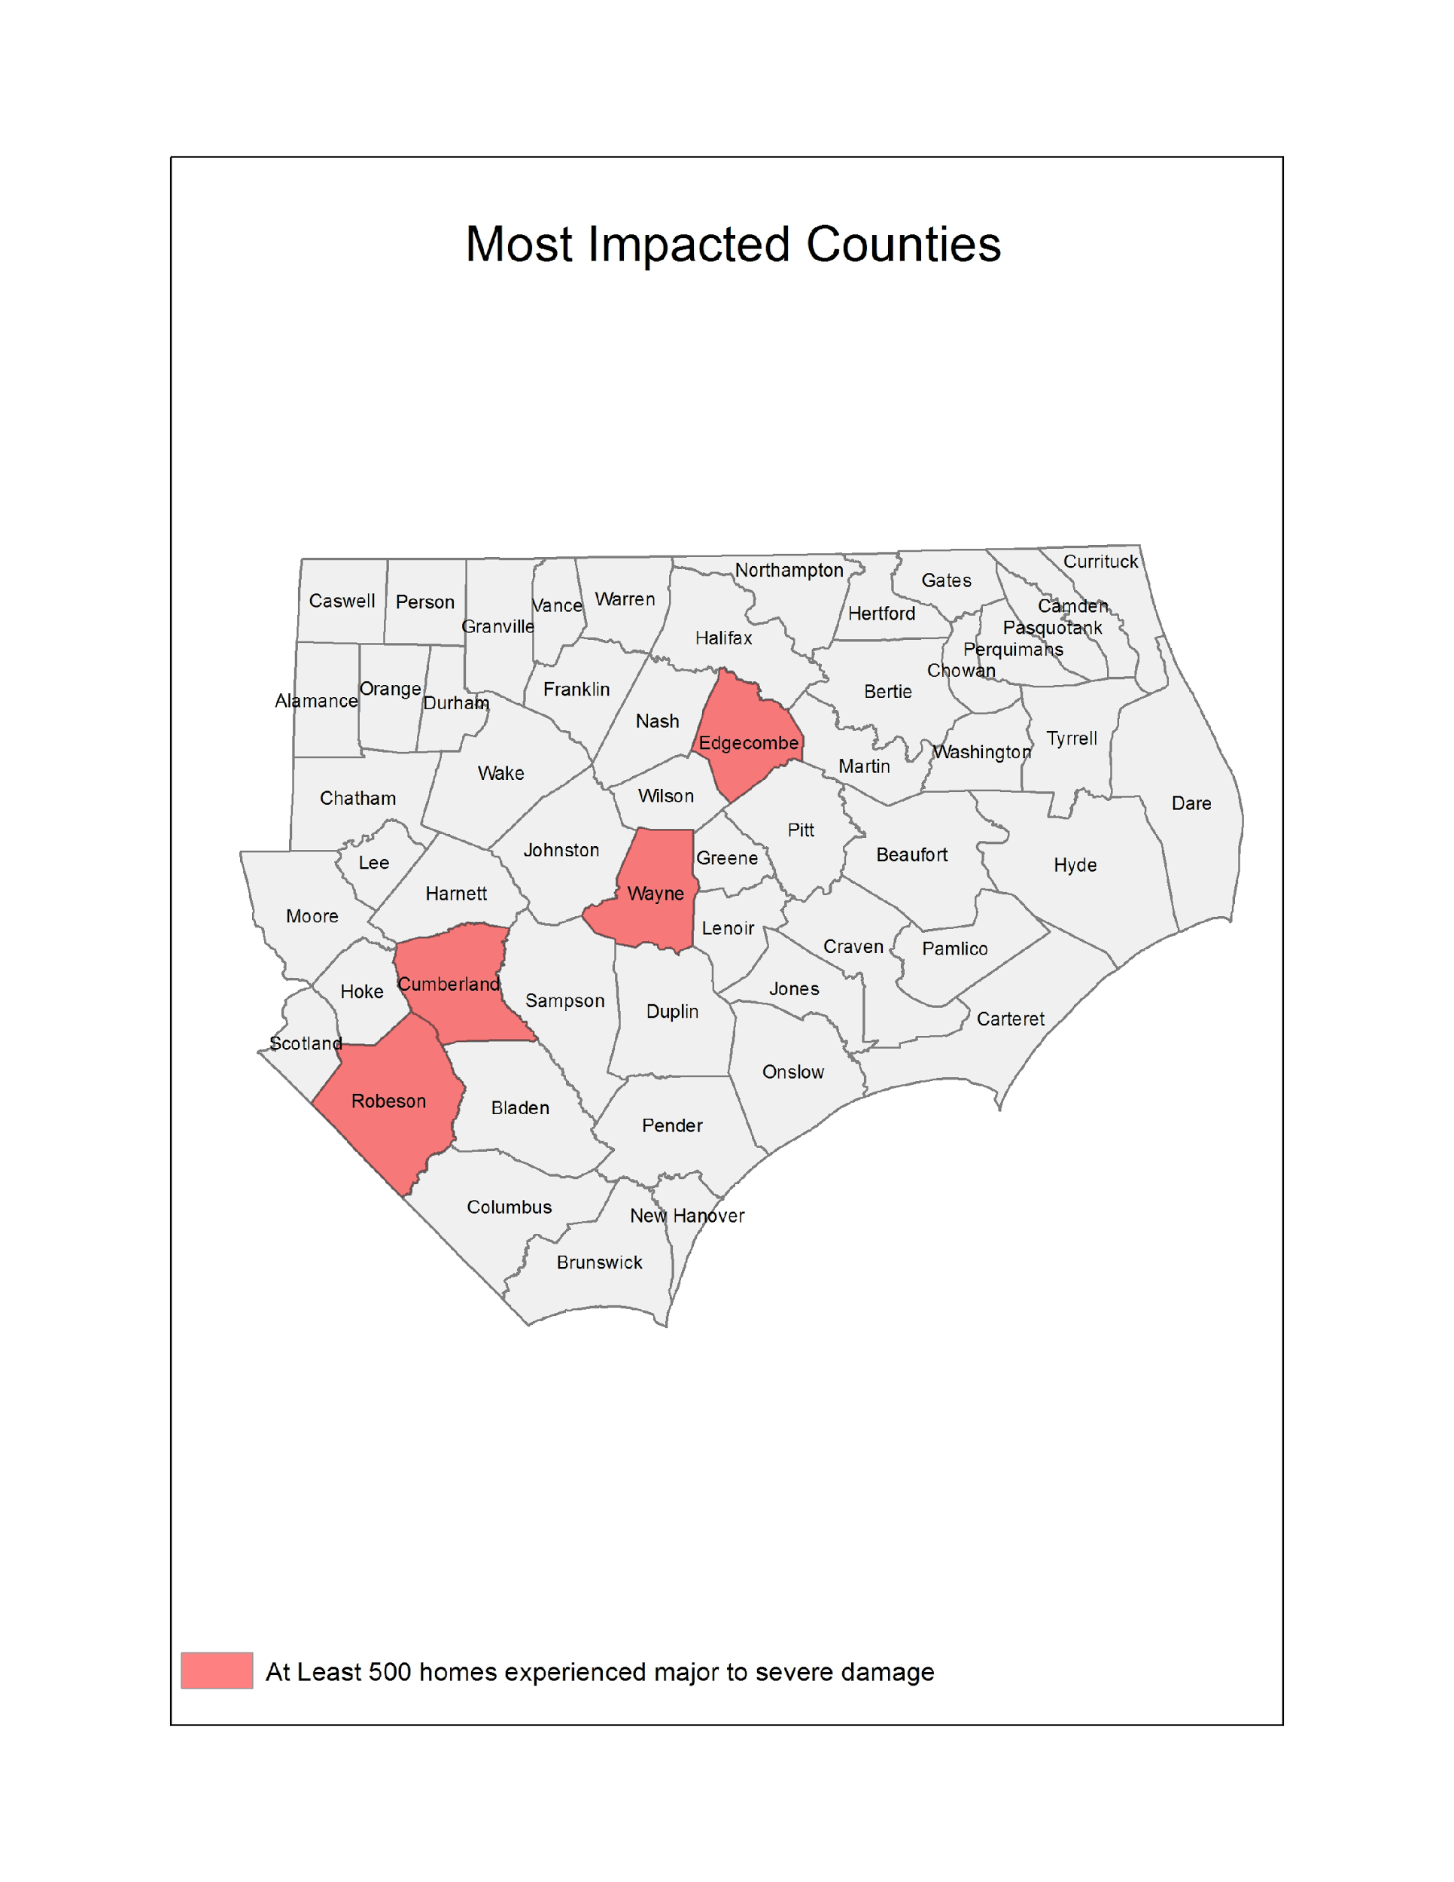

**Figure 2: Most Impacted Communities**

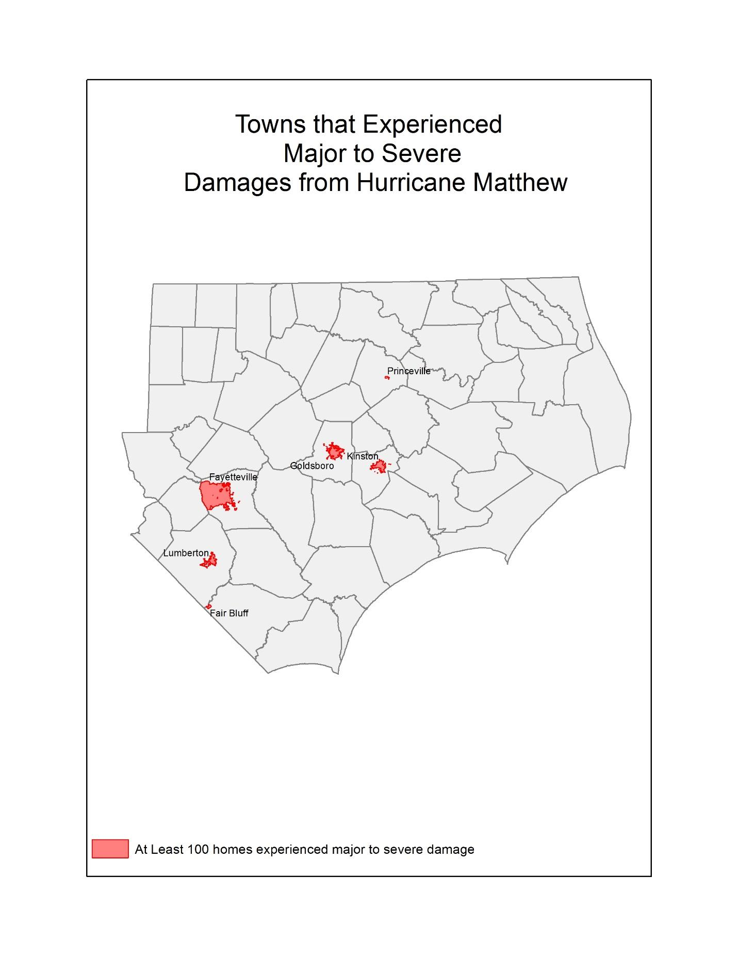

**Figure 3: Most Impacted Neighborhoods**

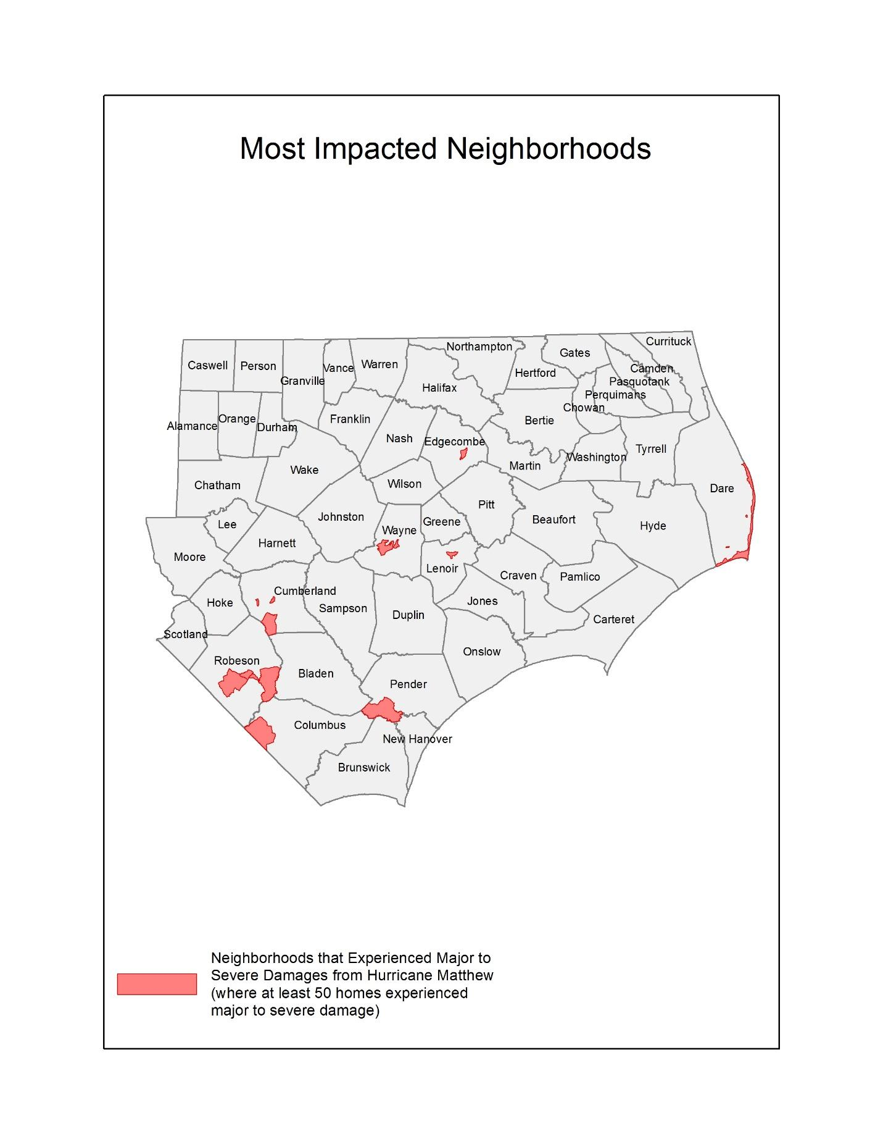

### Severely Impacted Communities

Hurricane Matthew concentrated its damage within specific areas, in particular riverine communities already grappling with a heavy rain season. There are six towns we consider “severely impacted,” where more than 100 homes experienced major to severe damage. These communities are predominantly low- and moderate-income (LMI) and have a higher concentration of African American, Native American, and Hispanic residents.

***Princeville – 367 homes had major to severe damage***: The town of Princeville, with a population of 2,373, is located in Edgecombe County along the Tar River just south of Tarboro. It is a largely African American community (96% of its residents are African American) and is reportedly the oldest community settled by freed slaves in the US. It is also located in a floodplain that has experienced frequent and substantial flooding over the years. The community is a low-income community, with the median household income of $33,011. In addition to flooded homes, the school and fire station were reported as flooded.

***Kinston – 181 homes had major to severe damage***: The town of Kinston, with a population of 21,589, is located in Lenoir County along the Neuse River. The community is predominantly African American (67%), and most of its residents are low-income, with the median household income of $28,608. The town experienced substantial damage to its main business district, flooding many small businesses serving the community.

***Lumberton – 876 homes had major to severe damage***: The city of Lumberton, with a population of 21,707, is located in Robeson County along the Lumber River. A racially and culturally diverse county, where 33.8% of the population is African American, 12.4% Native American (the Lumbee Tribe), and 11% Hispanic/Latino. Most of its families are LMI, with a median household income of $31,899. The community experienced substantial flooding after Hurricane Matthew, particularly along Fifth Street, its main commercial corridor, and among its public housing residents, where almost 500 very low-income renters lost their homes.

***Goldsboro – 251 homes had major to severe damage***: The town of Goldsboro, with a population of 35,086, is located in Wayne County along the Neuse River. It is a diverse, LMI community, where roughly 53% of the population is African American, and the median income is $29,456. It is also an agricultural community, where substantial livestock was lost.

***Fayetteville – 452 homes had major to severe damage***: Fayetteville, located on the Cape Fear River in Cumberland County, is a densely populated city of 200,000. It is a middle-income community, with a median household income of $44,514, and is racially diverse, where 41% of the population is African American and 10% are Hispanic. The flooding in Fayetteville was concentrated in the downtown area and in subdivisions near the Little River tributary, where flooding was so severe many residents had to be rescued to evacuate.

***Fair Bluff – 109 homes had major to severe damage***: Fair Bluff is a small town located along the Lumber River in Columbus County. Given its small population of 1,181 households, it was devastated by Hurricane Matthew, where approximately 25% of all families were severely impacted. The community is racially diverse, with 38% of the population white and 60% African American, and the majority of families are very low-income, with the median household income at $17,008. Fair Bluff’s main commercial district was particularly impacted by the floodwaters.

### Repairing Owner-Occupied Homes

The Unmet Needs Assessment examines the impact and unmet needs of homeowners using HUD’s own standard approach to analyzing housing damages, with slight modifications to the original plan based on available data.

The analysis uses the FEMA Individual Assistance (IA) data, SBA loan data to homeowners, and structural inspections performed by the State as of October 15, 2017. We determine the level of damage each property incurred using FEMA’s initial estimate of Real Property Loss and HUD’s guidance in FR-60120N-01. The damage categories range from 1 to 5; 1 being Minor-Low Damage and 5 being Severe Damage.

In total, 28,164 homeowners experienced some degree of damage to their homes; 2,569 homeowner families experienced major to severe damage. 78% of the total damages were to and 69% of the homeowners with major or severe damage were LMI.

**Table 4: Damage Counts of Owner-Occupied Homes by Damage Category and Income of Homeowner Family**

|  |  |  |
| --- | --- | --- |
| Damage Category | All Owners | Low and Moderate Income (LMI) Owners |
| Minor-Low | 22,795 | 18,128 |
| Minor-High | 2,800 | 2,102 |
| Major-Low | 1,581 | 1,121 |
| Major-High | 830 | 550 |
| Severe | 158 | 107 |
| **Total - All Damage** | **28,164** | **22,011** |
| **Total - Major to Severe Damage** | **2,569** | **1,780** |

Source(s): FEMA IA analysis effective 9/13/17

Because FEMA’s initial inspections have historically underestimated damage costs significantly, FEMA’s damage estimates are adjusted upwards based on the average SBA loan amount by damage category. For homes that received an SBA inspection, the damage costs are equivalent to that SBA inspection amount. For homes that did not receive an SBA inspection, damage costs are presumed to be the average SBA inspection amount for that damage category.

To estimate unmet needs, the Assessment subtracts the funds received from FEMA, SBA, and insurance from the damage costs. For homeowners that have flood insurance, the analysis assumes insurance covers 80% of the damage costs not covered by FEMA and SBA. The analysis also includes mitigation costs for homes that received major to severe damage, equivalent to 30% of damage costs. This reflects additional measures needed to ensure long-term sustainability of flooded homes.

The initial Unmet Needs Assessment examined what types of owner-occupied homes experienced major to severe damage. Approximately two thirds were single family structures, while the remaining one third were mobile homes.

**Table 5: Owner-Occupied Housing Units that Experienced Major to Severe Damage by Structure Type**

|  |  |  |
| --- | --- | --- |
|  | Count | Percent |
| Apartment | 1 | 0% |
| Boat | 1 | 0% |
| Condo | 4 | 0% |
| House/Duplex | 1,709 | 67% |
| Mobile Home | 831 | 32% |
| Other | 2 | 0% |
| Townhouse | 4 | 0% |
| Travel Trailer | 6 | 0% |
| (blank) | 11 | 0% |
| Total | **2,569** | **100%** |

Source(s): FEMA Individual Assistance data. Analysis effective 3/15/17

### Rental Housing

Almost half of all the housing that withstood major to severe damage from Hurricane Matthew was rental housing. The storm caused severe damage or destroyed at least 2,388 occupied rental homes, with 83% of this damage occurring in the six most impacted counties. In particular, Lumberton experienced the greatest loss of rental housing, with 526 units impacted. This is followed by Fayetteville (283 units) and Princeville (211 units).

Far more than owner-occupied homes, the vast majority (86%) of renters severely impacted by the storm were LMI.

**Table 6: Damage Counts of Renter-Occupied Homes by Damage Category and Income of Renter Family**

|  |  |  |
| --- | --- | --- |
|  | All Renters | Low and Moderate  Income  Renters |
| Minor-Low | 2,632 | 1484 |
| Minor-High | 1,097 | 618 |
| Major-Low | 963 | 543 |
| Major-High | 1,244 | 701 |
| Severe | 181 | 102 |
| Total - All Damage | **6,117** | **3,448** |
| Total - Major to Severe Damage | **2,388** | **1,346** |

Source(s): FEMA Individual Assistance data. Analysis effective 9/15/17

Of the rental units, seriously damaged by Hurricane Matthew, we see approximately half were apartment buildings, while 40% were single family homes or duplexes. A significant number of rented mobile homes were also flooded (13% of all major to severe damage).

**Table 7: Rental Housing Units that Experienced Major to Severe Damage by Structure Type**

|  |  |  |
| --- | --- | --- |
|  | Count | Percent |
| Apartment | 1,084 | 45% |
| Assisted Living Facility | 4 | 0% |
| Condo | 13 | 1% |
| House/Duplex | 955 | 40% |
| Mobile Home | 308 | 13% |
| Other | 5 | 0% |
| Townhouse | 8 | 0% |
| Travel Trailer | 1 | 0% |
| Unknown | 10 | 0% |
| Total | **2,388** | **100%** |

Source(s): FEMA IA data. Analysis effective 9/15/17

### Other Rental Housing

The State of North Carolina conducted outreach to housing providers in impacted areas to determine the damages, displacement, and unmet needs of subsidized and supportive rental housing. This included emails, a survey, and follow-up phone calls that took place between March 2 and March 20, 2017. NCEM contacted multiple Public Housing Authorities (PHAs), the State Housing Finance Agency, State Community Development Block Grant Disaster Recovery (CDBG-DR) Communities, and North Carolina’s Department of Health and Human Services (DHHS) to quantify the disaster’s results, understand how it has impacted the families served by the agencies, and determine what needs are still unmet. The following is a summary of these communications. This information will be updated as more details become available to include any data from the most impacted counties and communities.

#### Public Housing

The State contacted PHAs in the most impacted areas, including Greenville Housing Authority, Pembroke Housing Authority, Lumberton Housing Authority, the Housing Authority of the City of Rocky Mount, and Wilmington Housing Authority. The survey asked which properties/units (if any) were damaged and where they are located; how many people were displaced and if they have returned; what the overall damage cost is; whether the units have been repaired; and if any costs or repairs are remaining. Information was received by four of the five housing authorities, which resulted with Wilmington having no damage, Greenville and Rocky Mount having minor damage, and Lumberton experiencing severe damage. Pembroke is calculating the overall costs and will provide the information when available. Each of these facilities will be eligible for FEMA Public Assistance (PA) and will have, in addition to unmet needs, a 25% local match requirement that will need to be met and is part of the State’s unmet need.

**Table 8: Survey Results from Public Housing Authorities as of March 15, 2017**

|  |  |  |  |  |
| --- | --- | --- | --- | --- |
| City/County | What are the overall damage costs? | What amount of those costs was/is/will be covered by insurance and/or other sources? | Remaining Costs | Are there repairs that still need to be made? |
| Lumberton | $8,000,000 +/- | $3,000,000 +/- | Yes | Yes, $5,200,000 |
| Greenville | ~$8,000- $10,000 | None | No | No |
| Rocky Mount, Edgecombe, Nash Counties | $6,000 | $2,020 | $3,980 | Interior water damage not covered by insurance - repairs are being completed by force labor. |
| Wilmington | 0 |  |  |  |
| Pembroke | Unknown |  |  |  |

Source: Survey results from PHA outreach, effective 3/10/17.

The Lumberton Housing Authority had, by far, the most extensive damage totaling an estimated $8 million, with approximately $5 million in remaining unmet need. There are currently 264 families displaced, currently living with family members or using housing vouchers, who have yet to move back into their homes as all units are still in the process of being repaired.

In addition to Lumberton, Greenville and Rocky Mount had damages with a combined total of $16,000, and Rocky Mount still has $3,980 costs remaining. In Greenville, 105 Public Housing families were displaced; however, all of the units have since been repaired, and all families have moved back.

The housing programs within this Action Plan will address remaining unmet needs, after taking into account funds available from insurance and other sources, to restore public housing and return families to their homes.

#### Other Subsidized Housing

Similar to the PHAs, the State sent a survey to the North Carolina Housing Finance Agency (NCHFA), USDA, and other housing providers in impacted communities, to assess damages and unmet needs due to Hurricane Matthew. According to the NCHFA, 397 units were damaged. The agency believes they have sufficient funds to make the needed repairs using insurance proceeds. However, if there are instances where subsidized affordable rental housing has remaining unmet needs, their recovery will be given priority in the rental housing programs outlined in this Action Plan.

**Table 9: NC Housing Finance Agency Properties Damaged by Hurricane Matthew**

|  |  |  |  |
| --- | --- | --- | --- |
| Name | City | County | Units |
| Prince Court Apartments | Princeville | Edgecombe | 30 |
| Asbury Park Apartments | Princeville | Edgecombe | 48 |
| Holly Ridge Apartments | Lumberton | Robeson | 110 |
| Mount Sinai Homes | Fayetteville | Cumberland | 99 |
| ARC/HDS Northampton Co GH | Woodland | Northampton | 6 |
| First Baptist Homes | Lumberton | Robeson | 40 |
| Cypress Village | Fair Bluff | Columbus | 40 |
| Glen Bridge | Princeville | Edgecombe | 24 |

Source: North Carolina Housing Finance Agency, effective 3/10/17

The State also sent surveys to CDBG-DR Entitlement Communities in the impacted areas, and received responses back from Fayetteville and Rocky Mount. In Fayetteville, a reported 952 rental properties were severely damaged, and 671 remain unrepaired. The City cited a need for substantial mitigation and resiliency measures, as many damaged properties were severely damaged, exceeding 50% value. The city is currently determining the costs of repair and unmet needs, after factoring in other federal assistance and insurance proceeds. Rocky Mount reported 340 rental homes damaged and are currently determining repair costs and unmet needs.

#### Permanent Supportive Housing

The State contacted North Carolina’s to understand the impact Hurricane Matthew had on homeless shelters, transitional housing facilities, or any housing facilities that serve those with disabilities or supportive housing damages. They were asked what the total damaged properties were, how many people were displaced, and if they are still displaced.

The DHHS manages the delivery of health- and human-related services for all North Carolinians, especially our most vulnerable citizens – children, elderly, disabled, and low-income families. DHHS has not yet reported damage to any permanent supportive housing or service facilities, while the State is currently assessing unmet needs.

In addition to restoring existing permanent supportive housing and services, this disaster event likely calls for new services to families and residents who have not historically been served by DHHS. For many very low-income owners and renters, older adults, and persons with disabilities, the impact of severe flooding can lead to a variety of needs. For many families, the loss of their homes; lost wages due to job interruption; limited access to transportation; and the stress associated with living in overcrowded or unsafe conditions due to “doubling up” or remaining in their damaged homes out of necessity warrants additional services in the form of emergency housing assistance, mental health support services, homeless prevention services, and health and transportation assistance. The State will address these needs, working closely with local communities, with emphasis on assisting families currently displaced or at risk of displacement.

### Housing Unmet Need Summary

The State of North Carolina has taken multiple steps in estimating the unmet housing needs resulting from Hurricane Matthew. This includes conducting field inspections of damaged homes; analyzing and updating FEMA IA data, SBA loan information, and insurance information; conducting county-led planning efforts; and surveying PHAs and other housing providers to determine what financial needs will be required to restore our homes and neighborhoods.

This estimate accounts for the costs to repair damaged homes that are owned or rented by LMI persons. The State estimates that, to assist 7,831 LMI homeowners, it would need an additional $104,081,224 and, to assist 3,448 LMI renters, it would need an additional $68,912,793, which includes providing required mitigation for these homes to avoid future losses, resulting in an additional $172,994,017 in unmet need.

There are additional needs beyond repairing damaged homes. The State has been proactive in initiating outreach with the most impacted communities to determine the cost benefit of repairing homes that experience repetitive flood loss and/or are located in flood-prone areas versus the cost of acquiring these properties and relocating these families to safer ground. This is an ongoing effort, and as of October 15, 2017, the State estimates an additional need of $260,971,916 to elevate homes, or acquire and demolish homes, and then relocate families to new housing. The Table below shows, by county, the number of homeowners that have requested a buyout.

Additionally, the State will require that all new construction and repair of substantially damaged homes meet Advisory Base Flood Elevations, where the lowest floor is at least one foot above the 100-Year Floodplain elevation.

The estimate also accounts for the repair of the public housing units that were severely damaged ($15,200,000) as well as an increased estimate of need for support services for persons needing assistance relating to the homeless, families living in poverty, persons needing medical or mobility assistance due to disabilities, permanent supportive housing needs, persons who are currently displaced and need additional housing assistance, and services to older residents especially challenged by displacement ($17,371,361).

Finally, the unmet needs factors in a preliminary estimate of subsidies needed for LMI homeowners who will expect to see their insurance premiums increase and who will not be able to afford flood insurance once their homes are rebuilt ($8,800,000). In addition, the estimate includes the providing funds to address shortfalls for homeowners who sell their homes to the State through a buyout program and, because of the cost of new housing, will have a gap in what the home sale price was and the cost to move into the new residence ($10,077,200).

These estimates are based on existing data; as the State and local planning efforts continue to work with the most impacted communities, these figures may be adjusted based on better data and feedback.

**Table 10: Housing Unmet Needs**

|  |  |
| --- | --- |
|  |  |
| Owner - Repair Damages | $104,081,224 |
| Renter - Repair Damages | $68,912,793 |
| Elevation/Buyout | $260,971,916 |
| Public Housing | $15,200,000 |
| Supportive Services | $17,371,361 |
| Homeowner Assistance Program | $10,077,200 |
| Insurance Subsidies for LMI Owners | $8,800,000 |
| *TOTAL* | **$485,414,494** |

Source(s): FEMA Individual Assistance, Small Business home loan data; survey responses from State and local housing providers and agencies; analysis effective 9/13/17

## Vulnerability of the Most Impacted Communities

As was articulated in the initial Action Plan, North Carolina’s approach to recovering its homes and neighborhoods after Hurricane Matthew is to strategically examine where the damage occurred and then focus its recovery efforts in those areas, paying special attention to the housing types, household types, and special needs of these unique communities. The allocation of funds in the Action Plan Amendment, shows North Carolina’s commitment to the most vulnerable communities. The original analysis remains unchanged, and the use of the metrics in this analysis is shaping program design.

Families and individuals with social vulnerabilities oftentimes face greater challenges in evacuating during a disaster event, including finding suitable and affordable housing if displaced, and being able to afford making the repairs needed so that they can return to their homes. To address this issue, North Carolina analyzed IA applications to determine which neighborhoods withstood the brunt of Hurricane Matthew’s impact and then examined the socio-economic and demographic profiles of these neighborhoods.

For the purpose of this study, we consider a neighborhood to be “most impacted,” if at least 25 homes experienced major to severe damage (i.e. homes with a category 3, 4, and 5 damage level, or Major-Low, Major-High, and Severe damage), or where at least 5% of all homes had major to severe damage. The analysis defines vulnerable populations as older residents (65 years old or older), persons with disabilities, homeless or individuals at risk of homelessness, neighborhoods where at least 50% of households earn less than 80% Area Median Income (AMI) (LMI neighborhoods), households with English language barriers, and households who do not own personal vehicles. This data is publicly available using the 2010-2014 American Community Survey (ACS) and is collected at the Census Tract-level (aligned with our definition of a neighborhood). To determine if a Census Tract has a disproportionate number of residents or families with social vulnerability, we compare the figures to state averages, or use HUD-standard benchmarks (i.e. majority of households are low-income, for example).

Based on this analysis, there are five neighborhoods located in Lumberton, Princeville, Fayetteville, and Fair Bluff that were severely impacted (where at least 100 homes experienced major to severe damage). Of these five neighborhoods, an impacted family is more likely to be low-income, minority, and without a family car than what is typical in the State. Among the other impacted neighborhoods, there are pockets of damage where residents have English language barriers, disabilities, and are also low-income and minority neighborhoods. There are no substantially impacted neighborhoods with a disproportionate number of older residents. Even so, North Carolina understands that many older households have substantial rebuilding challenges, and their needs will be addressed through local outreach efforts and prioritization among programs.

Additionally, North Carolina is committed to rebuilding damaged communities in a manner that furthers fair housing opportunities to all residents. For this reason, the Assessment identifies which impacted neighborhoods have a disproportionate concentration of minority populations. As these communities rebuild, the State will focus its planning and outreach efforts to ensure that rebuilding is equitable across all neighborhoods, which may include providing affordable housing in low-poverty, non-minority areas where appropriate and in response to natural hazard-related impacts.

**Table 11: Most Impacted Neighborhoods and Social Vulnerability [Y = Disproportionate Social Vulnerability]**

|  |  |  |  |  |  |  |  |  |  |  |
| --- | --- | --- | --- | --- | --- | --- | --- | --- | --- | --- |
| **Town** | **County** | **Neighborhood** | **Owner** | **Renter** | **Total** | **Disability** | **Language Barriers** | **No Access to Vehicle** | **Minority** | **LMI** |
| **Lumberton** | ROBESON | 37155960801 | 150 | 320 | 470 | N | N | Y | Y | Y |
| **Princeville** | EDGECOMBE | 37065020900 | 156 | 211 | 367 | N | N | Y | Y | Y |
| **Lumberton** | ROBESON | 37155960802 | 125 | 144 | 269 | Y | N | Y | Y | Y |
| **Fayetteville** | CUMBERLAND | 37051003203 | 26 | 107 | 133 | N | N | N | Y | N |
| **Fair Bluff** | COLUMBUS | 37047930600 | 50 | 59 | 109 | Y | N | Y | N | N |
| **Fayetteville** | CUMBERLAND | 37051000200 | 53 | 40 | 93 | Y | N | Y | Y | Y |
| **Rural** | WAYNE | 37191000901 | 44 | 48 | 92 | N | Y | N | N | N |
| **Goldsboro** | WAYNE | 37191001500 | 24 | 61 | 85 | Y | N | Y | Y | Y |
| **Rural** | ROBESON | 37155961802 | 16 | 61 | 77 | Y | N | N | Y | Y |
| **Rural** | DARE | 37055970502 | 47 | 28 | 75 | N | N | N | N | Y |
| **Rural** | CUMBERLAND | 37051003001 | 52 | 16 | 68 | N | N | N | N | N |
| **Rural** | PENDER | 37141920502 | 41 | 24 | 65 | N | N | N | N | N |
| **Kinston** | LENOIR | 37107010800 | 2 | 62 | 64 | Y | N | N | Y | N |
| **Rural** | ROBESON | 37155961500 | 47 | 14 | 61 | N | N | N | N | N |
| **Hope Mills** | CUMBERLAND | 37051001601 | 32 | 17 | 49 | N | N | N | N | N |
| **Fayetteville** | CUMBERLAND | 37051003800 | 4 | 42 | 46 | Y | N | Y | Y | Y |
| **Lumberton** | ROBESON | 37155961302 | 23 | 23 | 46 | N | Y | N | Y | N |
| **Rural** | ROBESON | 37155961601 | 35 | 10 | 45 | N | N | N | Y | N |
| **Goldsboro** | WAYNE | 37191001400 | 12 | 31 | 43 | N | N | Y | Y | Y |
| **Rural** | EDGECOMBE | 37065021500 | 34 | 8 | 42 | N | N | N | N | N |
| **Fayetteville** | CUMBERLAND | 37051001400 | 22 | 20 | 42 | Y | N | N | Y | Y |
| **Goldsboro** | WAYNE | 37191002000 | 13 | 27 | 40 | N | N | Y | Y | Y |
| **Rural** | WAYNE | 37191001101 | 27 | 13 | 40 | N | N | N | N | N |
| **Rural** | PENDER | 37141920501 | 31 | 8 | 39 | N | Y | N | Y | N |
| **Rural** | BLADEN | 37017950100 | 34 | 4 | 38 | Y | N | N | N | N |
| **Seven Springs** | WAYNE | 37191000602 | 22 | 12 | 34 | N | Y | N | Y | N |
| **Kinston** | LENOIR | 37107010200 | 7 | 26 | 33 | Y | N | Y | Y | Y |
| **Rural** | SAMPSON | 37163971000 | 30 | 3 | 33 | N | Y | Y | Y | N |
| **Whiteville** | COLUMBUS | 37047930900 | 6 | 26 | 32 | Y | N | Y | Y | Y |
| **Lumberton** | ROBESON | 37155960701 | 29 | 2 | 31 | N | Y | N | Y | Y |
| **Kinston** | LENOIR | 37107011300 | 23 | 7 | 30 | Y | N | N | N | N |
| **Windsor** | BERTIE | 37015960400 | 18 | 12 | 30 | Y | N | Y | Y | N |
| **Rural** | CUMBERLAND | 37051001903 | 0 | 29 | 29 | N | N | N | N | N |
| **Tarboro** | EDGECOMBE | 37065021000 | 10 | 19 | 29 | N | N | Y | Y | Y |
| **Rural** | CRAVEN | 37049960200 | 24 | 3 | 27 | Y | N | N | N | N |
| **Rural** | LENOIR | 37107011300 | 15 | 12 | 27 | Y | N | N | N | N |
| **Rocky Mount** | EDGECOMBE | 37065020400 | 0 | 27 | 27 | N | N | Y | Y | Y |
| **Rural** | WAYNE | 37191001000 | 24 | 3 | 27 | N | Y | N | N | N |
| **Fayetteville** | CUMBERLAND | 37051000800 | 0 | 26 | 26 | N | N | N | N | N |
| **Rural** | CUMBERLAND | 37051001400 | 6 | 19 | 25 | Y | N | N | Y | Y |
| **Rural** | GREENE | 37079950102 | 20 | 5 | 25 | Y | N | N | Y | Y |
| **Rural** | MOORE | 37125950501 | 14 | 11 | 25 | N | N | N | N | N |

Source: Source(s): FEMA Individual Assistance data dated 1/16/17; American Community Survey 2010-2014; analysis effective 3/15/17.

The challenges associated with vulnerable populations can be categorized as follows:

***Evacuation Needs*** – Many low-income families lack the financial capacity to evacuate during a storm event, with limited resources to pay for alternative lodging. Many do not own a vehicle and simply cannot evacuate without assistance. Similarly, older residents and persons with disabilities may not be able to evacuate due to mobility challenges and the need to be near their existing medical care. There are also residents who are unaware of impending disasters due to language barriers and social isolation from to lack of technology. These individuals and families often risk their safety, and even their lives, due to their inability to get out of harm’s way as a storm approaches. Although the storm has since passed, North Carolina acknowledges that many impacted neighborhoods are at continued risk of flooding in the event of a future storm and are using this flood event to understand what the evacuation needs may be for the neighborhoods hit hardest by flooding.

***Displacement and Temporary Housing Needs*** – The greatest challenge most low-income families face immediately after evacuation is finding suitable temporary housing that is affordable and located near their jobs and basic services. Many are not able to pay for two homes (a mortgage on their damaged home and renting a new home) leading to severe debt or households “doubling up” with other family members. Even more challenging, many older adults and persons with disabilities have mobility challenges and medical needs, and moving far from their existing support network can lead to a sedentary, unhealthy living environment, or worse, a medical crisis. Very low-income residents, persons with disabilities, and many older adults impacted by Hurricane Matthew have supportive service needs like medical care, access to medicine, transportation assistance, and financial support during the rebuilding process.

***Rebuilding Needs* –** The long-term goal of North Carolina is to safely return families and individuals to their communities and homes. The cost of repair is a major issue for low-income homeowners, particularly for those whose homes were devastated by flooding and whose insurance did not cover the damages. Many low-income residents cannot afford to move and cannot afford to rebuild. What often happens is that they remain in their damaged home, living in an environment that poses health risks like mold and structural damage. Renters may face even greater challenges, since it is up to the landlord to rebuild or not, and if the rental income was insufficient to encourage rebuilding, the landlord may choose to keep the insurance payout and not rebuild. This leads to long-term displacement of renters, which can be particularly challenging in smaller communities where there is a limited supply of rental units.

North Carolina will address these challenges by tailoring its housing recovery programs to the communities most impacted while providing a suite of supportive services and financial assistance to low-income families and other vulnerable populations struggling to rebuild their lives.

**Figure 1: Most Impacted Neighborhoods that are Low- and Moderate-Income**

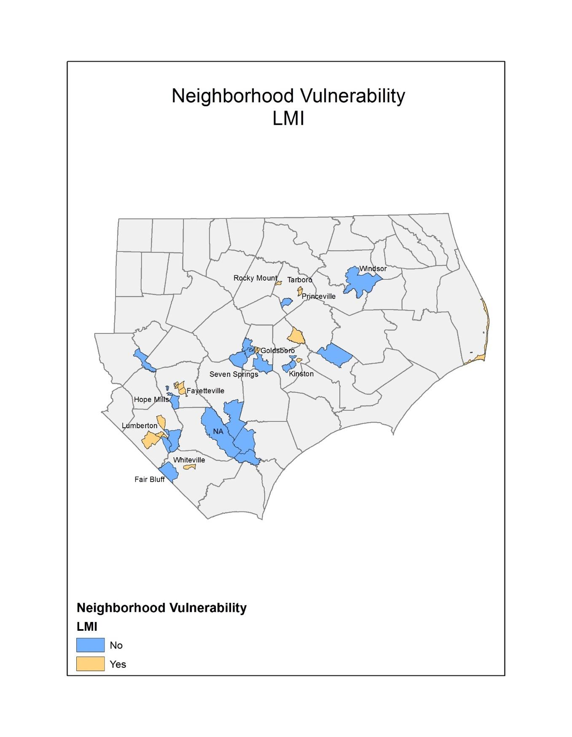

**Figure 2: Most Impacted Neighborhoods with a Disproportionate Concentration of Households without a Car**

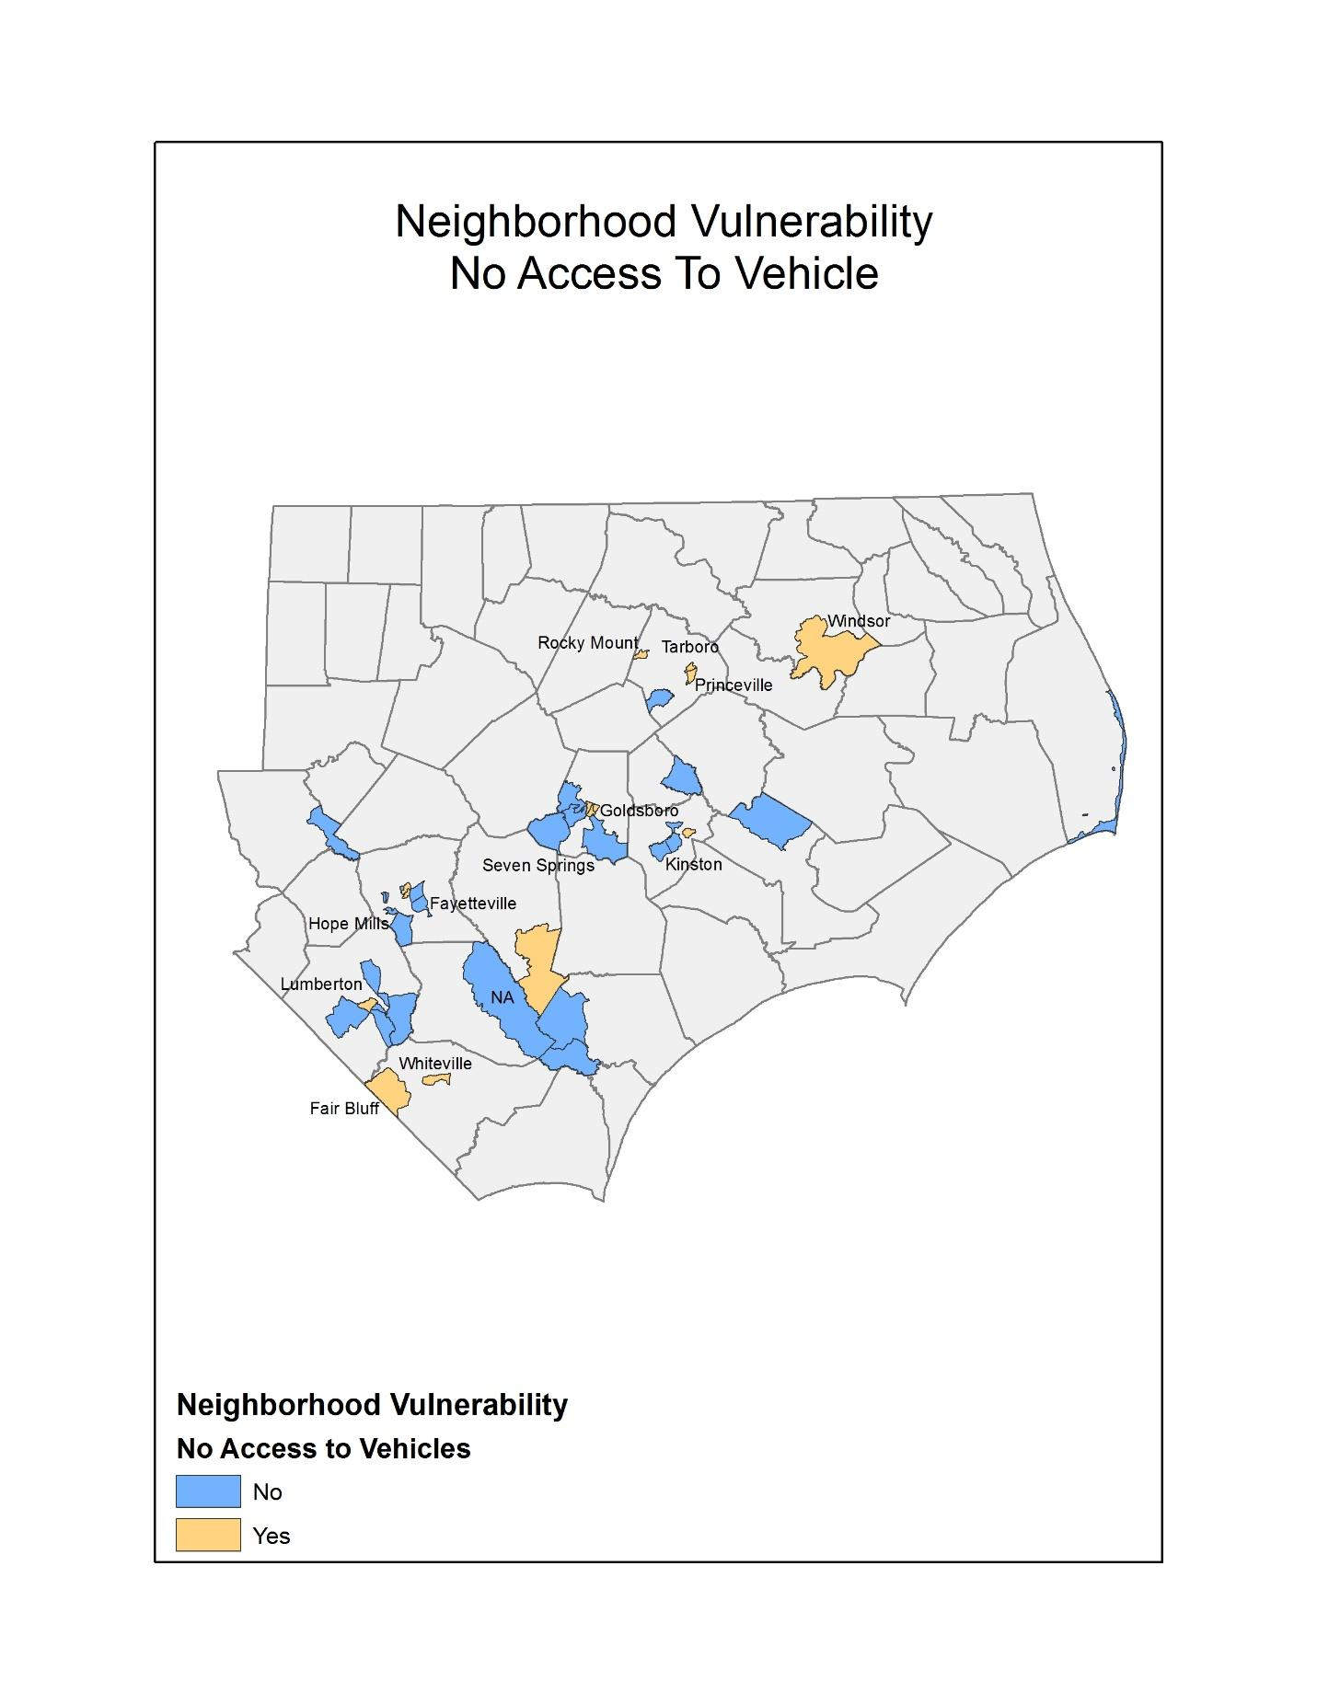

**Figure 3: Most Impacted Neighborhoods with a Disproportionate Concentration of Residents who Maintain Language Barriers**

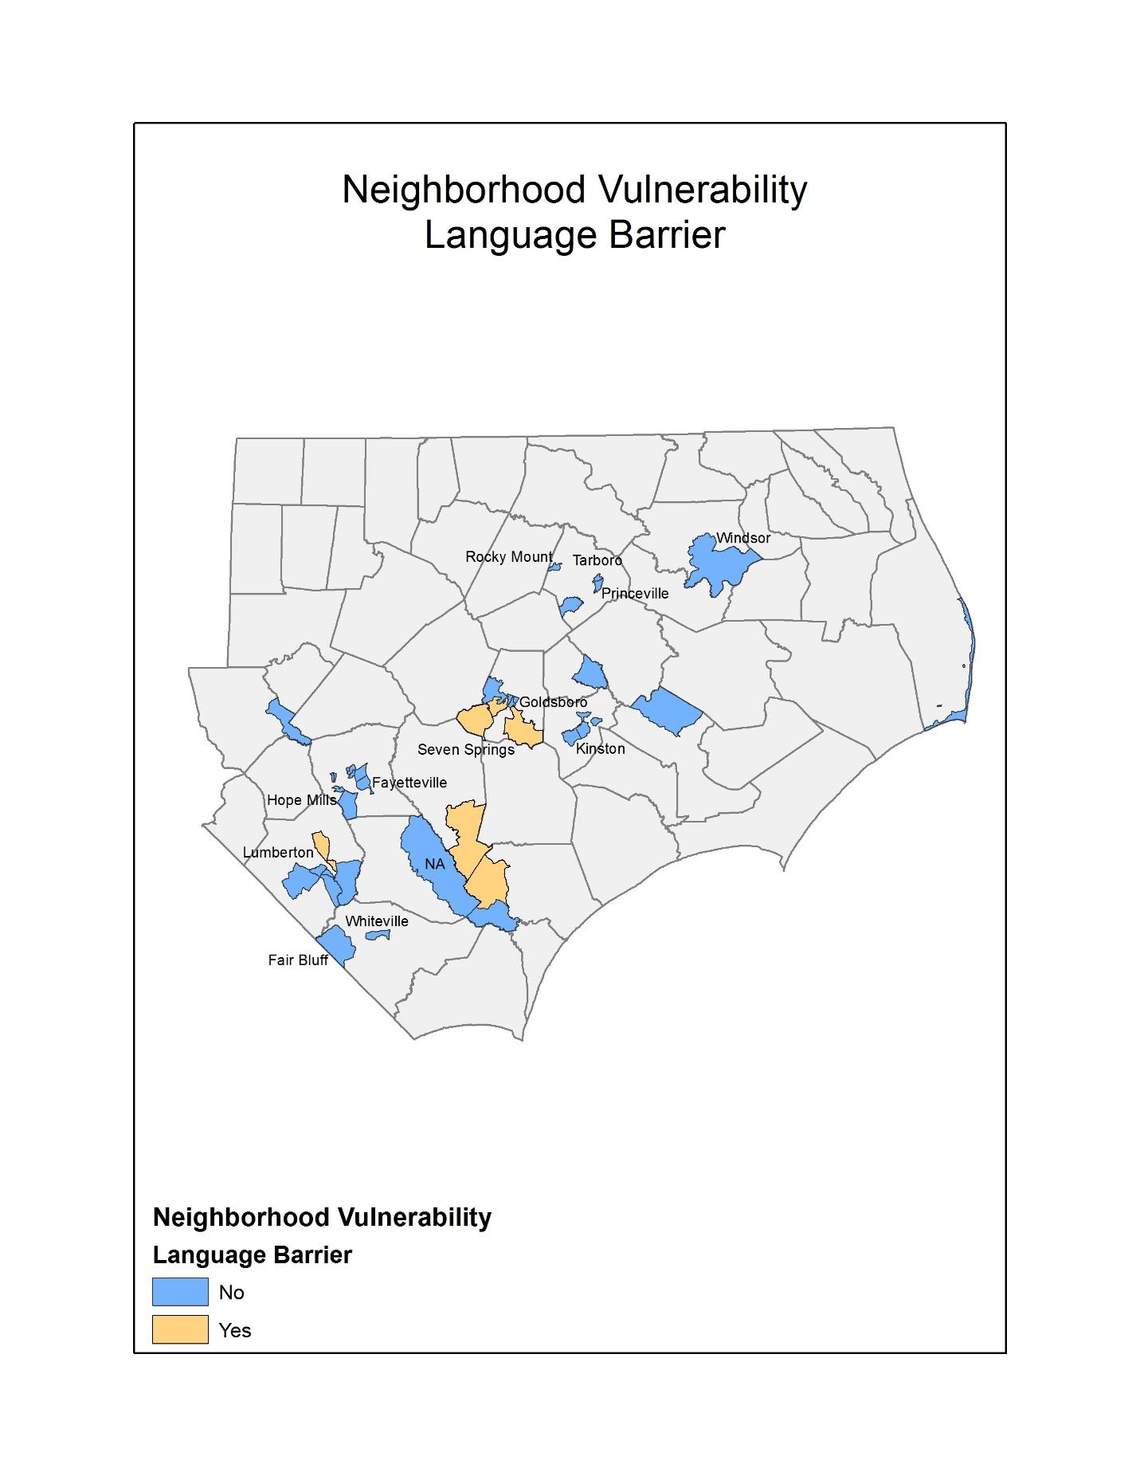

**Figure 4: Most Impacted Neighborhoods with a Disproportionate Number of Residents with Disabilities**

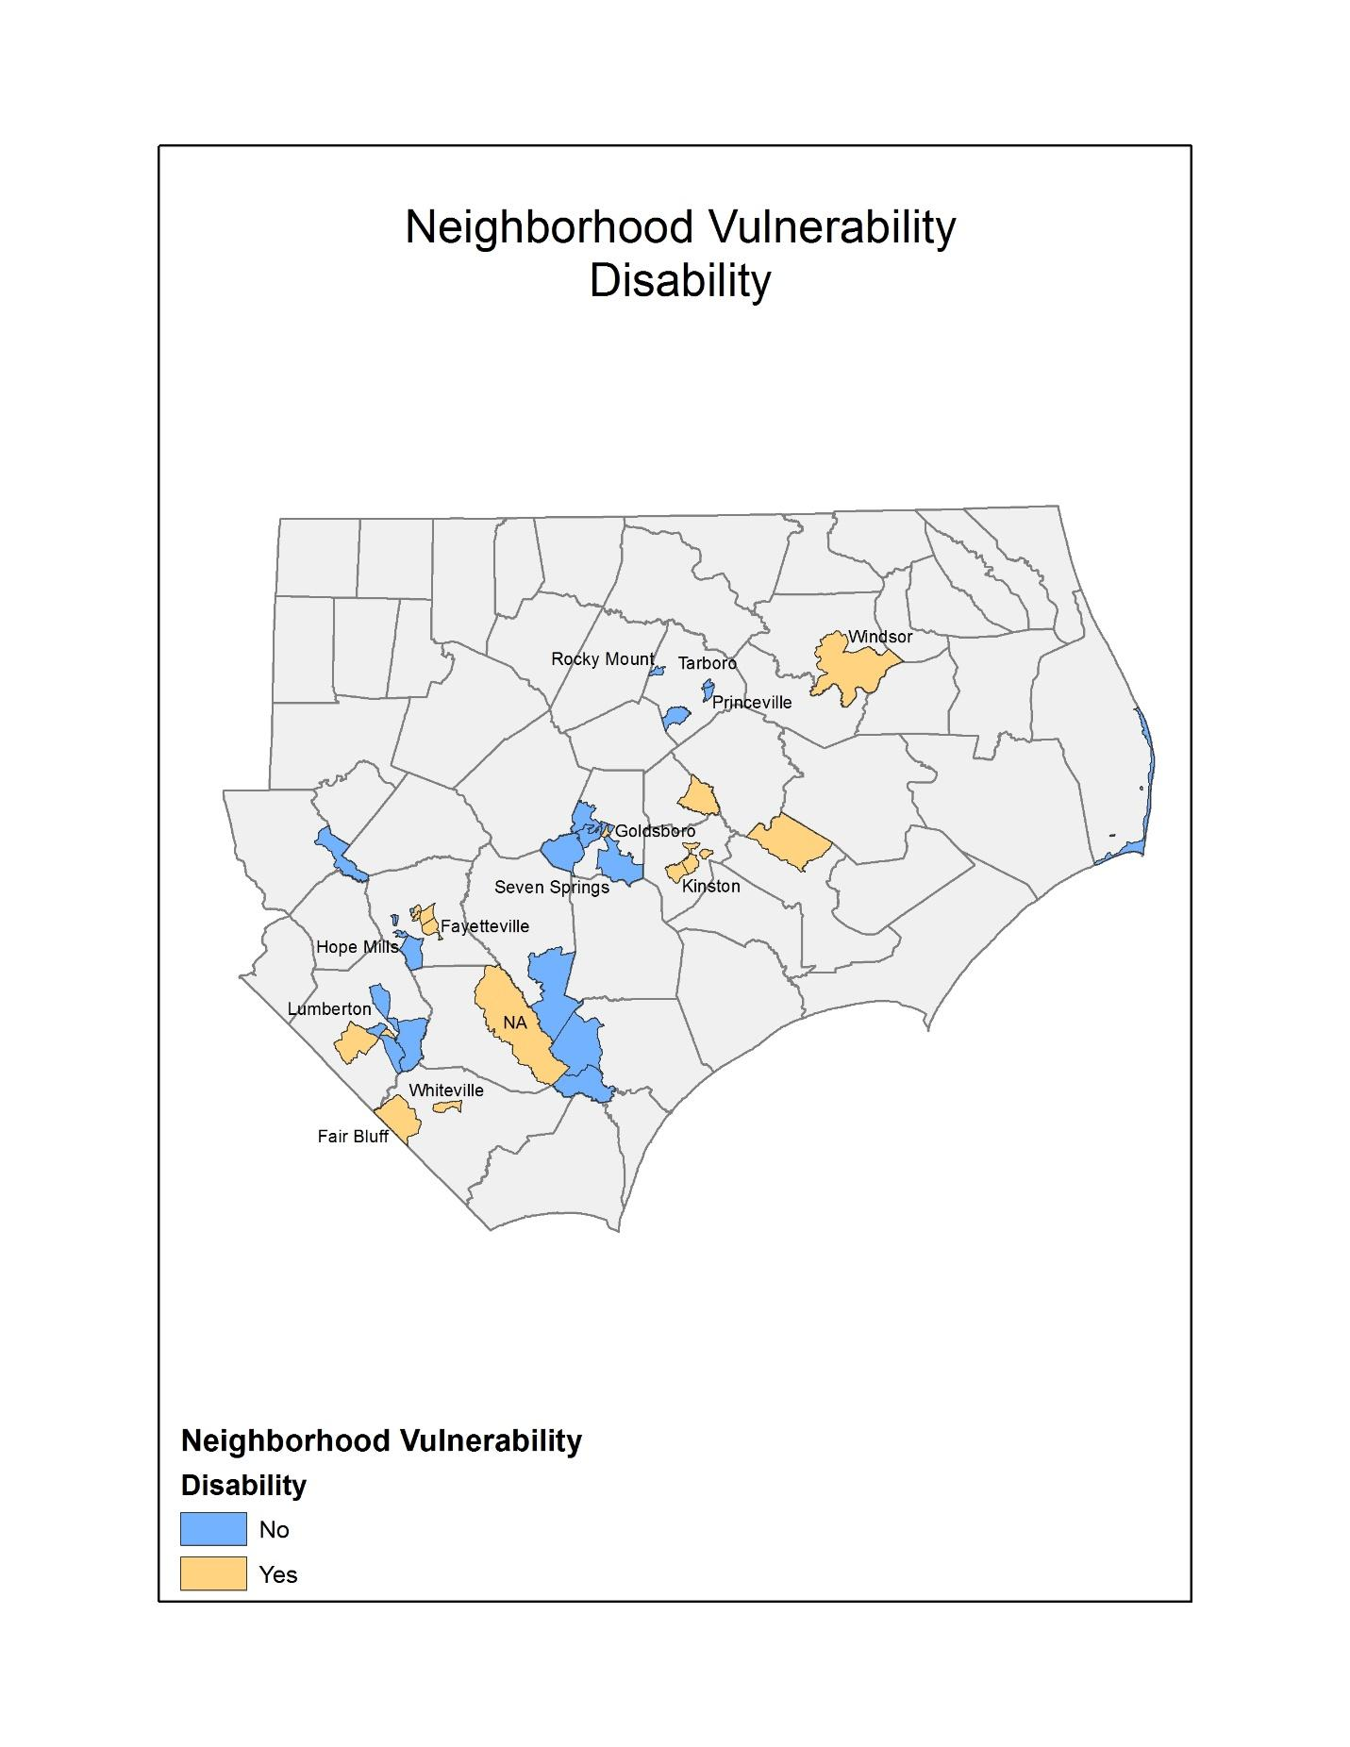

**Figure 5: Most Impacted Neighborhoods with a Disproportionate Concentration of Minority Populations**

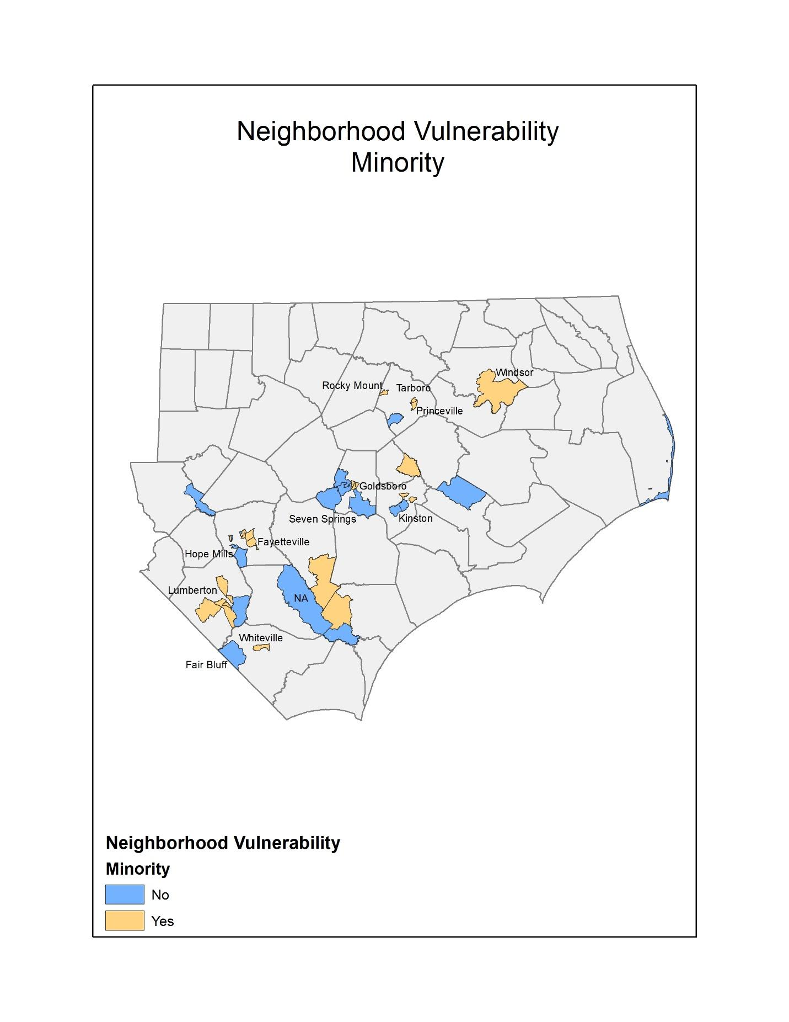

## Economic Recovery

As was shown in the initial Unmet Needs Assessment, Hurricane Matthew caused extensive damage to small businesses in eastern and central North Carolina with most businesses located in rural counties leaving a large unmet need. That analysis continues to be accurate as, to date, neither the SBA or USDA has addressed the recovery needs following Matthew. Small businesses are the economic backbone of most towns in North Carolina, and these businesses are where residents shop for groceries, buy gas, dine, lodge, and acquire retail and other services that define the community. Many businesses also support and rely on the state’s agricultural economy, including family farms and agribusinesses, for survival. As was shown in the initial Action Plan, a key industry sector that was impacted by Matthew was the State’s agricultural economy. The State still estimates that in part due to SBA loan denials and lack of dedicated recovery funding from the USDA for the farming community, the agricultural and small business community continues to have a $263M unmet need.

The most recent data from the SBA, continues to show that the counties most impacted by Matthew have the highest number of per county applications for assistance, and 95% of these businesses have less than 100 employees. Based on the September 2017 data on business related loans programs, small businesses in North Carolina are seeing more loans denied than approved, with 645 applications approved and 752 denied.

In addition to the businesses who were denied an SBA loan, there were 7,740 businesses who were referred to the program but never applied. The State, in consultation with community leaders and through the planning process, believes that many of these businesses, while having unmet recovery need, did not submit the loan package to SBA because they knew they would not qualify.

A primary component of North Carolina’s economic strength is its agricultural sector. The USDA declared 79 of the State’s 100 counties as having significant agricultural damage from Matthew and the North Carolina Department of Agriculture & Consumer Services reported that 48 counties were seriously impacted, with these counties accounting for 71% of the total farm cash receipts and representing $9.6 billion of the $13.5 billion total. The Department assessed that Matthew had a $422 million impact to major commodities and, because agriculture production is seasonal, many farms lost an entire year’s crop from Matthew and, along with it, a potential loss of markets. As a result, the State is continuing to assess agricultural recovery throughout the 2017-2018 growing season, but based on current information, there is substantial evidence that small agricultural businesses were substantially impacted, losing their anticipated 2017 earnings in the floodwaters. Without being fully compensated from USDA or SBA, they represent a large, unmet need.

Based on information from State Agencies and SBA, the current estimated unmet need for small businesses, including the agricultural sector, is $263,435,519. This assessment is based on a conservative approach of taking (1) 10% of the business losses for firms that were referred to FEMA who did not submit an application for an SBA, (2) all businesses that applied for an SBA loan but were denied, (3) an assumption that SBA business loans cover 80% of unmet needs, and (4) State estimates of ongoing agricultural losses that were not addressed by USDA through its programs. The data highlights that the most vulnerable businesses in North Carolina continue to be small businesses in rural counties, within the service, agriculture, and retail industries. The fact that these firms are located within or connected to the residential areas in the hardest hit counties amplifies the importance of obtaining funding to address the unmet needs of the business and agricultural sector as the services, local employment, and stability provided by small businesses are critical factors in ensuring that overall community and regional recovery will occur.

**Table 12: Unmet Business Needs**

|  |  |  |  |  |  |  |  |
| --- | --- | --- | --- | --- | --- | --- | --- |
|  | Business Loans Denied | Business Loans Approved | Referrals only | Average Loan Amount | Estimated Damages | Amount Received | Estimated Unmet Need |
| Total | 752 | 645 | 25,064 | $92,981 | $288,186,019 | $24,750,500 | $263,435,519 |

Source: US SBA, 09/18/17

## Public Infrastructure and Facilities

As was shown in the State’s initial Action Plan, Matthew devastated public infrastructure in eastern and central North Carolina. The State recognizes that the primary funding source used to repair and restore damaged public infrastructure is FEMA’s PA program. Since the initial Action Plan was published, the State has completed its 50-county comprehensive, ground up, community planning process. As a result, infrastructure-related projects will be implemented that were developed from these plans.

FEMA, through its PA program, assists communities rebuild following a disaster. The tables below show the current FEMA PA obligations for Matthew. In total, over 424 applicants now have eligible PA projects. While the amount of funding and number of applicants in the FEMA PA program is expected to grow as of October 10, 2017, these applicants had $292,780,270 obligated to PA projects, an increase of $279,253,605 since the initial Action Plan was published. As was shown in the State’s initial Action Plan, and remains true for this Amendment, the State estimates that once all FEMA PA projects are accounted for, the PA program will exceed $400 million, with over $101 million in match required.

**Table 13: FEMA PA Obligations by Category**

|  |  |  |  |  |  |
| --- | --- | --- | --- | --- | --- |
| FEMA Category | Category | Project Obligations (Project Worksheets (PWs)) | | Match Requirements | |
| 100% PW | Estimated | Current | Estimated |
| Debris Removal | A | $43,520,496 | $46,648,598 | $10,880,124 | $11,662,150 |
| Emergency Protective Measures | B | $54,284,215 | $55,465,188 | $13,571,054 | $13,886,297 |
| Roads & Bridges | C | $43,792,986 | $116,750,334 | $10,948,246 | $29,187,584 |
| Water Control Facilities | D | $17,304,456 | $10,634,800 | $4,326,114 | $2,658,700 |
| Public Buildings and Contents | E | $35,885,478 | $74,620,505 | $8,971,370 | $18,655,126 |
| Public Utilities | F | $47,524,289 | $48,290,124 | $11,881,072 | $12,072,531 |
| Parks, Recreational, Other Facilities | G | $50,468,351 | $53,932,676 | $12,617,088 | $13,483,169 |
| FEMA PA Total |  | $292,780,270 | $406,342,226 | $73,195,067 | $101,585,557 |

FEMA PA Data: October 10, 2017

In addition, to the PA program the State anticipates receiving $100M in Hazard Mitigation Grant Program funding with FEMA providing $75M and the State required to provide $25M. The State will use its Hazard Mitigation Grant Program (HMGP) allocation to buyout and acquire homes turning them into greenspace. As a result, the match required for both the FEMA PA and HMGP programs the current estimate for all FEMA programs exceeds $107M.

As was disclosed in the original Action Plan, all infrastructure related projects will refer to the Federal Resource Guide for Infrastructure Planning and Design: ([http://portal.hud.gov/ hudportal/documents/huddoc?id=BAInfra ResGuideMay2015.pdf](http://portal.hud.gov/hudportal/documents/huddoc?id=BAInfraResGuideMay2015.pdf))

The following sections provides more information on unmet public infrastructure and facilities service to address community recovery needs.

### Community and Supportive Facilities

As was documented in the State’s original Action Plan, some public facilities that were damaged will be repaired using FEMAPA funds. However, State facilities that provide social, community, and health (including mental health) services to support Matthew also incurred unmet needs that are not eligible for FEMA PA program funds. Through local outreach and needs assessments, the State continues to estimate an additional unmet need of $45.4M to address and pay for these services and facility upgrades.

### Dams and Levees

As was documented in the State’s original Action Plan, North Carolina has the largest number of dams in the nation with 1,200 high hazard dams that could potentially endanger lives and property if they fail. North Carolina’s Division of Energy, Mineral, and Land Resources reported that 20 dams were breached and 46 additional dams damaged as a result of Matthew, including the levee protecting the Town of Princeville, which resulted in millions of dollars in damages while other dams threatened more than 500 structures and residences.

North Carolina’s dam/levee work, which represents an unmet need of $38 million, will ensure the structures admitted under the United States Army Corps of Engineers (USACE) P.L. 84-99 are accredited under the FEMA National Flood Insurance Program (NFIP). The State will maintain file documentation of a risk assessment prior to flooding the flood control structure. That the investment includes risk reduction measures.

### Department of Transportation (DOT)/HUD/Federal Highway Association (FHWA) Transportation Facilities and Infrastructure

As was shown in the State’s original Action Plan, North Carolina’s road system was heavily impacted by Matthew. An important component of the national disaster response plan is the integration and delineation of how FEMA and US DOT provide funding to states to address storm-related repairs to road systems. As a result of Matthew, approximately 42,000 miles of roads needed to have either debris removal, emergency protective measures, and or specific site repairs. These activities will require the State to provide matching and, as disclosed in the initial Action Plan, represent an unmet need of $52.6M dollars.

### USDA / FSA Disaster Grant Programs

As was shown in the State’s original Action Plan and highlighted in the Economic Recovery section, Hurricane Matthew caused substantial damage to North Carolina’s rural areas. This included the loss of field crops and livestock who perished in the floodwaters, causing environmental hazards in the streams, ponds, and other bodies of water. The State, working with the USDA, continues to estimate an unmet need of $177.7M for USDA related activities including clean-up efforts and restoration of watersheds that are tied to Matthew.

### Environmental Protection Agency (EPA) - Drinking Water and Wastewater Repair and Mitigation

As was highlighted in the State’s original Action Plan, since the publication of the plan, the State has continued to work with the EPA and FEMA, to address the substantial unmet needs for the repair and mitigation of the water and wastewater treatment systems that were impacted by Matthew. Even after taking into account opportunities to restore and mitigate these systems with FEMAPA funds the State continues to have an unmet need of $274M dollars.

### National Guard Facilities and Equipment

The National Guard plays a vital and critical role in disaster recovery during the initial response period, providing emergency response functions (ESFs), helping citizens to safe ground, and securing assets. Its staging facilities and equipment must be maintained. Matthew impacted five facilities that will require a match that represents an unmet need of $730 thousand.

**Table 14: Infrastructure Unmet Need**

|  |  |
| --- | --- |
|  | Unmet Need |
| *FEMA PA and HMGP Match (estimate)* | $101,585,557 |
| *Repair health care, daycare, and other supportive facilities with remaining unmet needs (after subtracting FEMA and insurance)* | $45,370,264 |
| *Other Federal Agencies* |  |
| USACE - Levee and Dam Repair Safety | $38,132,675 |
| *DOT/HUD/FHWA - pavement, storm pipes, highway embankment* | $52,586,192 |
| *USDA /FSA Disaster Grant Programs* | $177,663,583 |
| *EPA - Drinking Water and Waste Water Repair and Mitigation* | $274,481,000 |
| *National Guard* | $734,000 |
| TOTAL | **$543,597,450** |

The State recognizes that the data collection and documentation of community infrastructure and public facilities needs is ongoing at this stage in the State’s recovery process. In addition to the documented costs in from Federal sources with the completion of the State’s community planning effort, additional recovery related projects will be implemented that represent an unmet need for infrastructure projects. The infrastructure projects are contained in each of the 50 county plans that were submitted to the State in the summer of 2017 and are shown on the Department of Commerce’s (DOC’s) website. As a result of the large unmet need in this program area, the State will need to maximize all funding sources and obtain additional resources to address this program area’s unmet need. As a result, the State may need to modify funding levels for sub-programs within this CDBG-DR allocation.

# Planning, Coordination, and Community Outreach Needs

The State’s initial Action Plan highlighted the robust planning effort in response to the unmet needs resulting from Hurricane Matthew. In addition to the Action Plan process, the North Carolina General Assembly established the North Carolina Resilient Redevelopment Planning (NCRRP) program as part of the 2016 Disaster Recovery Act (Session Law 2016-124). This effort was funded by the State and did not use CDBG-DR funds. North Carolina Emergency Management served as the coordinating body to develop regional planning strategies to ensure consistency across the State. The planning effort was initiated in February of 2017 and was completed in August of 2017 with the final submission of 50 county recovery plans. The plans can be found at <https://rebuild.nc.gov/HurricaneMatthew/Programs/RedevelopmentPlans>.

The purpose of the program was to provide a roadmap for community rebuilding and revitalization for areas that were impacted by the Matthew. The program empowered communities to prepare locally-driven recovery plans, to identify redevelopment strategies, suggest innovative reconstruction projects, and identify other needed actions to allow each community not only to recover from Matthew but also to become more resilient to future storm events. At the state level, this planning effort assisted in promoting sound, sustainable, long-term recovery planning. By using post-disaster evaluation of hazard risk, especially land-use decisions that reflect responsible floodplain management, the potential for possible sea level rise, increasing frequency and severity of rain and other storm events, the plans helped shape the recovery process that is incorporated in this Action Plan, which along with citizen input, provides a roadmap for how recovery, rebuilding, and resiliency can occur in impacted counties.

With the planning process complete, implementation of the proposed projects and actions described in the Plans can begin, subject to applicable federal, state, and local laws and regulations. Proposed projects or actions may be eligible for state or federal funding or could be accomplished with municipal, nonprofit, or private investments. While the State will utilize the Plans as a roadmap for recovery as it engages with community and county governments through this recovery process, inclusion of a project or action in a specific Plan does not guarantee that it will be eligible for recovery funding as currently the State is significantly oversubscribed and underfunded across all program areas.

# Nexus Between Unmet Need and Allocation of Resources

The State’s initial Action Plan prioritized providing funds to communities that experienced the most significant damage from Hurricane Matthew as described in the Unmet Needs Assessment. The State continues to be focused on providing assistance to these communities and the counties that were most impacted. Based on the recently completed 50 county planning process, the State will support recovery objectives in each of the impacted counties, with a focus on the four most impacted counties. Based on the county planning process, community outreach, and research and analysis of revised and updated available Federal data, the following unmet needs are the main priorities for this Action Plan Amendment #1 as reflected in the proposed recovery activities:

* Providing a significant portion of the allocation as additional assistance to the housing sector to ensure that homeowners that were impacted by Matthew have resources and options available as they begin to rebuild, repair, or replace homes with major to severe damage. Continuing to ensure that an adequate supply of rental housing is available that is safe, sustainable, and affordable in the most impacted areas.
* Providing additional assistance to LMI families and other persons with supportive service needs.
* Providing additional assistance to address community recovery needs, including funds to assist with the local match for FEMA funded programs (PA and HMGP) so that homeowners can relocate to higher and safer ground, to assist units of government address recovery and rebuilding needs of public infrastructure, and to ensure that some projects and priorities identified in the county planning process can be implemented.

All proposed activities and uses described in the following programs are authorized under Title I of the Housing and Community Development Act of 1974 or allowed by waiver or alternative requirement and will be located in a Presidentially declared county eligible for assistance.

### National Flood Insurance Restrictions

The State's initial Action Plan described in detail the general eligibility requirements for the program. These requirements remain in force with this Action Plan and can be found on the agency website.

For homeowners who receive Hurricane Matthew CDBG-DR funds via the suite of housing programs detailed in the Action Plan, homeowners should be aware that as part of the duplication of benefit check, the State must conduct a check to see if the homeowner has maintained flood insurance if they are located in specific areas that were previously assisted with FEMA IA or other federal disaster funds. In the event that a homeowner is found to have not maintained adequate flood insurance after receiving prior federal disaster assistance, this property will be ineligible for repair, replacement, or restoration assistance with CDBG-DR funds. After receiving Hurricane Matthew CDBG-DR funds, the homeowner must maintain adequate flood insurance to be eligible for future disaster assistance.

# Method of Distribution

The State of North Carolina prioritized, in the initial Action Plan, allocating CDBG-DR funds to address housing recovery needs. The initial Action Plan provided the State with $198,553,000 of CDBG-DR funding. Of that, the State allocated $142,886,811 to housing activities, accounting for 84.7% of the funds provided in the initial allocation, which includes providing funds for supportive services to families with the greatest needs. To address the overall recovery in a holistic way, the State also allocated 5.9% of available funds to assist small businesses, and 9.4% of available funds to restore necessary community facilities, to aid in the recovery of neighborhoods in most impacted areas.

With the additional $37,976,000 provided in this Action Plan Amendment, the State continues to provide funds to all three program areas with a continued focus on housing related activities. From the second allocation, the State is proposing to use 93% of the total program funds, $33,577,200, to advance homeowner programs. This includes providing funds for LMI persons to address instances where the homeowners new home cost is more than the cost of the property that was bought out, and providing additional funds to supportive service needs in the housing area. The State is also allocating an additional $2,500,000 to the small business program, which has unmet need particularly in the rural business communities. By using the funds to address these needs, funds provided in the initial allocation to the community recovery program can be used to assist local and county governments as they address recovery needs and implement county recovery plans.

In addition to allocating the $37,976,000 of funding provided to the State through PL 115-32 in this Action Plan, to address the pressing need to provide funding to assist impacted residents and communities, the State is proposing to move $8,000,000 from the Program Delivery, Planning, and Capacity Building allocation to two program areas. $6,000,000 will be moved into the State's homeowner program, where it will be used along with $4,077,200 of funds provided in PL 115-32 to create a $10,077,200 Homeowner Assistance Program, and $2,000,000 of funding will be moved to the Community Recovery Program so that units of governments can address specific recovery needs at local level.

**Table 16: Distribution of CDBG-DR Funds by Program**

.

# Non-Substantial Amendment #2 Method of Distribution

# This Action Plan is being amended to provide additional clarification related to how the State of North Carolina determined the method of distribution among the four most impacted counties categorized as Tier 1 Counties and all other counties will be referred to as Tier II counties.

**Allocation Methodology**

**Tier I Counties - Method of Distribution**

The CDBG-DR program held several public meetings throughout the impacted regions to review the State’s Action Plan and proposed activities eligible for funding. These meetings were held during the months of June, July and August and were targeted to County Managers, Emergency Management Personnel, Planners and Community Development Specialists.

The meetings highlighted the total amount of funding that the State received for the DR program ($198,553,000) and potentially the amount by each funding category that would be made available to both Tier I and Tier II counties and the process for applying for funding through the CDBG-DR program.

The Action Plan specifically indicates that 80% of program dollars or $158,842,400 must be spent in the counties of Cumberland, Edgecombe, Robeson and Wayne. These are categorized as Tier I counties. To determine the amount of CDBG-DR dollars each Tier I county would receive, an allocation methodology was determined based on the following: Percentages were derived from damage categories for repair counts of LMI households/structures that would require repair and determined to be: Major-Low; Major-High and Severe that HUD utilizes in determining financial damage. Other factors included damage to economic development (businesses) and infrastructure.

Based on this assessment, each county was awarded the following amount of funding:

Cumberland 22% $34,945,328

Edgecombe 18% $28,591,632

Robeson 44% $69,890,656

Wayne 16% $25,414,784

100% $158,842,400

To determine funding within each program categories, each Tier I county submitted a Pre-Application to the State on August 11, 2017. From these Pre-Applications, the State examined the Counties desired program activities, requested funding amounts, management structure and program operations.

A series of meetings was held with Tier I counties to review their Pre-Application Summary and funding requests. Based on feedback received from these review meetings, a more detailed application was submitted to the State on September 15, 2017. Upon the receipt of the formal application, all proposals were reviewed and a two- year budget developed and awarded on September 27, 2017. The Contract Effective Date is December 1, 2017.

Based on the two - year budget allocation, funds will be allocated as follows:

Cumberland $23,260,000

Edgecombe $19,060,000

Robeson $46,600,000

Wayne $16,940,000

Total Two-Year Budget $105,860,000

Distribution by Action Plan Activities:

Each county identified eligible activities that they opted to implement. The categories were housing recovery, rental housing, community recovery/infrastructure, supportive housing. Economic Development funds will be retained by the State with 80% or $8 million targeted to Tier I counties.

The State’s Action Plan developed a number of Housing Program activities to address rebuilding homes most impacted by Hurricane Matthew. Based on an assessment of damage and unmet needs, approximately 85% of available funds were dedicated to housing recovery and providing supportive services to families with the greatest need. Housing Recovery Programs included the following program activities:

Homeowner Recovery Programs. These include 1) Single-Family Homeowner Rehabilitation, 2) Single-Family Homeowner Reconstruction, 3) Mobile Home Repair, 4) Mobile Home Replacement, 5) Acquisition for Redevelopment, 6) Acquisition for New Construction, 7) Temporary Rental Assistance, 8) Housing Repair Reimbursement, 9) Flood Insurance Assistance.

Breaking out more specifically by activities, the following appropriations were made:

***Homeowner Recovery Programs:*** The Tier I counties allocated a total of $52,802,692

Cumberland County: $8,660,000

Edgecombe County: $8,880,000

Robeson County: $26,431,250

Wayne County: $8,831,442

***Multi-Family Rental Programs including Lumberton Public Housing:*** A total of $20,550,000 was allocated in Tier I counties.

Cumberland County: $4,900,000

Edgecombe County $3,500,000

Robeson County $9,900,000 (includes $5 million for repairs to Lumberton Housing Authority)

Wayne County $1,250,000

***Supportive Housing Programs***: A total of $5,000,000 was allocated in Tier I counties.

Cumberland County $2,500,000

Edgecombe County $1,500,000

Robeson County $1,000,000

Wayne County $0

***Community Recovery Programs*** includes activities that can address community recovery and infrastructure needs such as repairs, restore, rebuild or make more resilient public assets such as schools, water and wastewater treatment plants, parks, and other public facilities communities have determined to be important publicly owned assets. A total of $14,907,308 was allocated to Tier I counties.

Cumberland County $3,800,000

Edgecombe County $2,280,000

Robeson County $4,868,750

Wayne County $3,958,558

**Tier II Counties - Method of Distribution**

A series of 4 meetings were held throughout the impacted regions and in Raleigh at the State Emergency Management Offices to again review the program details of the CDBG-DR program activities and the process for funding. These counties were capped at $1 million.

The State also held weekly conference call application sessions to review any pending questions and provide technical assistance.

The Tier II counties submitted applications to the State by October 20, 2017. The State received 18 applications out of 46 eligible counties. Phone calls were made to counties to assess their interest. One factor was the ineligibility of a “buy-out” program in the first round of funding. **Many counties also wanted to focus on “resiliency” projects that may not have met a National Objectives especially low/moderate income targeting.**

A total of $ **17,277,500** was awarded to the following counties on November 20, 2017 for a **three - year contract.**

Beaufort $1,000,000

Bertie $777,500

Bladen $1,000,000

Carteret $1,000,000

Columbus $1,000,000

Craven $1,000,000

Duplin $1,000,000

Greene $1,000,000

Hyde $500,000

Jones $1,000,000

Lenoir $1,000,000

Martin $1,000,000

Nash $1,000,000

Pamlico $1,000,000

Pender $1,000,000

Pitt $1,000,000

Tyrrell $1,000,000

Wilson $1,000,000

The Contract Effective Date for Tier II counties is February 1, 2018 with a contract expiration date of February 1,2021.

**Distribution of Program Activities**

Like Tier I counties, major focus and priorities were placed on housing recovery activities. With the exception of Wilson County, no multi-family or supportive housing activities were identified given the limited program cap of $1 million. Likewise, community recovery programs were somewhat limited as well.

The distribution of activities for Tier II counties was allocated as follows:

Housing Recovery Programs $14,390,000

Multi-Family Rental $1,000,000

Community Recovery $875,000

**Small Business Recovery**

The NC Department of Commerce will implement the Small Business Recovery Program by sub- granting to Community Development Finance Institutes (CDFI’s). The State initially set aside $10,000,000.00 but will be increasing the total of funds available with the approval of the Action Plan Substantial Amendment. The numbers will be updated as the allocation methodology is determined for additional funding.

The distribution of funding for the Small Business Recovery was allocated as follows:

Carolina Small Business Organization $4,000,000

Self Help Credit Union $1,000,000

NC Community Development Initiative $2,500,000

As the allocation methodology changes, the NC Department Commerce will adjust through the amendment process.

# Recovery Programs

The State’s initial Action Plan created a suite of disaster recovery programs to address the impacts from Hurricane Matthew. The State’s initial Action Plan allocated $198,553,000 to recovery programs. This Amendment provides an additional $37,976,000 of funding, bringing the total allocation provided by HUD for Matthew recovery to $236,529,000. As is required by HUD, 80% of the entire allocation will need to be spent in the four most impacted counties. Based on current unmet need, the State is allocating $31,577,200 of the funding provided in this allocation to housing related programs, $2,500,000 to small business recovery programs, and $2,000,000 to community recovery programs. The remaining $1,898,800 of funding, which accounts for 5% of the total allocation, will be used by the State, local, and county governments and not-for-profit partners to design, implement, oversee, and provide assistance to storm impacted residents, businesses and communities that are provided funding. To address programmatic needs, the State is also moving $8,000,000 dollars allocated to planning and capacity building in the initial Action Plan into housing programs, $6,000,000, and community recovery programs, $2,000,000.

The State’s initial Action Plan created a suite of Housing Programs to address the recovery needs following Hurricane Matthew, providing $142,886,811 for housing activities using 85% of the initial allocation. To address programmatic needs the State is moving an additional $6,000,000 dollars of planning and capacity building from the initial Action Plan into the Housing Program to help create a Homeowner Assistance Program. This Amendment provides an additional $31,577,000 of funding to the Program, bringing the total Housing Program allocation to $180,464,011. With this Amendment and reallocation, over 85% of the program funds are being used for housing related activities.

## Program Name: Homeowner Recovery Program

The Homeowner Recovery Program will provide assistance to LMI homeowners who experienced major to severe damage to their homes and have remaining unmet needs, after subtracting other benefits received from FEMA, SBA, private insurance, and charitable organizations. The program will include rehabilitation and reconstruction activities, elevation, acquisition and construction of new homes, and insurance subsidies to eligible LMI homeowners.

Rehabilitation: For homeowners who wish to remain in their homes, the program will provide rehabilitation and reconstruction grants for the rebuilding and mitigation of damaged structures. Where homes located within the 100-year floodplain are substantially damaged (i.e., damage estimates exceed 50% of the homes pre-disaster value), these homes must be elevated to one foot above Base Flood Elevation (BFE) per FEMA’s 50% Rule.[3] Acquisition and/or New Construction: Where cost-benefit analysis indicates it is not feasible to rebuild, the program will provide homeowners with the option to purchase another home in a sustainable area. This may include acquiring an existing home, or acquiring vacant land and constructing a new home. It is anticipated that any such purchase will be done through an acquisition program versus the alternative of a buyout. The State may also begin to purchase property at current fair market value (FMV) through an acquisition program following HUD guidelines for acquisition in advance of the HUD grant agreement to ensure that projects are ready to go when funds become available. The State will ensure that any activity intended to be reimbursed by CDBG-DR will have environmental clearance before a choice limiting action is taken.

Reimbursement: LMI homeowners who expended private funds to make necessary repairs may be eligible for a reimbursement grant.

Insurance Subsidies: LMI homeowners whose flood insurance premiums increase substantially due to revised Advisory Base Flood Elevations may be eligible for insurance subsidies for up to two years.

Application Process

North Carolina citizens who were directly impacted by the disaster will have an opportunity to apply to the Housing Recovery Programs through one application into the program. As the State continues to develop Standard Operating Procedures (SOPs) to support the Action Plan Programs, further guidance will be provided on how citizens will apply, where they will apply, and to whom they will apply. The application will allow the applicant to list their housing recovery needs. Applicants may have unmet needs in more than one eligible category of assistance listed above. For example, an applicant may still be displaced from their residence and have already used FEMA temporary rental assistance. Their home is still uninhabitable, and they require assistance with the repairs or replacement of the damaged home. The home is substantially damaged and in a 100-year floodplain and will require elevations to meet Federal floodplain requirements.

**Allocation for Housing Activities:** $104,054,499

**Maximum Award:**  Single-Family Homeowner Rehabilitation: up to $53,000 per applicant for homes with damages totaling less than 51% of its pre-disaster value; additional $50,000 available on a case-by-case basis due to a home within the 100-year floodplain having repairs exceeding the 50% substantial damage rule thus requiring the home to be elevated as part of the rehabilitation. A minimum rehab amount of $1,000.

Single-Family Homeowner Resilient Reconstruction: up to $125,000 per applicant to resiliently rebuild homes with elevated with damages totaling 51% or more of the homes pre-disaster value, when all other options have been exhausted, including when a structure is technically unfeasible to elevate.

Housing Repair Reimbursement: up to $25,000 to reimburse homeowners for out-of-pocket expenses to clean and repair their homes following the disaster prior to applying to the Homeowner Recovery Program. The reimbursement of out-of-pocket funds will be paid to homeowners who have disaster related receipts for repairs verified by inspections and program staff and that exceed funding provided by FEMA, SBA, private insurance, or other charitable organizations to address disaster repairs. These costs are only reimbursable if expended within one year of the disaster incident (i.e., October 8, 2017) or prior to application for assistance.

To exercise the reimbursement option, owners must stop making repairs to their homes while an inspection and site specific environmental review are completed. Owners must comply with all Program requirements, and if there are building code or life-safety issues to be addressed, the owner must commit to completion of the remaining work through other Housing Recovery programs. Costs must be shown to reasonable and necessary as allowed by the program and verified by inspection. All reimbursements will be in the form of grants to the homeowner.

Mobile Home Repair: Up to $15,000 per applicant for homes with damages totaling less than 51% of its pre-disaster value. The Mobile Home must have a minimum unmet need of at least $1,000. It must be determined through the inspection that after repairs the home will meet HUD’s requirements for decent, safe, and sanitary conditions.

Mobile Home Replacement: up to $75,000 per applicant for mobile home replacement when damages total 50% or more of the pre-disaster value of the home. HUD has determined that it is not cost effective to invest repair funds into a significantly damaged mobile home as the overall soundness of the structure is likely compromised. Where a mobile home is determined to have substantial damage (more than 50% pre-disaster value), than the home will be replaced and elevated to one [1] foot above Base Flood Elevation (BFE) to provide a safer and more sustainable solution for the household.

Home Buyout (Acquisition and Demolition of primary residential structures): Based on the pre-storm Fair Market Value (FMV), minus any duplication of benefits for structural repairs that are not offset by receipts. The buyout program will include the purchase of eligible storm impacted and severely damaged properties inside the 100 or potentially 500-year floodplain in storm impacted areas. Eligibility criteria of severe damage includes but is not limited to: 1) being declared substantially damaged by a local floodplain administrator; 2) residents were/are displaced for a significant period of time in either the Temporary Sheltering Assistance or Direct Housing programs, or have been displaced with friends/family/non-FEMA arrangements; 3) the structure is deemed by local officials to not be safe nor sanitary or 4) having applied to the state HMGP buyout program

These properties remain in certain highest risk areas in floodplains that are determined to be among the most susceptible to future disasters and therefore, present a greater risk to people and property, will be identified by the State and its local partners as enhanced buyout areas (See below). The State will conduct purchases inside of the enhanced buyout areas as “buyouts” as defined by HUD, whereby they will be eligible for purchasing starting at 100% of the properties pre-storm FMV, plus incentive(s) as outlined below.

*Enhanced Buyout Areas*

Enhanced Buyouts in select pre-defined targeted buyout areas, which will be determined by the program, will include as incentive(s) ranging from 5%-15% on top of the pre-storm FMV of property acquired through the buyout program. Reconstruction may not occur on lots within these designated areas. Lots will be maintained as a buffer zones or other non-residential/commercial uses. This program may also include acquisition of vacant or undeveloped land in these targeted areas.

Homeowners Assistance: The Homeowner (or Mobile Home owner) Assistance Program is designed to help families relocate to higher ground who submitted their home into FEMA’s Hazard Mitigation Grant Program (HMGP) or HUD Buyout program for acquisition. If the homeowner’s property is acquired by the State using either FEMA or HUD funds in a buyout/acquisition program, and the homeowner needs assistance to bridge the gap between the price that State acquired the old home and the cost of the new home, the State can provide down payment assistance in the form of a grant that is tied to the purchase price of the home as shown below.

Acquisition for Redevelopment: up to $80,000. While the State at this time does not anticipate that it will need to acquire properties for redevelopment as a result of the buyout program, the State understands that local and county governments may find it desirable or necessary to acquire property for redevelopment to both assist homeowners and ensure community recovery goals and objectives are realized. Homes will be purchased through the process identified in the buyout program at the post-disaster FMV based on appraisals. While the buyout program leaves the property in perpetual green space, this activity allows purchased properties to be redeveloped and made more resilient before being put back into the market for additional affordable housing.

Acquisition for New Construction: up to $1,000,000 to develop affordable housing outside of flood prone areas. Property will be purchased and used to develop new affordable housing units in the impact areas. To ensure that properties are acquired in the most economically efficient manner, the State reserves the right to enter into agreements with county and local governments for acquisition of property.

Temporary Rental Assistance: up to $10,000 per applicant will be provided to households who are not able to re-enter their homes. Any units occupied and paid for with CDBG-DR funds would be subject to Housing Quality Standards (HQS) inspection.

**National Objective:**  LMI, Urgent Need, Slum and Blight, earns less than 80% of AMI

**Eligible Activities:** 105 (a) (1) (3) (4) (5) (6) (7) (8) (9) (10) (11) (13) (14) (15) (16) (18) (20) (23) (24) (25) Rehabilitation; Reconstruction, Acquisition; New Residential Construction; Relocation, Demolition and Clearance, Non-Federal Match, and Homeowner Assistance

Flood Insurance Assistance; up to $2,000 per household for a maximum of two years for LMI homeowners that are located in the 100-year floodplain. Homeowners residing in the floodplain, who receive CDBG-DR assistance for their homes, must maintain flood insurance into perpetuity on the property. To assist LMI homeowners still struggling to get their lives back on track and lessen burdens of recovery, the State will fund the first two years on flood insurance.

**Priorities:**  Homeowner Rehabilitation and Reconstruction: LMI households who reside in a 100-year floodplain will have equal priority as well as a) homes that sustained major to severe damage; b) the householder is 65 years of age and older; c) a member of the household receives Social Security Disability Income or Supplemental Security Income.

Homeowner Reimbursement: Funds will be distributed on a first-come-first-serve basis as the program is for repairs already completed in the home.

**Eligible Applicants:**  Homeowner Rehabilitation, Reconstruction, Mobile Homes: Homeowners who were directly impacted by Hurricane Matthew.

Homeowner Reimbursement: Homeowners who were directly impacted by the disaster may apply for reimbursement up to $25,000. 50% of funds will be reimbursed to LMI households, and 50% will be available for households up to 120% of AMI.

## Program Name: Homeowner Assistance Program

The State in its initial Action Plan and in this Amendment, has been proactive in initiating outreach with the most impacted communities to determine the cost benefit of repairing homes that experience repetitive flood loss and/or had homes located in flood-prone areas versus the cost of acquiring these properties and relocating these families to safer ground. In October of 2017, the State estimated an additional need of $260,971,916 to elevate homes, buyout, or acquire and demolish homes, and then relocate these families to new housing. Since that time the State’s HMGP program had 2,987 homes apply for the buyout program with FEMA provided funding only possible for approximately 800 properties. The Homeowner Assistance Program is designed to help families relocated to higher ground who submitted their home into FEMA‘s HMGP buyout program. If the homeowner’s property is acquired by the State using either FEMA or HUD funds in a buyout/acquisition program, and the homeowner needs assistance to bridge the gap between the price that State acquired the old home and the cost of the new home, the State can provide down payment assistance through this program. The program will be administered by North Carolina Emergency Management.

**Allocation for Activity:** $10,077,200

**Maximum Award:**  Up to 25% of the purchase price of new homes value or $25,000 whichever amount is lower.

**National Objective:**  LMI, Urgent Need, Slum and Blight

**Eligible Activity:** Sec. 105 (a) (24) Homeowner Assistance as amended through Federal Register Notice (82 FR 5591, January 18, 2017) allowing up to 100% of down payment assistance for unmet need.

**Geographic Eligibility:**  Home must be located in a storm eligible county.

**Priorities:**  LMI households will be given priority. Priority will be given to homes located in the flood plain, or with a history of repetitive flood and loss and or located in a community designated as being “severally impacted”.

**Eligible Applicants:**  Applicants must have submitted an application to have their primary residence bought out in North Carolina’s HMGP or CDBG-DR buyout program and be determined to be eligible for HUD funding.

## Program Name: Small Rental Repair Program

The State in its initial Action Plan outlined the small rental repair program. As a result of this Action Plan there are no changes to this program or additional funding provided. The Small Rental Repair Program will provide assistance to landlords whose rental units experienced major to severe damage and have not been repaired. The program is reserved for small rental structures, including single family rental units, duplexes, triplexes, and buildings with less than 8 units. The program will be administered by North Carolina Emergency Management and is estimated to develop 500 to 750 units serving LMI renters.

**Allocation for Activity:** $18,204,756

**Maximum Award:**  Up to $30,000 per unit

**National Objective:**  LMI, Urgent Need, Slum and Blight

**Eligible Activity:** Sec. 105 (a) (1) (3) (4) (5) (6) (7) (8) (9) (10) (11) (13) (14) (15) (16) (18) (20) (23) (25) Rehabilitation; Reconstruction, Acquisition; New Residential Construction; Relocation, Demolition and Clearance, Non-Federal Match.

**Priorities:**  60% of funds are set aside for damaged rental units located in a town or city where at least 100 homes sustained major to severe damage, or in a Census Tract where at least 50 homes sustained major to severe damage.

**Eligible Applicants:**  Rental units in structures with less than 8 units that experienced major to severe damage and have remaining unmet needs. Units must be affordable to renters earning less than 80% AMI for five years.

## Program Name: Multi-Family Rental Housing

The State in its initial Action Plan outlined the multi-family rental housing program. As a result of this Action Plan there are no changes to this program or additional funding provided. The Multi-Family Rental Housing Program will provide gap financing to repair majorly to severely damaged rental housing in the most impacted communities, and to create new multi-family housing affordable for LMI renters in the most impacted communities. The program will be administered by North Carolina Emergency Management and is estimated to help create 300 to 500 units.

**Allocation for Activity:** $18,204,756

**Maximum Award:**  Up to $53,000 per unit for rehabilitation. Up to $150,000 for reconstruction. The State, upon review of applications for this Housing Program, reserves the right to alter the maximum award based on applications and may on a case by case utilize this exception policy to address specific rental housing needs.

**National Objective:**  LMI, Urgent Need, Slum and Blight

**Eligible Activity:** Sec. 105 (a) (1) (3) (4) (5) (6) (7) (8) (9) (10) (11) (13) (14) (15) (16) (18) (20) (23) (25) Rehabilitation; Reconstruction, Acquisition; New Residential Construction; Relocation, Demolition and Clearance, Non-Federal Match, Construction of Housing

**Geographic Eligibility:** Rental housing must be located in one a damaged-declared county eligible to receive HUD funds.

**Priorities:**  Priority will be given to projects located in the most impacted counties. Priority will also be given to projects that leverage other resources and produce new housing that is sustainable, integrated with neighborhood services and jobs, and provides deeper affordability. Projects will be selected through a competitive application process.

**Eligible Applicants:** Developers building rental housing reserved for households earning less than 80% of AMI for a minimum of 5 years. Projects must be multi-family new construction or substantial rehabilitation, consisting of at less than 8 units.

## Program Name: Buyout and Acquisition Sub Program

In the State’s initial Action Plan both the buyout and acquisition program were mentioned as eligible activities. This Amendment further clarifies and expands on the initial Action Plan.

Buyout Program in the initial action plan the state mentioned that the buyout program was a HUD optional program that could be part of a suite of housing recovery programs, but at the time, felt that buyouts would be addressed via FEMAHMGP. This amendment modifies that approach and adds buyouts as a new housing activity. The program is needed to address an unmet recovery need, identified by residents and local, county, state officials. Specifically, while FEMA operates an HMGP buyout program, the program is substantially over subscribed with over 2,987 homes submitted to the program while approximately 800 homes will be acquired through the FEMA program. This Amendment describes the buyout program in more detail that is being proposed to address some of the demand buyouts in North Carolina. Specific policy and procedures for the buyout program will be developed and placed on the DOC’s website.

The Acquisition program was an eligible activity in the initial Action Plan that was unfunded and envisioned to be used to support.

**Program Description:**

In accordance with the notice governing the use of these funds, properties purchased as a “buyout” will be maintained in perpetuity as buffer zones, while properties purchased as “acquisitions” will be eligible for redevelopment in the future in a resilient manner to protect future occupants of this property. The post-purchase fate of acquired properties will be determined by the State, in consultation with local officials, to ensure these properties best serve the future goals of the community. In some cases, the properties will remain undeveloped and be transformed into parks or other non-residential uses, while in most cases they will be redeveloped in a resilient manner. The final disposition plan will be further detailed by the State in the acquisition program guidelines, but disposition may include: the sale of property through a FMV and competitive process; the conversion of the property into public green space; and/or the donation of property to an eligible recipient to carry out eligible activities.

The State will use the 2013 Federal Housing Association (FHA) loan limits as the ceiling for the purchase price for properties that participate in this program.

**Activity Type:** Buyout or Acquisition of one- and two-unit homes

**Allocation for Activity:** $25,000,000

**Maximum Award:**  FMV. The State upon review of applications for the Program reserves the right to offer incentives to alter the maximum award amount.

**National Objective:** LMI, Urgent Need, Slum and Blight

**Eligible Activity:** Sec. 105 (a) (1) (2) (4) (11) (24) 42 U.S.C. 5305(a) (1) (2) (4) (11) FR–5696–N–01 (VI) (B) (31)

**Geographic Eligibility:** Homes must be located in one of the damaged-declared counties eligible to receive HUD funds.

**Priorities:** Homes located in a HUD defined most impacted county and/or homes located in the floodplain or homes with a history of repetitive flood and loss.

**Eligible Applicants:** All applicants’ damaged property must have been their primary residence at the time of the storms. Additionally, the program may acquire vacant land within targeted areas.

## Program Name: Public Housing Restoration Fund

The State’s initial Action Plan created the Public Housing Restoration Fund and allocated $5 million to the program. This Amendment does not add additional funding to the program, but it does expand the program design to allow any PHA in a storm eligible county to be in this program. The Amendment also increases the types of activities that PHAs can engage in, including using funds to cover the non-federal share or local match from FEMA PA program and engaging in activities that make facilities and units more resilient to future storm events. The maximum award limit of $53,000 per unit identified in the original action plan has been modified to reflect award limits provided to specific PHAs as the State is working with eligible PHA’s to identify unmet recovery needs in each facility. If necessary, the State twill through its policy and procedures to devise allocation strategies to address a per facility and per unit maximum award amount.

The original Action Plan highlighted the significant damages that PHAs suffered as a result of Hurricane Matthew based on surveys administered to PHAs in March 2017. The action plan singled out the Lumberton Public Housing Authority as having $5 million of unmet recovery need. Since the initial Plan, additional PHAs have identified potential unmet recovery needs. In total, seven PHA’s have eligible FEMA PA claims that will require a local match. As a result of the additional facilities having identified unmet recovery needs, funds from the program can be used to assist any of the PHAs that were impacted by Matthew.

**Program Description:**

The Public Housing Restoration Fund will be administered by North Carolina Emergency Management. Funds from the Program can be used to rehabilitate and/or repair PHA properties that were damaged from Hurricane Matthew. Funds can also be used to address unmet recovery needs after accounting for insurance and other Federal disaster funding, to cover the non-Federal share or local match that PHAs have to provide to access FEMAPA grant program, or to make facilities more resilient from future storm events. Based on direct communication between Emergency Management and the PHAs, deeply affordable rental units managed by PHAs in impacted areas experienced severe damage due to Hurricane Matthew. Emergency Management is working directly with the PHAs to assess and determine the total unmet need for each facility. In the event that the unmet need of the PHAs exceeds the total allocation of funds, the program, through its policy and procedures, will document how funding allocations to PHAs were made and what eligible activities will be prioritized. The State also reserves the right for this program to either State manage the Public Housing Restoration fund or provide grants directly to the PHAs to implement the projects using program funds.

**Activity Type:** Public Facilities Repair and Rehabilitation

**Allocation for Activity:** $5,000,000

**Maximum** A**ward:**  Up to $53,000 per unit

**National Objective:** LMI, Urgent Need, Slum and Blight

**Eligible Activity:** Sec. 105 (a) (1) (2) (4) (5) (8) (9) (11) (14) (18) (24)

**Geographic Eligibility:** PHA must be located in a Federally declared county for Matthew.

**Priorities:** PHAs located in a HUD defined most impacted county.

**Eligible Applicants:** PHAs

## Program Name: Supportive Housing and Services Grant

The State’s initial Action Plan created the Supportive Housing and Services Grant Program providing $7.5 million for activities to assist families and individuals in need of assistance. This   
Amendment provides an additional $2.5 million of funding to the program, bringing the total program allocation to $10 million. This program has been initiated with the State starting to provide some grant funding to lead county agencies that are engaged on the ground in the most impacted areas of the State with persons in need of assistance.

**Program Description:**

The Supportive Housing and Services Grant program is being administered by North Carolina Emergency Management. Emergency Management is providing grants to state, county, local, and non-profit agencies to provide supportive services to families and individuals in need of assistance. Funds may be used to repair or construct permanent supportive housing and housing for the homeless that was damaged from Hurricane Matthew and/or to increase the supply of permanent supportive housing and housing for the homeless in the most impacted areas. The program may also provide assistance that addresses homeless service needs including mental health services, child services, and financial assistance to very low- and extremely low-income families. While Emergency Management is currently providing grants to lead county agencies involved in supportive service issues in the most impacted areas, Emergency Management may consider issuing a notice of funding availability (NOFA) that would allow other applicants to apply and be selected based on a competitive application process, that will consider applicant capacity and target groups served. Emergency Management will consider this action in coordination with lead county agencies that are engaged on the ground with this population of individuals. In the event that the request for funding exceeds the total allocation of funds, the program through its policy and procedures will document how funding allocations to entities were determined and what subprograms activities will be prioritized.

**Allocation for Activity:** $2,500,000. Total Program Allocation is $10,000,000.

**Maximum Award:** Up to $500,000 for non-construction supportive services; $2,000,000 for construction-related projects. Needs-based award based on a competitive application process. For individual services, a $5,000 cap will be applied. For household services, a $10,000 cap will be applied.

**National Objective:**  LMI, Urgent Need, Slum and Blight

**Eligible Activity:** Public Facilities, Public Services, and Reconstruction and Rehabilitation 105 A (2) (4) (8)

**Priorities:** 80% of program funds are set aside for services within the most impacted counties.

**Eligible Applicants:**  State, county, local, and non-profit organizations who provide supportive services in storm-impacted counties

## Program Name: Small Business Recovery Assistance

The State’s initial Action Plan created the Small Business Recovery Assistance Program providing low interest revolving loans to impacted businesses after highlighting the significant damages that small businesses suffered as a result of Hurricane Matthew. The initial Action Plan provided $10 million to fund the program. This amendment provides an additional $2.5 million of funding to the program, bringing the total program allocation to $12.5 million. This Amendment also expands the types of eligible activities that storm impacted small businesses can undertake and expands the geographic eligibility of the program.

This Amendment also clarifies and activates Economic Revitalization as an eligible activity to increase the potential to support the resurgence of the economy at the local and county level. For the purposes of the programs detailed herein, economic revitalization is not limited to activities that are ‘‘special economic development’’ activities under the Housing and Community Development (HCD) Act, or to activities that create or retain jobs. For CDBG-DR purposes, Economic Revitalization can include any activity that demonstrably restores and improves some aspect of the local economy; the activity may address job losses, or negative impacts to tax revenues or businesses. All Economic Revitalization activities must address any economic impact(s) caused by the disaster (e.g., loss of jobs, loss of public revenue).

10,419 North Carolina small businesses have applied for assistance with SBA with business types ranging from, retail operations, entertainment, and tourism-based businesses to industries that support the agricultural and fishing sectors. While many businesses were impacted by Matthew, unfortunately, two-thirds of businesses that apply for an SBA business loan are denied funding, due to SBA’s tightened credit requirements, reporting requirements, and repayment stipulations, leaving a large amount of unmet need. Due to the expected demand for program funds, a maximum award limit of $150,000 dollars per business will be utilized. In the policy and procedures for the program, it outlines how the State will devise allocation strategies to address a per unit maximum award amount if the program is oversubscribed.

**Program Description:**

The Small Business Recovery Assistance Program will be administered by the DOC who has expertise and experience working with small businesses providing resources and technical assistance. The DOC also has relationships with key partners including Small Business Development Centers (SBDC’s) and Community Development Financial Institutions (CDFI’s) located in the impacted areas. DOC’s experience and the relationships will inform the setup, implementation, and management of the revolving loan fund. The DOC has begun to implement this recovery program.

Funding of up to $150,000 per business can be used to address unmet recovery needs and to rehabilitate and or repair small businesses that were damaged from Hurricane Matthew. This includes using funds to address storm-related business losses, to reimburse businesses for costs that have been incurred from Matthew to enable business to resume including replacement of equipment that was damaged or destroyed, or to undertake storm-related repairs in the future. The Small Business Loan Program will provide small businesses the financial support needed to stabilize their business operations at very low interest rates. The loans, when repaid, may be used to establish an ongoing source of funding to further address unmet needs with small businesses through replenishment of the program through loan repayments as program income. Standard, uniform, underwriting procedures will be followed in determining both capacity and amount of loan per business and will be documented in the programs policy and procedures manuals and provided online at the DOC’s website.

The program will enable a broad spectrum of activities to support the varied needs of businesses and communities recovering from the Matthew. By expanding assistance to include a comprehensive range of economic development activities, the State and local governments will also have the opportunity to address economic impacts of the disaster in such a way that aligns with the long-term economic development goals of impacted communities. Additional activities supporting the business sector may include: small business technical assistance, commercial redevelopment or enhancement, development of public facilities related to economic development, industry cultivation and/or preservation, workforce training or development, planning for economic growth, and other activities to catalyze the state’s economic recovery. Eligible activities may also include infrastructure development for economic revitalization purposes as well as mitigation, resiliency, and green building efforts to protect, strengthen, and increase efficiency of such investments. Through this comprehensive approach to revitalize, the State will be able to support communities as they rebuild and grow.

**Allocation for Activity:** $2,500,000. Total Program Allocation $12,500,000

**Maximum Award:** Up to $150,000 per business

**Activity Type:** Reimbursement,repair, replacement, or rehabilitation of damaged facilities and equipment, business operating loss

**National Objective:** LMI, Urgent Need, Slum and Blight

**Eligible Activity:** Sec. 105 (a) (1) (2) (4) (8) (11) (14) (15) (17) (21) (22) (24) 42 U.S.C. 5305(a) (14) (15) (17) (22); Economic Revitalization FR–5696–N–01 (VI) (D);

Applicants can use funds to address business operation losses that were already incurred (reimbursement for the repair and/or replacement of damaged structures and equipment) or to undertake remaining repair and rebuilding costs.

* + - * In addition to providing direct assistance to impacted small business through a grant and loan program mentioned above and assisting microenterprise assistance and special economic development activities needed to restore commercial activity, the program can use economic revitalization efforts to enable a multi-pronged approach to ensure the businesses in North Carolina’s most impacted areas are provided the support they require, this includes: Financial and technical assistance to microenterprise, small and medium-sized businesses coordination of priority projects, and key economic revitalization needs identified within the County Resiliency Reconstruction Plans
      * Alignment to state and local long-term economic development priorities Financial support to impacted communities for economic revitalization efforts including, but not limited to:
        + Prioritized economic revitalization assistance to impacted LMI communities
        + Workforce training in key economic sectors
        + Development of high-growth industry clusters
        + Revitalization and preservation of key industry sectors including agriculture and fisheries
        + Rebuilding and expansion of infrastructure to attract and retain businesses and improve job access
        + Rebuilding and development to mitigate and increase resiliency for future impacts
        + Conducting planning activities to develop comprehensive revitalization and development plans
        + Enhancement of public facilities promoting economic development, including but not limited to: streetscapes, lighting, sidewalks, other physical improvements to commercial areas, and other activities for transformative projects such as property acquisition, demolition, site preparation and infrastructure repair and installation

**Geographic Eligibility:** Small Businesses located in one of the damaged-declared counties.

**Eligible Applicants:** Any SBA/NC definedSmall Business or agriculture enterprise who has documented unmet recovery needs related to Hurricane Matthew. Eligible applicants may also include local and county governments and nonprofits, who are engaged in activities that support small business economic recovery in the most impacted areas.

## Program Name: Community Recovery Program

The State’s initial Action Plan created the Community Recovery Program, highlighting the significant amount of damage that communities and local and county governments suffered as a result of Hurricane Matthew. The State’s initial Action Plan allocated $15,883,239 in funding to the program. This amendment provides an additional $4,000,000 of funding bringing the total program allocation to $19,883,239. $2,000,000 of the funding is provided from this allocation, with an additional $2,000,000 reallocated from the initial Action Plan’s P.L. 114-32 planning and capacity allocation to this program for implementation. Funding in this program can be used to address a wide range of community recovery and infrastructure needs including engaging in projects that restore, repair, rebuild, or make more resilient public assets that were impacted by Matthew. Examples include but are not limited to: roads, schools, water and wastewater treatment facilities, parks, and other public facilities that communities have determined are important publicly owned assets. The funds provided in this round will primarily be for recovery projects that are community based projects or for cost share for FEMA disaster recovery programs including the HMGP and the PA Program, which allows the State to have FEMA provide 75% of the cost for each project with the State or applicant providing the remaining 25%. Via HMGP, the State is offering homeowners who live in the floodplain or have homes that suffer repetitive losses, the opportunity to take part in a state-run buyout program that allows homeowners to sell their homes and relocate to higher and safer ground.

This Amendment also clarifies that in addition to using funds to implement community recovery plans from the planning process that was completed in the summer of 2017, the State will be using funds to address the non-federal share requirements for other Federal disaster recovery programs. To ensure that the nonfederal share program remains compliant with HUD, The State is adding two activities, debris removal and buyout and acquisition as eligible activities, as to utilize CDBG-DR funds for non-federal share program activities, the State must identify one eligible HUD activity in addition to match as an eligible activity.

In addition to the planning process, FEMA’s disaster recovery programs have a 25% local cost share. Currently 423 units of local government and not-for-profits have obligated FEMAPA claims. While costs within the PA program are expected to increase, currently there is $292,780,272 obligated to address recovery from Matthew with an estimated total match across the disaster of $101,585,557.

The State’s HMGP is focused on offering a voluntary homeowner buyout program for residents who wish to sell their homes and relocate to higher and safer ground out of the floodplain. This program is dramatically oversubscribed, with over 2,987 residents requesting a buyout. FEMA provided funding for the buyout program will only cover 800 homes whose total cost is $100,649,434. FEMA will only provide 75% of the total cost of the program providing $75,487,098 in funds, leaving a $26,162,366 match that is an unmet need that the State will be providing through this program. In addition to funding provided in this allocation, the State will implement a HUD funded housing buyout program providing an additional $10 million of funds to acquire more homes.

**Program Description:**

The community recovery program will be managed and run by North Carolina Emergency Management. Emergency Management will implement the program by providing grants to assist to local and county jurisdictions and not-for-profits to repair and make more resilient storm damaged facilities after factoring in FEMA funding, other federal funds, and private insurance proceeds. While the program is expected to be primarily state managed, the State may enter in sub-recipient agreements with units of governments or not-for-profit entities in storm impacted areas to implement specific programs. Funding for the community recovery program is expected to be used to cover the nonfederal share or local match for FEMA disaster recovery programs, centered on the PA and HMGP, however a significant portion of the funds may also be used to address recovery and resiliency needs of public facilities that are not covered by FEMA PA and or have been identified through the county recovery and resiliency plans.

Each UGLG's total allocation for the program will be determined based on criteria outlined and published in the program's policy and procedure manual that is shown on the DOC’s website.  Additional program specific information will be contained in the policy and procedures manual, including how projects were selected. All applicants in this program will need to clearly document that the facility was substantially damaged by Matthew. They will also need to document that the facility is used and needed by residents living in the community and that the applicant has accessed and exhausted all other resources to address the recovery need. While a project’s total cost can exceed $2 million no project can use more than $2 million of CDBG-DR funds within a project. In the event that a UGLG desires to use more than $2M of its CDBG-DR allocation for a project, a written request must be submitted to the State, prior to entering into project design, to exceed the $2 million cap.  The request should justify how the proposed use of funds addresses a recovery objective for the UGLG and is subject to approval by the State.

Due to the large unmet need, the State plans to prioritize funding to assist community facilities that serve older adults, children, persons with disabilities, and/or families living in poverty. It will also prioritize funding projects that are located within a substantially damaged, town, cities, or neighborhoods.

**Activity Types:** To repair, replace, rebuild, make more resilient or improve public facilities that were damaged by Hurricane Matthew. To engage in public service activities that support community recovery and or to provide funds to cover the local match from other Federal disaster recovery programs primarily FEMA.

**Allocation for Activity:** $2,000,000. Total Program Allocation is $19,883,239

The State as documented in its policy and procedures manual will provide specific allocation of funds to UGLGs.

**Maximum Award:** Up to $2,000,000 per project. Applicants can on a case by case request an exception to the maximum award amount.

**National Objective:** LMI, Urgent Need, Slum and Blight

**Eligible Activity:** Sec. 105 (a) (1) (2) (3) (4) (5) (7) (8) (9) (11) (12) (14) (15) (16) (17) (19) (21) (22) (23) – public facilities, public services, debris removal, relocation, buyout and acquisition, and payment of the non-federal share

**Geographic Eligibility:** Projects must be in a Federally declared county for Hurricane Matthew.

**Eligible Applicants:** Local, county and State governments, non-profit organizations in a storm eligible county. All applicants in FEMAPA program with a DR-4285 designated project who have been determined to be eligible for funding.

# General Eligibility Requirements

The State’s initial Action Plan, described in detail the general eligibility requirements for the program. These requirements remain in force with this Action plan and can be found on the DOC’s website.

# Leveraging

The State’s initial Action Plan and through this Amendment has described how, given the limited resources and large amount of unmet need, that the State would need to leverage and maximize every resource made available to the State to address the recovery needs from Matthew. Since the posting of the original Action Plan, the State has continued to advance strategies that will maximize Federal funds, and is looking at innovative strategies and techniques that other States who are recovering from disasters are employing to repair, rebuild, and make more resilient public and private assets. The State continues to look for additional funding to address large unmet needs in three primary areas;

1. Funds in the housing and Homeowner Assistance Programs;
2. Funds for the community recovery program that will not only address public assets that were damaged by Matthew but also funding for innovative projects identified through the planning process that will make communities more resilient to future storm events; and
3. Targeted recovery funds for the business community focusing on the needs of rural businesses and key industry sectors including the agriculture industry.

The State is committed to maximizing the impact and use of all CDBG-DR funds. This includes ensuring that all other available funds available for recovery are utilized before CDBG-DR funds are used; continuing to work in close coordination with other local, State, and federal agencies, to address North Carolina’s recovery needs; and, when feasible, combining CDBG-DR funds with other public and private investment as a means to increase the overall benefit to impacted residents, families, businesses, and communities.

# Program Income

In the previously submitted Action Plan, the State described how any program income that is derived will be utilized to address remaining unmet recovery needs within the program area where the program income was derived. This Action Plan Amendment modifies how the State will address program income. In the event that the State receives program income from a project, the State will assess and determine how to redeploy the program income to other recovery programs that maintain unmet recovery needs. The determination of what program to allocate the funding will be based on existing program priorities, determining what remaining unmet needs have not been addressed with prior CDBG-DR funding, and prioritizing what programs are in the most urgent need. While throughout the life of this recovery program priorities are expected to change, the State currently estimates the program area with the most pressing unmet recovery need is housing. In the event that program income results from economic revitalization and development projects or from assisting small business through the planned revolving loan program, to address other recovery needs in the housing or community recovery program areas, the State may use the program income generated from those programs and create a revolving loan fund for future generations of loans to address remaining unmet recovery needs and community recovery and revitalization objectives that are consistent with the policies and procedures of the program.

The State will retain up to 5% of any funds to address unanticipated administrative costs resulting from the program income. The maximum 5% administrative cap will be maintained for the overall total of CDBG-DR funds including program income. In the case that program income is generated through an activity that a subrecipients undertakes, the State, in consultation with the sub-recipient, may determine that program income will remain with the sub-recipient, providing the activity or activities in the sub-recipient agreement continue to have unmet need. The State reserves the right to have the program income be returned to the State to address other unmet recovery needs.  In the case of a sub-recipient which maintains no remaining unmet needs, any program income shall be returned to the State. The State will then redeploy the funds to programs and projects in a manner consistent with this policy. The State’s administrative policy and procedure manual will document how reallocation of any program income will occur.

# Schedule of Expenditures and Outcomes

With the additional $37,976,000 in funding provided in this Action Plan combined with $8,000,000 of funds reallocated from planning and capacity building to programs areas, the State of North Carolina has updated the schedule of expenditures and outcomes section shown in the original Action Plan to reflect the new allocation. As is outlined in this document, the additional funding was provided to five (5) programs: Supportive Housing and Services, Small Business Recovery and Community Recovery Programs, and funds were used to create the Homeowner Assistance and Housing Buyout and Acquisition Programs. Buyout and Elevation was included in the original Action Plan but not funded, and, in this allocation, are now a funded program area. All funds will be expended within six years of HUD’s grant execution date. The State anticipates that it will expend funds based on the following expenditure schedule and anticipated outcomes.

**Table 17: Expenditure and Outcome Schedule**





**Table 18: Expenditure Schedule by Percentage**



# Minimum Threshold for Substantial Amendment

In the State’s initial Action Plan, the State identified the thresholds which will trigger the requirement for a substantial amendment. Those thresholds being a) a change in program benefit or eligibility criteria, b) the addition or deletion of an activity or c) allocation or reallocation of $5 million within the approved Action Plan activity allocations. This Action Plan Amendment maintains these same threshold levels.

# State of North Carolina Green Building Standards for Construction and Contractor Oversight

The State’s initial Action Plan, published on the DOC’s website, identified how the State planned to follow best energy practices identified by EPA. It also stated that the State will work with contractors to ensure that, to the greatest extent feasible when CDBG-DR funds are used, that green building standards will be incorporated into home repair, rebuilding, and construction activities and that green appliances and other materials will be used in the housing program when fiscally possible. Those efforts, best practices, and assurances remain in force for this Action Plan Amendment.

In addition, the initial Action Plan, provided direction and oversight for how the State will engage to oversee contractor and construction results. These efforts also remain in force and include language that North Carolina will implement and monitor construction results to ensure the safety of residents and the quality of homes assisted through the program. All Single Family, Rental, and Mobile Home repaired must comply with the current HUDHQS. In addition, North Carolina Emergency Management, responsible for implementation, will ensure applicants are aware of the risks associated with mold and take steps to limit the impact of any mold issues that may arise.

Contractor compliance will be maintained through the review and approval of monthly project performance reports, financial status reports, and documented requests for reimbursement throughout the contract period. The State will utilize the HUD- provided contract reporting template (for PL 113-2) for upload to the Disaster Recovery Grant Reporting (DRGR) on a quarterly basis: <https://www.hudexchange.info/resource/3898/public-law-113-2-contract-reporting-template/>.

In addition to these internal mechanisms, the State will provide to applicants a hotline and online mechanisms to inform the State about contractor-related issues throughout the life of the program.

# Broadband

The State’s initial Action Plan, highlighted that all recipients receiving CDBG-DR funds for the substantial rehabilitation or new construction of residential units, with four or more units per structure, must include broadband infrastructure in accordance with program requirements. This requirement remains in force with this Action Plan Amendment.

# Monitoring Standards and Procedures

The State’s initial approved Action Plan, published on the DOC’s website, identified how the State planned to provide monitoring and oversight of projects funded with HUD CDBG-DR funds. Those requirements remain in force with this Action Plan Amendment. The State will begin monitoring shortly after commencement of contracted activities, and risk-based on-site monitoring will occur as appropriate to contracted activities and award amounts. The State will also conduct at least one on-site monitoring visit with each sub-recipient prior to project completion, to verify funds were expended appropriately.

The State will implement its monitoring and compliance program for both state managed and sub-recipient managed programs using policies and guidance that are designed to be consistent with the US HUD monitoring policies as defined in the HUD Monitoring Desk Guide: Policies and Procedures for Program Oversight. The Desk Guide is located at: <http://portal.hud.gov/hudportal/documents/huddoc?id=DOC_35339.pdf> .

As was also disclosed in the initial Action Plan, the State will, at the beginning of each calendar year, conduct a monitoring Risk Analysis for all recipients of CDBG-DR funding. The Risk Analysis identifies risk criteria and establishes a baseline level of risk for each recipient on annual basis. The Risk Analysis is used to determine which recipients will need to receive an on-site monitoring visit during the funding year, the frequency of visits, and if additional reporting and monitoring requirements are necessary. Each criterion is weighted based on the level of risk indicated by each item and applicants that are selected for monitoring following the published procedures will be informed of the monitoring activity

# Contractor Performance Standards and Appeals Process

In the States initial approved Action Plan, the State outlined the contractor performance standards and appeals process, stating that construction contractors performing work funded with CDBG-DR funds shall be required to be a licensed contractor with the State of North Carolina and to possess all applicable licenses and permits from applicable jurisdictions where work will be performed, prior to incurring any costs to be CDBG-DR reimbursed. Licenses will confirm the required standards set forth by the applicable county, city and/or town code to conduct work within the jurisdiction and the reflected scope of work (SOW) in the construction contract. Permits will be the required registration and documentation of county, city, and/or town code to be secured prior to any construction work commences. It will be the obligation of the contractor to secure all such permits, provide copies to the State agency or sub-recipient administering the contract prior to commencing work.

This requirement will be included as a standard in any applicable sub-recipient agreement and will need to be enforced by the sub-recipient involving housing, small business, or community recovery programs and or projects. All CDBG-DR funded contracts involving construction contractors performing work for homeowners and small business activities shall be required to have in the contract work pertaining to an individual homeowner and small business owner a one-year warranty on all work performed. The contractor is required to provide notice six months and one month prior to the end of the one-year warranty to the homeowner and small business owner with a copy of each notice to the state agency and/or sub recipient administering the applicable activity.

Each homeowner and small business shall be provided prior to the commencement of any work involved through such contracts, a written notice of their right to appeal the work being performed when it is not to the standards set forth or the scope established.  The homeowner and small business owner shall be provided an appeal contact person within the state agency or sub recipient responsible for managing the activity.  Policies and procedures will be established as part of the activity setting forth timelines and step-by-step process for resolving appeals and said policies and procedures shall be provided to each homeowner and small business prior to the start of any work and shall be included in the contract with each participating contractor as an enforceable part of the contract.

|  |
| --- |
| Citizen Participation Plan In the State’s initial HUD approved Action Plan, the State outlined and provided a detailed description of the citizen participation plan. The Citizen Participation Plan remains in force and can be found on the North Carolina’s DOC Hurricane Matthew website at <http://www.nccommerce.com/rd> and www.[rebuild.nc.gov](http://rebuild.nc.gov/). This website is featured prominently on, and is easily navigable from, the State’s homepage [www.nc.gov](http://www.nc.gov).  Citizen participation is key component in HUD disaster recovery programs and public engagement and inclusion is an important factor for the State as recovery programs are developed. North Carolina’s Citizen Participation Plan includes sub sections relating to how the State will work with persons with Limited English Proficiency (LEP), and it informs the public that documents for this program will be translated into Spanish, and how the State will assist persons with disabilities so that they can be engaged in the recovery process. The participation plan also discusses the 14-day time period for public comment which is part of the Public Notice process, how the State seeks to encourage citizen participation in the Action Plan and outreach process, and what mechanisms are in place for citizen complaints and appeals relating to the use of these recovery funds.  The Citizen Participation Plan also includes information that allows the public to learn how projects are reported to HUD on quarterly basis, using HUD’s DRGR system and explains the difference between how substantial and non-substantial amendments will be addressed and how the State will engage with participants in recovery programs. Notice and Comment Period for Substantial Amendment 1 A comment period of at least fourteen (14) days, as required by HUD, shall be provided for citizens, affected local governments, and other interested parties an opportunity who wish to comment on this substantial amendment to the Action Plan.  The State will post this and all Action Plans and amendments on the State’s CDBG-DR website at <http://www.nccommerce.com/rd> and http://www.[rebuild.nc.gov](http://rebuild.nc.gov/) to give citizens an opportunity to read the plan and to submit comment(s). At the conclusion of the public comment period, all comments will be reviewed with the State providing responses to the comments. The State’s consideration of all public comments can be reviewed in Attachment #1. Following submittal by the State of the action plan amendment to HUD, HUD has an expedited 60-day period to review and approve the amendment. The State estimates that this Action Plan Amendment will be submitted to HUD on or before November 7, 2017. Copies of the Final Action Plan will also be available upon request. The State estimates that HUD’s 60-day period shall conclude on or before January 7, 2018. Upon approval by HUD, a final version of this amendment will be posted on the Departments website. |

# Appendix A – Substantial Amendment Public Meetings

Listing of Action Plan Meetings 2017

CDBG-DR Informational Sessions and Substantial Amendment Public Meetings

|  |  |
| --- | --- |
| **Date** | **Location** |
| June 9th | Tier I Counties Raleigh, NC |
| June 12th | Region I Meeting - Beaufort Community College, Roper, NC |
| June 23rd | Region II Meeting – Jones County Civic Center, Trenton, NC |
| June 26th | Region III Meeting – White Lake Town Hall, White Lake NC |
| July 18th | Follow Up Meeting All Counties - Raleigh, NC |
| July 26th | Technical Assistance Meeting - Wayne County - Goldsboro, NC |
| July 27th | Technical Assistance Meeting – Robeson County, Lumberton, NC |
| July 28th | Technical Assistance Meeting – Edgecombe County, Tarboro, NC |
| August 21st | Pre-Proposal Meeting -Tier I counties, Raleigh, NC |
| August 22nd | Conference Call Technical Assistance – Robeson County |
| August 29th | Conference Call – Non-Tier I counties Application Review – Non-Tier I counties Application Review |
| August 31st | Conference Call – Non Tier I counties Application Review |
| September 7th | Conference Call – Non Tier I counties Application Review |
| October 11th | Conference Call – Non Tier I counties Application Review |
| October 12th | Substantial Amendment – Housing Recovery Task Force Meeting |
| October 17th | Substantial Amendment Public Meeting, Lumberton NC |
| October 19th | Substantial Amendment - VOAD Meeting (Volunteer Organizations Active in Disaster) Raleigh, NC |
| October 19th | Public Meeting – Fayetteville, NC |
| October 24th | Substantial Amendment Public Meeting, Windsor, NC |
| October 30th | Substantial Amendment Public Meeting, Raleigh, NC |

# Appendix B - Public Comments

| **NC CDBG-DR Action Plan Amendment #1 Comment Disposition Form** | | | | | |
| --- | --- | --- | --- | --- | --- |
| **No.** | **Reference** | **Comment** | **Disp.** | **Response** | **Ver.** |
| 1 | Pg. 50 – Public Housing Restoration Fund | Any PHA located in a Federally declared county for Matthew may apply for funds to build public housing units that already have authorization from HUD with Annual Contributions Contract (ACC) funding to increase affordable housing in a HUD defined most impacted county. | C | The Action plan amendment expands and makes eligible any Public Housing Authority (PHA) that is located in a Hurricane Matthew declared county.  Through this amendment and based on available program funding, any PHA in a declared county can apply and work with the State to address unmet recovery and resiliency needs identified as a result of Matthew.  This also includes the ability to apply to the State to have the FEMA Public Assistance cost share provided using program funds.  Unlike traditional HUD programs where allocations are provided to address a range of identified projects, the use of HUD disaster funds, CBDG-DR, requires that the applicants also demonstrate that the proposed project and use of funds has a tie to the storm.  PHA’s are advised to contact and work with the State to determine if a proposed project would meet HUD’s CDBG-DR requirements. | C |

**Notes:**

|  |  |  |
| --- | --- | --- |
| **INITIAL DISPOSITION CODES:**  **C** = Will Comply **D** = Delete Comment **F** = Further Clarify | **FINAL DISPOSITION CODES :**  **C D** | **Ver:**  Incorporation of C (Initials) |

1. Major and Severe Damage is defined using United States (US) Department of Housing and Urban Development’s (HUD’s) definition within FR-6012-N-01, where an owner-occupied home is considered majorly or severely damaged if it incurs at least $8,000 in real property loss according to FEMA Individual Assistance inspections. Similarly, a renter-occupied home is considered majorly or severely damaged if it incurs at least $2,000 in personal property loss.
2. For this analysis, a neighborhood is defined as a Census Tract, which is a geographic area defined by the US Census that on average contains 2,000 to 4,000 residents.
3. Basic rule: If the cost of improvements or the cost to repair the damage exceeds 50 percent of the market value of the building, it must be brought up to current floodplain management standards. [www.fema.gov/pdf/floodplain/nfip_sg_unit_8.pdf](http://www.fema.gov/pdf/floodplain/nfip_sg_unit_8.pdf)