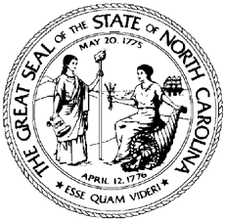

North Carolina Division of Workforce Solutions
Policy Statement Number: PS 11-2019

Date: October 21, 2019
Subject: Rescind Workforce Innovation and Opportunity Act (WIOA) Planning Enhancement Grant Application
From: Linda Cheatham, Assistant Secretary for Workforce

Purpose:
To rescind the Workforce Innovation and Opportunity Act (WIOA) Planning Enhancement Grant Application PS 22-2017, Change 1.

Action:
Funding of WIOA Planning Enhancement Grants to Workforce Development Boards for building capacity, creating systemic change within the workforce system, improving career development access, and enhancing workforce services to individuals and businesses has been temporarily suspended.
No additional Planning Enhancement Grant applications will be accepted until further notice. Workforce Development Boards may continue to expend previously awarded Planning Enhancement Grant funds.

Effective Date:
Immediately

Contact:
Agreta Limerick

