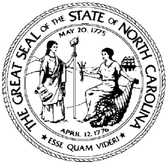

North Carolina Division of Workforce Solutions Policy Statement Number: PS 14-2015

Date: August 14, 2015
Subject: Non-Criminal Program Complaints
From: William H. Collins, Jr., Assistant Secretary for Workforce

Purpose:
To provide local Workforce Development Boards and other Workforce Innovation and Opportunity Act (WIOA) subrecipients the minimum standards and procedures for processing non-criminal program complaints and to rescind Local Area Issuance No. 2009-06.

Background:
WIOA Section 181(c) requires the State and each local Workforce Development Board (WDB) receiving funds under Title I to establish and maintain a procedure for grievances or complaints alleging violations of the requirements of this Title regarding its programs and activities from participants and other interested or affected parties. The attached procedures are designed pursuant to Section 3.10 of the State ofNorth Carolina and local WIOA Grant Administration Agreements and WIOA Section 181(c).
Local Workforce Development Boards and other WIOA subrecipients are required to establish and maintain policies and procedures that incorporate these minimum standards.

Effective Date:
Immediately

Expiration:
Indefinite
Contact:
Director of Field Operations

Attachment:
Non-Criminal Program Complaints

