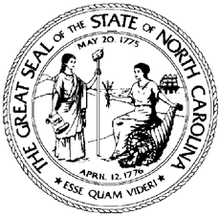

North Carolina Division of Workforce Solutions
Policy Statement: PS 17-2015

Date: September 4, 2015
Subject: To rescind Workforce Investment Act (WIA) North Carolina Local Area Issuances and Policy Statements
From: William H. Collins, Jr., Assistant Secretary for Workforce

Purpose:
To rescind inactive Workforce Investment Act (WIA) Local Area Issuances and Policy Statements.

Background:
The Workforce Innovation and Opportunity Act (WIOA) was effective July 1, 2015 unless otherwise noted in the Act. WIOA is designed to assist job seekers to access employment, education, training, and support services to succeed in the labor market and to match employers with the skilled workers they need to compete in the global economy. WIOA supersedes the Workforce Investment Act of 1998 and amends the Adult Education and Family Literacy Act, the Wagner-Peyser Act, and the Rehabilitation Act of 1973.

Action:
North Carolina has implemented the Workforce Innovation and Opportunity Act and operates WIOA workforce programs within the guidelines of the WIOA and state policies.
In order to update the status of Division of Workforce Solutions Policy Statements, the Division has prepared a list of Local Area Issuances and Policy Statements to rescind. This list does not include previously rescinded or expired Local Area Issuances and Policy Statements.
The Local Area Issuances and Policy Statements provided as an Attachment are rescinded and will be noted as such on the North Carolina Department of Commerce website.
Local Workforce Development Areas should share this information as appropriate.

Effective Date:
Immediately

Expiration:
Indefinite

Contact:
Division Planner

Attachment:
List of Rescinded WIA Issuances and Policy Statements

