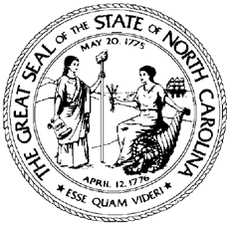

North Carolina Division of Workforce Solutions Operational Guidance N Guidance Number: OG 01-2021

Date: February 19, 2021
Subject: Utilization of Certified Historically Underutilized Businesses
From: Jessica Englert, Assistant Secretary for Workforce

Purpose:
To provide guidance on how Local Area Workforce Development Boards (WDBs) may take advantage of services provided by the North Carolina Historically Underutilized Businesses (NC HUB) Office and to help meet statewide utilization goals.

Background:
In Executive Order 143, the NC HUB Office was charged with creating a Small Business Enterprise (SBE) program to enhance opportunities for small historically underutilized businesses.

Action:
The State of North Carolina encourages Local Area WDBs to assist meeting the goal of 10% in utilization of certified historically underutilized business to include minority contractors, physically handicapped contractors, and women-owned contractors in purchasing goods and services. All Workforce Innovation and Opportunity Act (WIOA) and Division of Workforce Solutions (DWS) guidelines on purchasing and contracts apply.
Training is available on outreach to historically underutilized businesses in local areas and can be found at https://ncadmin.nc.gov/businesses/historically-underutilized-businesses-hub/outreachtraining-request-form.
If there are any questions, please contact the North Carolina Department of Administration’s Office for Historically Underutilized Businesses (HUB Office) at 984-236-0130 or huboffice.doa@doa.nc.gov.

Effective Date:
Immediately

Expiration:
Indefinite

Contact:

Director of Field Operations/Jobseeker Services

