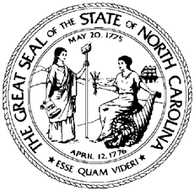

North Carolina Division of Workforce Solutions Operational Guidance N Guidance Number: OG 06-2021

Date: April 9, 2021
Subject: Workforce Innovation and Opportunity Act (WIOA) and Wagner-Peyser Employment Act Participant Eligibility Reference Guide
From: Chet Mottershead, Assistant Secretary for Workforce

Purpose:
To update the Workforce Innovation and Opportunity Act (WIOA) and Wagner-Peyser Employment Act Participant Eligibility Reference Guide and to rescind PS 04-2020, Change 2.
This change updates the verification sources for Date of Birth, Citizenship, Veteran Status, Low Income – Family Income, Disability, Foster Care Status, Displaced Homemaker, Pregnant and Parenting Youth, and Youth Who Need Additional Assistance.
This change updates the definitions for Selective Service, Category 13 and Low Income – Family Income. Information pertaining to the Deferred Action for Childhood Arrivals was added to the Notes section of the attachment.

Background:
The United States Department of Labor allows various sources to determine WIOA eligibility. The attached guide outlines eligibility items with accompanying definitions and acceptable forms of documentation.

Action:
Local Workforce Development Areas and the DWS are to use the attached guide and descriptions for reference and training purposes. This guide should be distributed to appropriate parties involved in participant eligibility.

Effective Date:
Immediately

Expiration:
Indefinite
Contact:

Division Program Monitors

Attachment:
WIOA and Wagner-Peyser Employment Act Participant Eligibility Reference Guide

