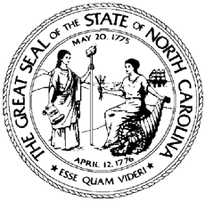

North Carolina Division of Workforce Solutions Operational Guidance N Guidance Number: OG 26-2021

Date: October 6, 2021
Subject: Employer Accounts and Job Order Procedures
From: Chet Mottershead, Assistant Secretary for Workforce

Purpose:
To provide protocols and procedures regarding the Division of Workforce Solutions’ (DWS) Employer Accounts and Job Orders and to rescind PS 02-2016.
This Operational Guidance has been converted from the previous DWS policy format and the procedures contained herein supersedes all previous policy, procedures, and guidelines. Minor edits have been made for clarification and consistency.

Background:
The scope and process for managing employer accounts and job orders using NCWorks Online has been operable for several years. Review of policy and procedures has been conducted and the DWS, with assistance from Local Area Workforce Development Board staff, has developed updated employer accounts and job order procedures.

Action:
NCWorks Career Center staff are required to operate the administration of all employer accounts and job orders as detailed in this DWS Operational Guidance.

Effective Date:
Immediately

Expiration:
Indefinite

Contact:
DWS Applicant Services State Office Staff

Attachment:
DWS Employer Accounts and Job Order Operational Guidance

