

North Carolina Division of Workforce Solutions Operational Guidance N Guidance Number: OG 03-2023

Date: May 3, 2023
Subject: Wagner-Peyser Application Signature Requirements
From: Chet Mottershead, Assistant Secretary for Workforce

Purpose:
To detail the requirement that all Wagner-Peyser applications must be signed beginning July 1, 2023.

Background:
Beginning on July 1, 2023, all completed Wagner-Peyser applications must be signed to fulfill data validation requirements. As discussed in more detail in Operational Guidance (OG) 16-2021, Change 2, under Workforce Investment Opportunity Act (WIOA) Section 116(d)(5) and the further guidance of Training and Employment Guidance Letter (TEGL) 23-19 and TEGL 07-18, states are required to develop a data validation strategy that helps ensure the accuracy of the annual statewide performance reports, safeguards data integrity, and promotes the timely resolution of data anomalies and inaccuracies. Wagner-Peyser is one of the component programs of North Carolina’s overall data validation policy.
Because Wagner-Peyser is intended to be a universal access program, the Division of Workforce Solutions (DWS) has striven to minimize the documentation necessary to meet data validation requirements. Because all services available in Wagner-Peyser in North Carolina fall under Basic Career Services, all required elements for Wagner-Peyser data validation can be met with Self-Attestation. Per TEGL 23-19, Change 1 Attachment II, the U.S. Department of Labor defines Self-Attestation as “a written, or electronic/digital declaration of information… signed and dated by the participant.” (Attachment 2)
Signed Wagner-Peyser Applications
In order to meet the self-attestation requirements for a document to be used for data validation, beginning on July 1, 2023, all Wagner-Peyser applications must be signed by the participant. This signature can be either electronic or a physical, hand-written signature. The DWS encourages the use of electronic signature capabilities as it makes for an easier process regardless of whether the participant is physically in the local office or not. Instructions for how the electronic signature capabilities of NCWorks Online can be used may be found at https://my.ncworks.gov/ElectronicSignature.\
This signature requirement applies to all completed Wagner-Peyser applications, including Reemployment Services and Eligibility Assessment (RESEA) participants. Applications must be signed prior to the provision of services to ensure compliance with the signature requirements. Wagner-Peyser applications without a signature are not usable for self-attestation purposes and will therefore result in a failure for data validation.
Disability Version of Wagner-Peyser Application
As a reminder of the requirement detailed in OG 16-2021, Change 2, if the participant is physically signing a printed-out application for scanning, be sure to print the application with the disability information to ensure that the necessary information is available for data validation purposes. Like the signature requirement, printing the disability version of the application is required as of July 1, 2023. Failing to print the disability version of the application (when the participant is physically signing the application) may result in some data validation items failing due to a lack of the necessary documentation.
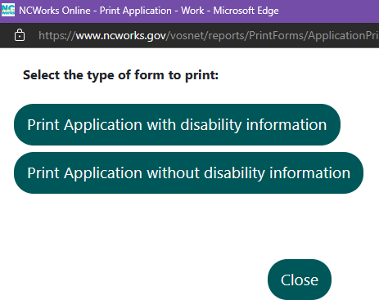

Migrant and Seasonal Farm Worker (MSFW)/Agriculture Remote Application and Remote Application Addendum
The MSFW/Agriculture program often necessitates working with participants where they are, meaning in the field. To aid staff in serving these participants, DWS has created a Remote Wagner-Peyser application and Remote Application Addendum (Attachment 1). This application can be used to collect the necessary data using pen and paper in the field when electronic entry of information is not a viable alternative.
The application must be completed in its entirety to ensure that the participant’s data can be later transferred into NCWorks Online. Data validation items are denoted with an asterisk (*) throughout the application. As a reminder to staff, paper applications are to be securely stored prior to data entry into NCWorks Online and immediately securely destroyed following data entry.
The Remote Application Addendum serves an important role in fulfilling self-attestation documentation requirements. First, it is the document containing the participant’s signature and date attesting to the validity of the information provided in the Remote Application. Second, it fulfills another requirement of self-attestation, that the document be traceable to the participant. The completed Wagner-Peyser application information can be immediately connected with the Remote Application Addendum via the Wagner-Peyser Application Details section of the form. This critical, required section of the Addendum provides all the necessary case details, allowing a direct link between the participant’s electronic application and the Remote Addendum, which acts as the participant’s self-attestation statement.
The Remote Application Addendum must be completed whenever a Remote Application is completed for a participant in the field. After the document has been completed and the participant’s data has been correctly entered into NCWorks Online, this document can be scanned into the participant’s electronic record. Similar to the application, staff are reminded that the Remote Application Addendum must be securely stored prior to being scanned into NCWorks Online and, once scanned, must be immediately securely destroyed.

Action:
Local Area Workforce Development Boards (WDBs) must ensure that all completed Wagner-Peyser applications are signed beginning July 1, 2023.

Effective Date:
July 1, 2023

Expiration:
Indefinite

Contact:
DWS Director of Performance

Attachment:
- Remote Wagner-Peyser Application and Remote Application Addendum
- Participant Individual Record Layout (PIRL) Elements

