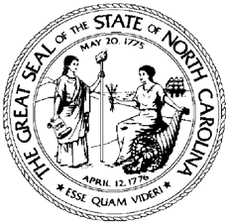

North Carolina Division of Workforce Solutions Operational Guidance N Guidance Number: OG 07-2023

Date: July 18, 2023
Subject: Rescission of Implementation of Employability Assessment Interview Policy
From: Chet Mottershead, Assistant Secretary for Workforce

Purpose:
To rescind Policy Statement 03-2016, Implementation of Employability Assessment Interview (EAI).

Action:
As a result of the EAI program ending, effective July 1, 2023, all claimants who are still receiving Unemployment Insurance (UI) benefits that were selected to participate (received an appointment letter) in Reemployment Services and Eligibility Assessment (RESEA) must participate and comply as instructed. No exemptions from RESEA are allowed. Staff should attempt to conduct a RESEA appointment, and when unable to do so follow established RESEA procedures. When a UI claimant has an issue with the process or believes their circumstances dictate otherwise, staff should continue to follow the established RESEA protocols and refer the claimant to the Division of Employment Security (DES) Customer Call Center, 888-737-0259, for possible alternative resolutions.

Effective Date:
Immediately

Contact:
Assigned Regional DWS Representatives

