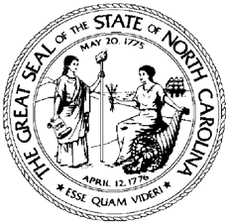

NCWorks Commission Policy Statement Number: CPS 04-2021

Date: May 13, 2021
Subject: Distribution of Workforce Innovation and Opportunity Act (WIOA) Funding
From: Tom B. Rabon, Jr., Chair, NCWorks Commission

Purpose:
To authorize the Division of Workforce Solutions (DWS) to administer, through Operational Guidance, the distribution of WIOA funding, on behalf of the NCWorks Commission.

Background:
The U.S. Department of Labor’s (USDOL) Employment and Training Administration has mandated that the NCWorks Commission have approval authority over major statewide WIOA policy. DWS has responsibility for administering federal WIOA Title I funds, Trade Adjustment Assistance (TAA), and WIOA Title III Wagner-Peyser (WP) funds. In that capacity, DWS issues Operational Guidance in reference to WIOA funds and interactions with the USDOL’s Employment and Training Administration.

Action:
The DWS shall release Operational Guidance that outlines amounts, procedures, and criteria mandated in the administration of WIOA funds, on behalf of the NCWorks Commission. In addition to Title I, Title III, and TAA funds, allocations will include all federal funding issued by DOL, and other federal and state agencies to include State Set-aside, Rapid Response, Infrastructure Costs, Finish Line Grants, and all other funding for special initiatives.
Effective Date:
May 12, 2021

Expiration:
Indefinite

Contact:
DWS Planner

