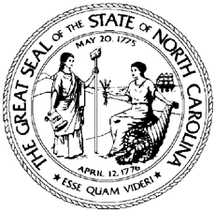

NCWorks Commission Policy Statement Number: CPS 02-2021

Date: February 11, 2021
Subject: Status and Use of Current Division of Workforce Solutions (DWS) Policy Statements
From: Tom B. Rabon, Jr., Chair, NCWorks Commission

Purpose:
To clarify the status and use of current DWS Policy Statements during the transition of policies according to NCWorks Commission Policy Statement (CPS) 01-2020.

Background:
NC Department of Commerce, Division of Workforce Solutions (DWS) has state responsibility for administering federal Workforce Innovation and Opportunity Act (WIOA) Title I funds, Trade Adjustment Assistance (TAA), and WIOA Title III Wagner-Peyser (WP) funds. In that capacity, DWS offers operational guidance in reference to those funds and interactions with the US Department of Labor’s Employment and Training Administration (USDOL ETA). This structure of communication consolidates the organization of information and replaces the former DWS Policy Statement format. The USDOL ETA has mandated this process change to grant the NCWorks Commission approval authority over major statewide WIOA policy. The role of the DWS is to provide operational and programmatic guidance to Local Workforce Boards and strategic partners based on new and existing policy.

Action:
All policy statements that were previously approved by DWS will continue to be in effect until reissued as CPS or Operational Guidance (OG). See CPS 01-2020 for additional guidance.

Effective Date:
Immediately

Expiration:
Indefinite

Contact:
Director of Policy, Planning, and Accountability

