**NC Department of Labor**

**Termination Dispute**

**Employment at Will**

The term "employment-at-will" simply means that unless there is a specific law to protect employees or there is an employment contract providing otherwise, then an employer can treat its employees as it sees fit (including the assignment of demeaning tasks) and the employer can discharge an employee at the will of the employer for any reason or no reason at all. It is also up to each employer to decide if its employees may see their own personnel file or not.

The most common protected categories are those that protect an employee's civil rights based on age, race, sex, religion, national origin, color, disability [including the Americans with Disabilities Act], or pregnancy. For questions or information on these protected categories, you need to contact the federal Equal Employment Opportunity Commission at 1-800-669-4000 (toll-free) to be connected to your local EEOC office.

Another protected category is under the Retaliatory Employment Discrimination Act, which is administered by the Department of Labor's Retaliatory Employment Discrimination Bureau. REDA protects against retaliation by an employer when an employee engages in activities protected under the Occupational Safety and Health Act, the Mine Safety and Health Act, the North Carolina Wage and Hour Act, and Workers Compensation Act, as well as for carrying the sickle cell trait, use of genetic testing information, participating in the North Carolina National Guard, and participating in the juvenile court system concerning the employee's child. The Retaliatory Employment Discrimination Bureau can be reached at the telephone numbers listed below.

**If the discrimination or unfair treatment is not based on one of the factors listed above, then you need to consult with a private attorney. If you do not have an attorney or know of one to contact, you may contact the**[**North Carolina Lawyer Referral Service**](https://www.ncbar.org/public-resources/find-an-nc-lawyer/)**at 919-677-8574 to be referred to an attorney. If you cannot afford an attorney, you may be eligible for free legal advice through a Legal Aid Services office in your area. You need to contact their**[**Central Office in Raleigh**](http://www.legalaidnc.org/)**at 919-856-2564 for information on local offices throughout the state.**

**NCDOL Toll-Free Phone Number**

**1-800-NC-LABOR (1-800-625-2267)**

**Wage and Hour Complaints**

In order for the N.C. Department of Labor’s Wage and Hour Bureau to assist an employee with a wage dispute, [a complaint must be filed](https://www.labor.nc.gov/workplace-rights/employee-rights-regarding-time-worked-and-wages-earned/how-file-wage-complaint).  If you have questions regarding working hours and pay, contact the Wage and Hour Bureau at 1-800-625-2267.

**Workplace Safety and Health Complaints**

If you feel that your working conditions are unsafe or unhealthy, or you would like to report hazardous conditions at your worksite, or to report a workplace accident, a [complaint](https://www.labor.nc.gov/do-i-have-safety-and-health-complaint) can be filed either online or by phone at 1-800-625-2267. Please note that a complaint must be filed before an onsite investigation of alleged workplace conditions can be initiated.

**Retaliatory Employment Discrimination Complaints**

REDA protects against retaliation by an employer when an employee engages in activities protected under the Occupational Safety and Health Act, the Mine Safety and Health Act, the North Carolina Wage and Hour Act, and Workers Compensation Act, as well as for carrying the sickle cell trait, use of genetic testing information, participating in the North Carolina National Guard, and participating in the juvenile court system concerning the employee's child.

For employment discrimination complaints call the Retaliatory Employment Discrimination Bureau at 1-800-625-2267.

**Youth Employment Violations**

If you would like to report a youth employment violation, please contact the Wage and Hour Bureau at 1-800-NC-LABOR (1-800-625-2267).

**Elevator and Amusement Safety Concerns**

Safety concerns regarding elevators, escalators, amusement devices, aerial tramways, or other related equipment in the state of NC can be reported by calling 1-800-625-2267 or 919-707-7927.

**US Department of Labor**

The following complaints should be filed with the [United States Department of Labor](https://www.dol.gov/agencies/whd/contact/complaints):

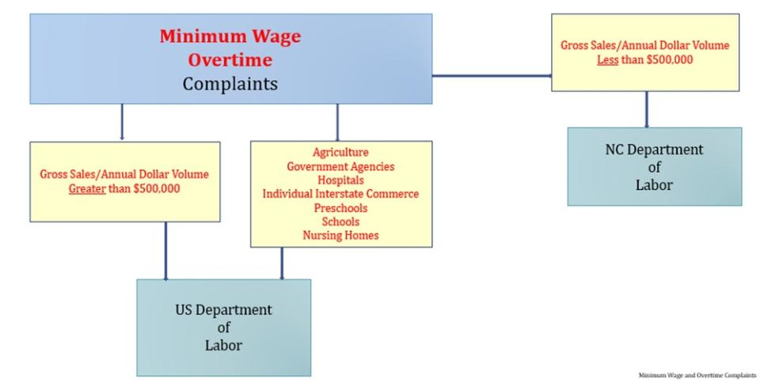

* Government or Instrumentality of Government
* Minimum wage
* Overtime
* Wages that include overtime
* Wages involving tips

 Complaints involving the following must be filed with the [US Department of Labor](https://www.dol.gov/agencies/whd/contact/complaints)

* Davis Bacon Act
* Family Medical Leave Act
* Employee Retirement Income Security Act

You may contact the US Department of Labor at **866-487-9243** or <https://www.dol.gov/agencies/whd/contact/complaints>.

**EEOC**

The most common protected categories are those that protect an employee's civil rights based on age, race, sex, religion, national origin, color, disability [including the Americans with Disabilities Act], or pregnancy.

If you feel you are being discriminated against based on age (over 40 years of age), race, sex, religion, national origin, color, disability or pregnancy, please call the Equal Employment Opportunity Commission at 1-800-669-4000 and you will be connected to the closest EEOC office.

To file a job discrimination complaint, it is helpful to have the following information:

1. The name, address, and telephone number of the person who is being treated unfairly;
2. The name, address, and telephone number of the employer you are filing the complaint against;
3. A brief description of the event or events that you believe are unfair or harassing; and
4. The dates these events occurred.

Individuals who need assistance to file a complaint (e.g., sign language interpreter, foreign language interpreter, print materials in an accessible format) should inform the EEOC field office so appropriate arrangements can be made.

**Legal Aid of North Carolina**

(866) 219-5262

legalaidnc.org

Mon – Fri, 8:30 am – 1:30 pm

Mon & Thu, 5:30 pm – 8:30 pm

Legal Aid of North Carolina is a statewide, nonprofit law firm that provides free legal help with civil (noncriminal) issues to low-income and at-risk North Carolinians.

**Disaster Relief:** Our Disaster Relief Project helps victims of natural disasters with problems related to housing, benefits, consumer issues, insurance and more.

**Housing:** We can help with evictions, fair housing, foreclosures, housing discrimination, maintenance disputes and more.

**Family Law:** We have clinics, articles, videos and other resources to help you with divorce, child custody and other family law services.

**Employment:** Topics covered here include right to work, discrimination, retaliation, unemployment benefits and more.

**Education:** We fight for students in the public education system to get access to the quality education they have a right to, and to end the school to prison pipeline.

**Government Benefits:** Find resources to answer questions and resolve issues with Social Security benefits, Medicaid, Medicare, food stamps and more.

**Domestic Violence & Sexual Assault:** We secure court protective orders for survivors and provide other services to help victims lead safe, independent lives.

**Consumer Issues:** Learn how to protect yourself from fraud and scams. Find information on bankruptcy, credit repair, debt collection and more.

**Other**: Resources on criminal record expunction, community economic development, disaster relief, and how we help veterans and immigrants.

**Free help**

Main Helpline.................................866.219.5262

Seniors (60+) .................................877.579.7562

Health insurance ..........................855.733.3711

Fair housing ...................................855.797.3247

Battered Immigrant Project......866.204.7612

Self-help clinics .................. legalaidnc.org/clinics

Self-help videos ................. legalaidnc.org/videos

Donate ................................... legalaidnc.org/donate