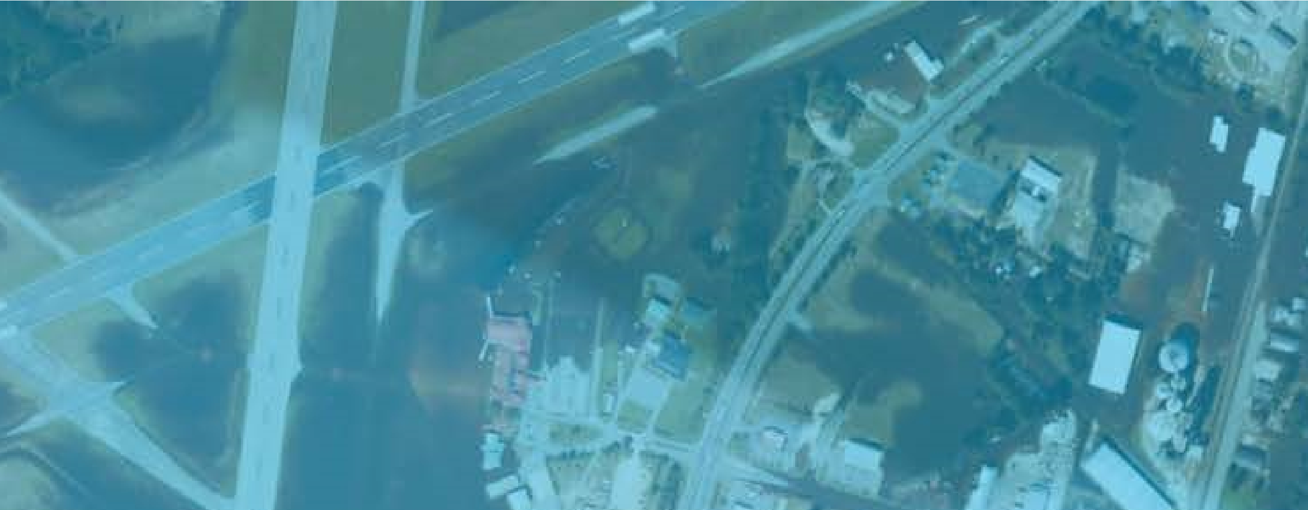
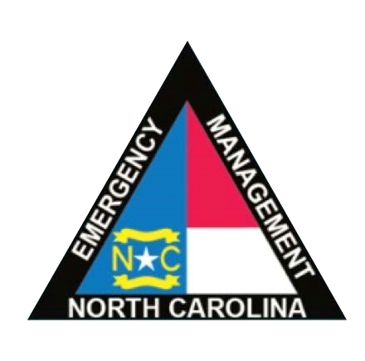
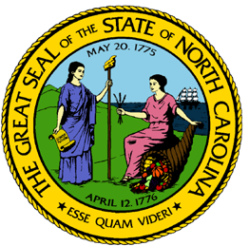

State of North
Carolina CDBG-DR
Action Plan
CDBG-DR Grants under Public Law 114-223/254

April 21, 2017
STATE OF NORTH CAROLINA DEPARTMENT OF COMMERCE

Table of Contents
Acronym List 4
Introduction 6
Hurricane Matthew’s Impact 6
Unmet Needs Assessment 10
Housing 12
Where did most of the damage occur? 13
Severely Impacted Communities 18
Repairing Owner-Occupied Homes 22
Rental Housing 23
Other Rental Housing 25
Housing Unmet Need Summary 29
Vulnerability of the Most Impacted Communities 30
Economic Recovery 40
Public Infrastructure and Facilities 42
Community and Supportive Facilities 44
Dams and Levees 44
DOT/HUD/FHWA Transportation Facilities and Infrastructure 45
USDA - Emergency Watershed and Conservation Protection 45
EPA - Drinking Water and Waste Water Repair and Mitigation 45
National Guard Facilities and Equipment 45
Planning, Coordination, and Community Outreach Needs 46
Nexus Between Unmet Need and Allocation of Resources 47
Method of Distribution 48
Recovery Programs 51
Program Name: Homeowner Recovery Program 51
Program Name: Small Rental Repair Program 56
Program Name: Multi-Family Rental Housing 57
Program Name: Supportive Housing and Services Grant 57
Program Name: Public Housing Restoration Fund 58
Program Name: Small Business Recovery Assistance 59
Program Name: Community Recovery Program 60
General Eligibility Requirements 61
Leveraging 61
Program Income 61
Schedule of Expenditures and Outcomes 62
Minimum Threshold for Substantial Amendment 64
State of North Carolina Green Building Standards for Construction and Contractor Oversight 65
Monitoring Standards and Procedures 68
Summary of Monitoring Objectives 68
Risk Analysis 69
On-Site Agency Monitoring 69
Contractor Performance Standards and Appeals Process 70
Broadband 72
Citizen Participation Plan 73
Public Notice 73
Encouragement of Citizen Participation and Outreach 74
Public Notice, Comment Period and Website 75
Individuals with Limited English Proficiency (LEP) 75
Persons with Disabilities 76
Response to Citizen Complaints and Appeals 76
Performance Review 77
Action Plan Amendments 77
Applicant Status: 78
The Final HUD-Approved Action Plan 78
Attachment 1: Uniform Relocation Act 79
Attachment 2: Consideration of Public Comments 83
Attachment 3: Certifications, Waiver, and Alternative Requirements 93

Acronym List
ACS – AMERICAN COMMUNITY SURVEY AFH – ASSESSMENT OF FAIR HOUSING
AMI – AREA MEDIAN INCOME
BFE – BASE FLOOD ELEVATION
CDBG – COMMUNITY DEVELOPMENT BLOCK GRANT
CDBG-DR – COMMUNITY
DEVELOPMENT BLOCK GRANT – DISASTER RECOVERY CFR – CODE OF FEDERAL REGULATIONS DBE – DISADVANTAGE BUSINESS
ENTERPRISE DHHS – DEPARTMENT OF HEALTH AND HUMAN SERVICES
DOB – DUPLICATION OF BENEFITS
DOC – NORTH CAROLINA
DEPARTMENT OF COMMERCE
DOT – NORTH CAROLINA DEPARTMENT OF
TRANSPORTATION DRGR – DISASTER RECOVERY GRANT REPORTING SYSTEM
ECR – ESTIMATED COST OF REPAIR
EIDL – ECONOMIC INJURY DISASTER LOANS EPA – ENVIRONMENTAL PROTECTION AGENCY FEMA – FEDERAL EMERGENCY MANAGEMENT AGENCY FHWA – FEDERAL HIGHWAY ADMINISTRATION
FR – FEDERAL REGISTER
FWS – FISH AND WILDLIFE SERVICE
HMGP – FEMA’S HAZARD
MITIGATION GRANT PROGRAM
HQS – HUD HOUSING QUALITY STANDARDS HUD – HOUSING URBAN DEVELOPMENT HVAC – HEATING, VENTILATION, AND AIR CONDITIONG
IA – INDIVIDUAL ASSISTANCE
LEP – LIMITED ENGLISH PROFICIENCY
LMI – LOW AND MODERATE INCOME
NC – NORTH CAROLINA NCEM – NORTH CAROLINA EMERGENCY MANAGEMENT
NCHFA – NORTH CAROLINA
HOUSING FINANCE AGENCY
NCRRP – NORTH CAROLINA
RESILIENT REDEVELOPMENT PLANNING NFIRA – NATIONAL FLOOD
INSURANCE REFORM ACT NMFS – NATIONAL MARINE FISHERY SERVICES
PA – PUBLIC ASSISTANCE
PER – PERFORMANCE EVALUATION REPORT PHA (s) – PUBLIC HOUSING AUTHORITIES SBA – SMALL BUSINESS ADMINISTRATION SHPO – STATE HISTORIC
PRESERVATION OFFICE

UGLG (s) – UNITS OF GENERAL LOCAL GOVERNMENT
URA – UNIFORM RELOCATION ACT
US – UNITED STATES USACE – US ARMY CORPS OF ENGINEERS USDA – UNITED STATES
DEPARMENT OF AGRICULTURE

Introduction
Hurricane Matthew began as a Category 5 storm in the Caribbean, devastating Haiti, before moving up the Atlantic seaboard. By the time it hit the coast of North Carolina on October 8, 2016, it had been downgraded from a Category 5 to a Category 1 storm. But it lingered along the coast, inducing severe rains over several days, which caused rivers and their tributaries to swell and ultimately overflow into adjacent communities. Over a three-day period, the central and eastern parts of North Carolina experienced between four and 18 inches of rainfall, setting record levels in 17 counties. The Tar, Cape Fear, Cashie, Lumber and Neuse Rivers all flooded, and would remain at flood levels for two weeks.
Because of these circumstances, when we discuss the impacts of Hurricane Matthew on North Carolina, we are largely discussing riverine communities further inland that flooded due to river overflow. In particular, the towns of Princeville, Kinston, Lumberton, Goldsboro, Fayetteville, and Fair Bluff experienced catastrophic damages. The vast majority of these communities are historic, dating to before the 20th century, and are disproportionately minority and low income.
As a result of the storm, 3,744 individuals were moved to shelters, more than 800,000 families lost power, and 635 roads were closed. This included a portion of Interstate 40 West and Interstate 5 North which were closed in some cases for up to ten days.
Additionally, 77,607 households applied for FEMA emergency assistance, and FEMA found that 34,284 of these households had evidence of flood damage to their homes. Of those homes, nearly 5,000 homes had major to severe damage.
The State estimates that more than 300,000+ businesses experienced physical and/or economic impacts from the storm. While we have yet to know the full ramifications of economic loss, preliminary indicators suggest that Hurricane Matthew’s economic impact is roughly $2 billion. Of this loss, small businesses and family farmers with the least amount of resources will be the most challenged to get back on their feet. This includes the small “mom and pop” businesses found along community main streets, North Carolina’s farmers and food producers who lost a tremendous amount of livestock and crops, and businesses located in heavily flooded towns who anticipate not having the same revenue they once did due to continuing recovery needs of the whole community.

Hurricane Matthew’s Impact
On October 8th, 2016, Hurricane Matthew hit North Carolina with hurricane and tropical storm force winds, rain, and storm surge which created life-threatening conditions and caused the declaration of a State of Emergency by Governor Pat McCrory. Hurricane Matthew moved north off the Florida east coast as a major hurricane before weakening to a Category 2 hurricane off the North Carolina coast and then eventually making landfall around Cape Romain, South Carolina as a Category 1 hurricane during the late morning of October 8. The storm produced peak wind gusts at 66 mph. The storm produced severe rainfall amounts, setting new record highs in 17 counties.
The disastrous impact from Hurricane Matthew was monumental: it caused loss of life and extensive damage to North Carolina homes, businesses, and infrastructure. Hundreds of roads were closed; thousands of citizens were displaced across 109 shelters, which were not closed until a month after the disaster; automobiles were submerged in water; access to and from communities was brought to a standstill; and the agriculture of NC was impacted. Thousands of National Guard troops and State Troopers were deployed in the recovery efforts which consisted of rescuing people from their homes who were stranded via water and air rescues.
The Disaster Relief Appropriations Act of 2016 (Pub. L. 114-113, approved December 18, 2015) (Appropriations Act) was enacted to appropriate federal funds for disaster relief. Fifty counties in North Carolina are eligible for FEMA’s Public Assistance program as of December 23rd, 2016, forty-five of these counties are also eligible for Individual Assistance. To date, $95.3 million in federal/state financial assistance was approved to help flood survivors recover through FEMA’s programs. The Department of Housing and Urban Development (HUD) appropriated $198,553,000 in Community Development Block Grant Disaster Recovery (CDBG-DR) funding to the State of North Carolina, using the best available data to identify and calculate unmet needs for disaster relief, long-term recovery, restoration of infrastructure, and housing and economic revitalization. In addition, 80% of the total funds, or $158,842,400, will go to the most impacted areas: Robeson, Cumberland, Edgecombe, and Wayne counties. Within these counties, the following cities were most impacted: Fair Bluff; Fayetteville; Cumberland; Princeville; Edgecombe; Lumberton; Robeson; Goldsboro; and Wayne. These funds are to be used in order to satisfy a portion of unmet need that still remains after other federal assistance, such as the Federal Emergency Management Agency (FEMA), Small Business Administration (SBA), or private insurance, has been allocated.
Figure 1: Counties Eligible for Disaster Relief from Hurricane Matthew
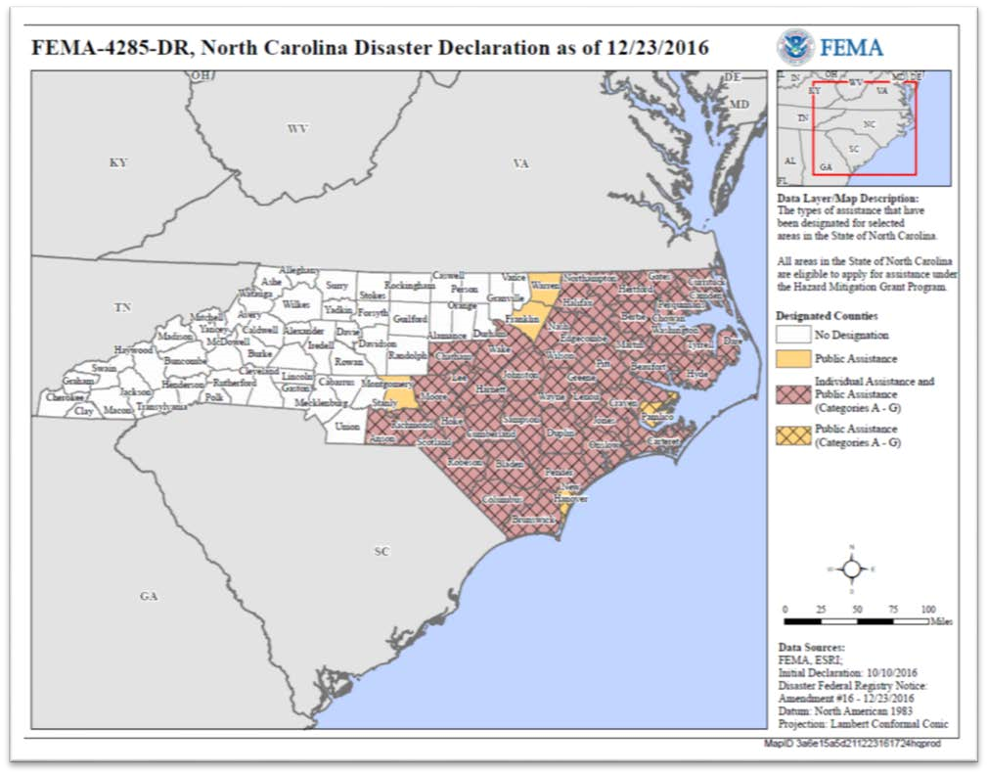

In the initial evaluation of Unmet Needs in North Carolina, it was found that 34,284 homes were damaged in Hurricane Matthew, 4,957 homes were majorly or severely damaged, and 3,635 homes of low and moderate income neighborhoods were majorly or severely damaged.
Governor Pat McCrory established the Hurricane Matthew Recovery Committee to coordinate efforts to rebuild after the storm. The Hurricane Matthew Recovery Committee will help meet five objectives:
To raise money for those in need through the North Carolina Disaster Relief Fund for Hurricane Matthew, particularly in regards to providing permanent housing;

To reopen and rebuild critical infrastructure as fast and as safe as possible;
To implement a comprehensive strategy for how to rebuild towns and communities in a sustainable way;
To assess the storm's financial impact on agriculture, small businesses, commercial fishermen and other industries, and develop an economic recovery plan of action; and
To implement a plan for any needed legislative action for any additional relief funding.
The Unmet Needs Assessment, which evaluates the three core aspects of recovery – housing, infrastructure, and economic development--forms the basis for the decisions outlined in the Method of Distribution. This Action Plan was developed with the help of many state and local stakeholders as well as the public to target the unmet need that can be addressed by these limited federal funds.

Table 1: Counties Eligible for Assistance
✓ Anson County | ✓ Dare County | ✓ Lee County | ✓ Perquimans County
✓ Beaufort County | ✓ Duplin County | ✓ Lenoir County | ✓ Pitt County
✓ Bertie County | - Edgecombe County  - Franklin County | ✓ Martin County | - Richmond County  - Robeson County
✓ Bladen County | ✓ Gates County | ✓ Montgomery County | ✓ Sampson County
✓ Brunswick County | ✓ Greene County | ✓ Moore County | ✓ Scotland County
✓ Camden County | ✓ Halifax County | ✓ Nash County | ✓ Tyrrell County
✓ Carteret County | ✓ Harnett County | ✓ New Hanover County | - Wayne County  - Wake County
✓ Chatham County | ✓ Hertford County | ✓ Northampton County | ✓ Warren County
✓ Chowan County | ✓ Hoke County | ✓ Onslow County | ✓ Washington County
✓ Columbus County | ✓ Hyde County | ✓ Pamlico County | ✓ Wilson County
- Craven County  - Cumberland County  - Currituck County | - Johnston County  - Jones County | - Pasquotank County  - Pender County

Unmet Needs Assessment
The Unmet Needs Assessment within this Action Plan represents the first comprehensive analysis of unmet needs in the State of North Carolina following Hurricane Matthew. It presents damage estimates and recovery needs as of March 15, 2017, roughly six months after the flooding occurred. Since October 2016, the State has been working with county governments and other federal agencies to assess the full scope of unmet needs. The process is just beginning for many of the local planning efforts, and since this is the first recovery plan poststorm, North Carolina has not had the opportunity to assess needs through the performance of its recovery programs. Therefore, the information presented here will likely be augmented as new information comes to light.
The analysis is organized around the programmatic categories of the CDBG-DR program, namely Housing; Economic Revitalization; Infrastructure; and Resilience. The analysis also includes a summary of long-term planning needs North Carolina has identified to support longterm success.
As part of this first Action Plan, the State of North Carolina has made it a priority to focus on assisting low and moderate income families who experienced severe flooding to rebuild their lives. Therefore, the funding priorities emphasize housing and supportive service needs. Additionally, the State understands that community health is not just about rebuilding homes, but restoring the basic fabric of neighborhoods and ensuring future economic health. Therefore, North Carolina also prioritizes assisting small businesses and farmers struggling to get back on their feet, and rebuilding community and supportive service facilities that communities rely on as part of their basic needs.
Based on this analysis, effective March 15, 2017, North Carolina’s unmet recovery needs total $1,865,129,898.

Table 2: Summary of Unmet Needs
 | Unmet Need
Housing | $849,078,846
Economic Development | $278,907,901
Infrastructure | $655,078,162
Resiliency | $16,168,000
Planning and Capacity | $65,896,989
Total | $1,865,129,898
Source(s): FEMA Individual Assistance data dated 1/16/17; Small Business home loan data effective 2/28/17; survey responses from State and local housing providers, federal and State agencies, and local units of government, effective 3/10/17; analysis effective 3/15/17.

Housing

Hurricane Matthew inflicted devastating damage to families throughout North Carolina’s eastern and central parts. The swelling of the Tar, Neuse, and Lumber Rivers caused rainwater to overflow into neighboring towns, inundating business districts and homes with floodwaters. In total, almost 35,000 homes were damaged in the storm, and the homes of roughly 5,000 families were damaged so extensively as to make them unlivable.
North Carolina’s number one priority is to allow families to return to their homes, and to ensure those homes are in safe and sanitary conditions. For this reason, the Unmet Needs Assessment focuses on housing recovery programs and supportive services to families and persons in need. This includes an understanding of where homes experienced the greatest damage, and the capacity of those families to recover from the disaster.
The analysis and resulting recovery programs also account for long-term sustainability, with a priority placed on the homeowner and renter finding safe and suitable housing rather than simply rebuilding a damaged unit. Therefore, North Carolina will conduct a cost-benefit analysis on rebuilding a severely damaged home versus constructing a new home in an area safe from repetitive flood loss, which will take into account the cost of repairing versus replacement, and estimated long-term losses due to repeat flood events.
We began the process of assessing unmet housing need by analyzing who applied for FEMA assistance, which is the first step most flood victims take immediately after a disaster. This information is combined with the State’s own damage assessments and the Small Business Administration’s loan application information. From this data, we generated a detailed understanding of housing damages and recovery needs. Specifically, we are able to estimate the following:
- What counties, towns, and neighborhoods experienced the greatest damage;
- The types of units that were damaged (rental versus homeowner, and the structure);
- The incomes of the homeowner or renter impacted, and combined with household size, the income classification of these impacted families;
- How many homeowners and renters were impacted, categorized by severity of damage;
- An estimate of housing recovery needs (in dollars); and
- In combination with other data, what impacted neighborhoods have a high concentration of vulnerable populations and/or additional needs.
Following is a summary of this analysis, which North Carolina will continue to build upon as the State captures more information from our community engagement meetings and outreach efforts at the county and local level.

Where did most of the damage occur?
Hurricane Matthew impacted 50 counties in North Carolina, largely along the eastern and central regions and along major rivers and tributaries. As previously noted, almost 35,000 families experienced some degree of damage to their homes, but the majority of damage was minor. For the purpose of the unmet needs assessment, we assume that the majority of homes which experienced minor damage have likely been repaired six months after the storm event.
Unfortunately, families whose homes received major to severe damage have a far greater challenge in recovering, particularly when their homes are rendered uninhabitable due to mold, insulation issues, unstable foundations, leaky roofs, and lack of heat or plumbing due to flood damage of pipes and HVAC systems. These families either remain in their damaged homes, living in unsafe conditions, because they are unable to find alternative housing they can afford, or they are displaced from their homes. The families with limited resources – low and moderate income families who have limited savings or disposable income – are the families with the greatest needs. These homes are the focus of this unmet needs assessment.
To determine which counties, towns and neighborhoods experienced major damage, the State mapped the FEMA applications by the address of the damaged unit, and then associated that “point” with the neighborhood, town and county the home falls within.
What we found, based on this analysis, is that major housing damage happened in very specific areas, as follows:
64% of major to severe damage is concentrated in the “most impacted” four counties
52% of major to severe damage is concentrated in 13 towns
41% of major to severe damage is concentrated in 14 neighborhoods

So while damage was widespread due to power outages, minor flooding and wind damage, the serious impacts of Hurricane Matthew were felt in a specific handful of places. These counties, towns and neighborhoods are defined in Tables 3 through 5.

Table 3: Most Impacted Counties
(where at least 500 homes experienced major to severe damage)
County | Owners | Renters | Total
CUMBERLAND | 364 | 401 | 765
EDGECOMBE | 247 | 284 | 531
ROBESON | 645 | 689 | 1,334
WAYNE | 278 | 263 | 541
Total | 1,863 | 1,982 | 3,845
As % of all Major to Severe Damage in NC | 60% | 69% | 64%

Table 4: Towns that Experienced Major to Severe Damages from Hurricane Matthew (where at least 100 homes experienced major to severe damage)
County | Community | Damage Level | Owners | Renters | Total
COLUMBUS | Fair Bluff | Severe | 50 | 59 | 109
CUMBERLAND | Fayetteville | Severe | 169 | 283 | 452
EDGECOMBE | Princeville | Severe | 156 | 211 | 367
LENOIR | Kinston | Severe | 49 | 132 | 181
ROBESON | Lumberton | Severe | 350 | 526 | 876
WAYNE | Goldsboro | Severe | 87 | 164 | 251
Total |  |  | 984 | 1,570 | 2,554
As % of All Major to Severe Damage in NC |  |  | 38% | 66% | 52%

Table 5: Neighborhoods that Experienced Major to Severe Damages from Hurricane Matthew (where at least 50 homes experienced major to severe damage)
Town | County | Neighborhood | Owner | Renter | Total
LUMBERTON | ROBESON | 37155960801 | 150 | 320 | 470
PRINCEVILLE | EDGECOMBE | 37065020900 | 156 | 211 | 367
LUMBERTON | ROBESON | 37155960802 | 125 | 144 | 269
FAYETTEVILLE | CUMBERLAND | 37051003203 | 26 | 107 | 133
Town | County | Neighborhood | Owner | Renter | Total
FAIR BLUFF | COLUMBUS | 37047930600 | 50 | 59 | 109
FAYETTEVILLE | CUMBERLAND | 37051000200 | 53 | 40 | 93
Rural | WAYNE | 37191000901 | 44 | 48 | 92
GOLDSBORO | WAYNE | 37191001500 | 24 | 61 | 85
Rural | ROBESON | 37155961802 | 16 | 61 | 77
Rural | DARE | 37055970502 | 47 | 28 | 75
Rural | CUMBERLAND | 37051003001 | 52 | 16 | 68
Rural | PENDER | 37141920502 | 41 | 24 | 65
KINSTON | LENOIR | 37107010800 | 2 | 62 | 64
Rural | ROBESON | 37155961500 | 47 | 14 | 61

Figure 2: Most Impacted Counties
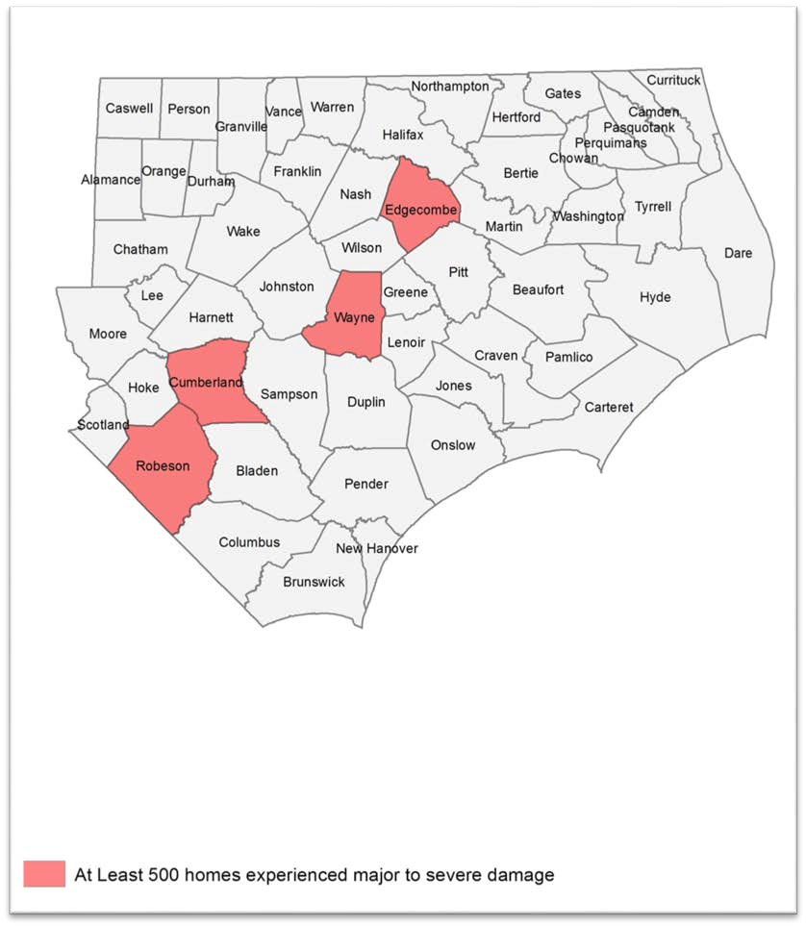

Figure 3: Most Impacted Communities
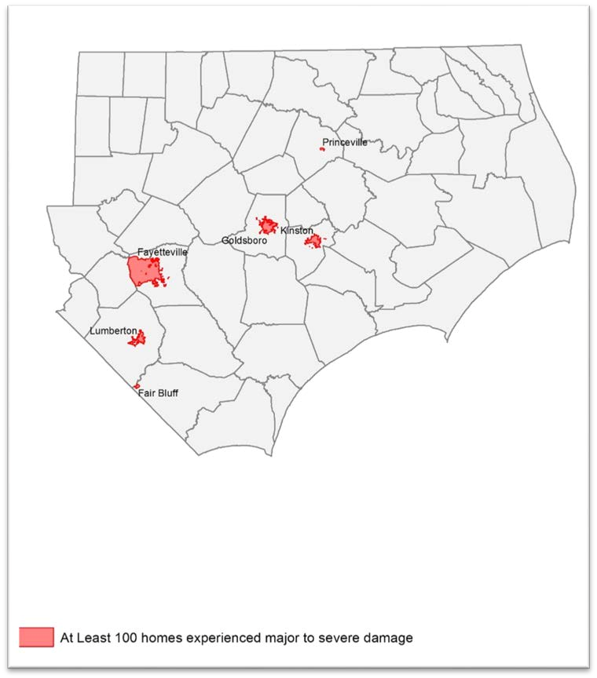

Figure 4: Most Impacted Neighborhoods
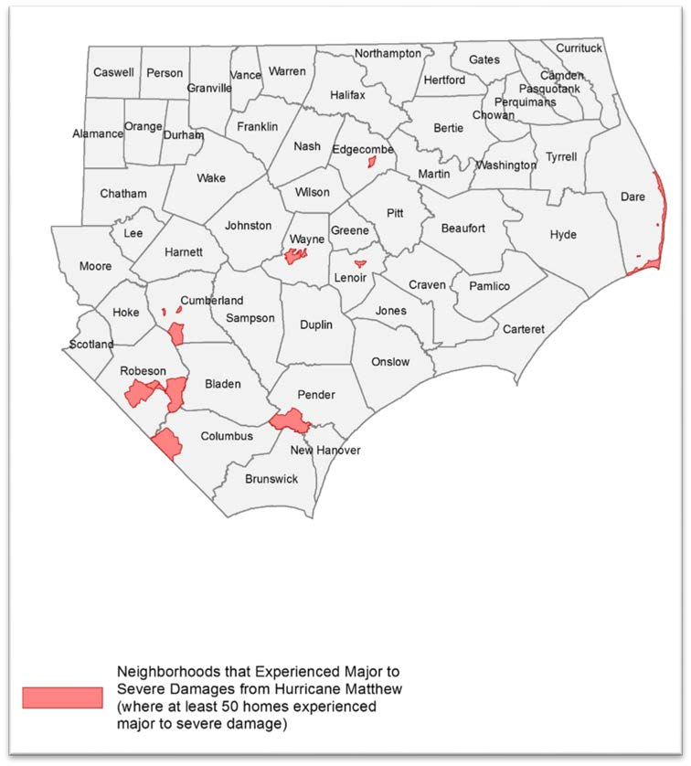

Severely Impacted Communities
Hurricane Matthew concentrated its damage within specific areas, in particular riverine communities already grappling with a heavy rain season. In particular, there are six towns we consider “severely impacted,” where more than 100 homes experienced major to severe damage. These communities are predominantly low and moderate income and have a higher concentration of African American, Native American, and Hispanic residents.
Princeville – 367 homes had major to severe damage: The town of Princeville, with a population of 2,373, is located in Edgecombe County along the Tar River just south of Tarboro. It is by large an African American community (96% of its residents are African American) and is reportedly the oldest community settled by freed slaves in the U.S. It is also located in a floodplain that has experienced frequent and substantial flooding over the years. The community is a low-income community, with the median household income of $33,011. In addition to flooded homes, the school and fire station were reported as flooded and are currently operating out of tents.
Kinston – 181 homes had major to severe damage: The town of Kinston, with a population of 21,589, is located in Lenoir County along the Neuse River. The community is predominantly African American (67%) and most of its residents are low income, with the median household income of $28,608. The town experienced substantial damage to its main business district, flooding many small businesses serving the community.
Lumberton – 876 homes had major to severe damage: The city of Lumberton, with a population of 21,707, is located in Robeson County along the Lumber River. A racially and culturally diverse county, where 33.8% of the population is African American; 12.4% is Native American (the Lumbee Tribe); and 11% Hispanic/Latino. Most of its families are low and moderate income, with a median household income of $31,899. The community experienced substantial flooding after Hurricane Matthew, particularly along Fifth Street, its main commercial corridor, and among its public housing residents, where almost 500 very low income renters lost their homes.
Goldsboro – 251 homes had major to severe damage: The town of Goldsboro, with a population of 35,086, is located in Wayne County along the Neuse River. It is a diverse, low to moderate income community, where roughly 53% of the population is African American, and the median income is $29,456. It is also an agricultural community, where substantial livestock was lost.
Fayetteville – 452 homes had major to severe damage: Fayetteville, located on the Cape Fear River in Cumberland County, is a densely populated city of 200,000. It is a middle income community, with a median household income of $44,514, and is racially diverse, where 41% of the population is African American and 10% are Hispanic. The flooding in Fayetteville was concentrated in the downtown area and in subdivisions near the Little River tributary, where flooding was so severe many residents had to be rescued to evacuate.
Fair Bluff – 109 homes had major to severe damage: Fair Bluff is a small town located along the Lumber River in Columbus County. Given its small population of 1,181 households, it was devastated by Hurricane Matthew, where approximately 25% of all families were severely impacted. The community is racially diverse, with 38% of the population white and 60% African American, and the majority of families are very low income, where the median household income is $17,008. Fair Bluff’s main commercial district was particularly impacted by the floodwaters.

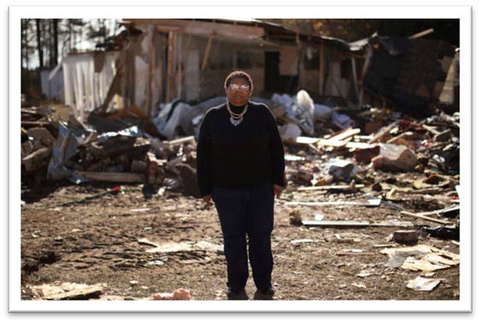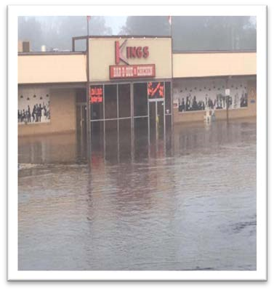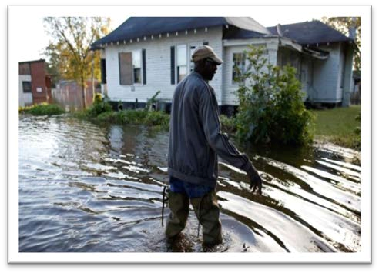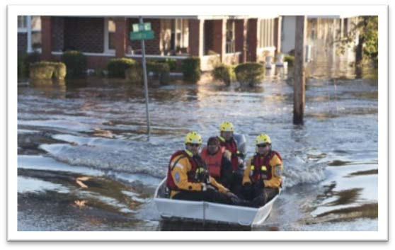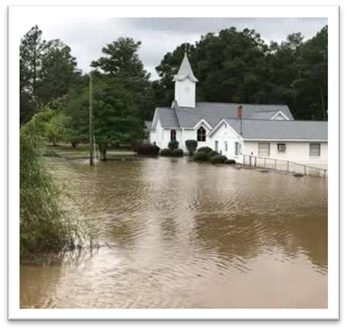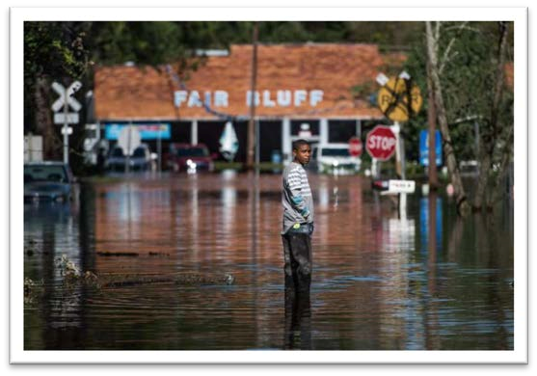

Image 6: Princeville

Image 6: Kingston

Image 6: Goldsboro

Image
6
:
Lumberton

Image 6: Fayetteville

Image 6: Fair Bluff

Repairing Owner-Occupied Homes
The unmet needs analysis examines the impact and unmet needs of homeowners using HUD’s own standard approach to analyzing housing damages, with slight modifications based on available data.
The analysis uses the FEMA Individual Assistance (IA) data; Small Business Administration (SBA) loan data to homeowners; and structural inspections performed by the State as of February 24, 2017. We determine the level of damage each property incurred using FEMA’s initial estimate of Real Property Loss and HUD’s guidance in FR-60120N-01. The damage categories range from 1 to 5; 1 being Minor-Low Damage and 5 being Severe Damage.
In total, 28,164 homeowners experienced some degree of damage to their homes; 2,569 homeowner families experienced major to severe damage. The majority of this loss impacted low and moderate income homeowners.
Table 6: Damage Counts of Owner-Occupied Homes by Damage Category and Income of Homeowner Family
Damage Category | All  Owners | Low and Moderate Income (LMI)  Owners | LMI as % of All Damage
Minor-Low | 22,795 | 16,348 | 72%
Minor-High | 2,800 | 1,884 | 67%
Major-Low | 1,581 | 998 | 63%
Major-High | 830 | 486 | 59%
Severe | 158 | 95 | 60%
Total - All Damage | 28,164 | 19,811 | 70%
Total - Major to Severe  Damage | 2,569 | 1,579 | 61%
Source(s): FEMA Individual Assistance data dated 1/16/17; analysis effective 3/15/17
Because FEMA’s initial inspections have historically underestimated damage costs significantly, FEMA’s damage estimates are adjusted upwards based on the average SBA loan amount by damage category. For homes that received an SBA inspection, the damage costs are equivalent to that SBA inspection amount. For homes that did not receive an SBA inspection, damage costs are presumed to be the average SBA inspection amount for that damage category.
To estimate unmet needs, the analysis subtracts the funds received from FEMA, SBA and insurance from the damage costs. For homeowners that have flood insurance, the analysis assumes insurance covers 80% of the damage costs not covered by FEMA and SBA. The analysis also includes mitigation costs for homes that received major to severe damage, equivalent to 30% of damage costs. This reflects additional measures needed to ensure longterm sustainability of flooded homes.
The analysis also examined what types of owner-occupied homes experienced major to severe damage. Approximately two thirds were single family structures, while the remaining one third were mobile homes.
Table 7: Owner-Occupied Housing Units that Experienced Major to Severe Damage by Structure Type
 | Count | Percent
Apartment | 1 | 0%
Boat | 1 | 0%
Condo | 4 | 0%
House/Duplex | 1,709 | 67%
Mobile Home | 831 | 32%
Other | 2 | 0%
Townhouse | 4 | 0%
Travel Trailer | 6 | 0%
(blank) | 11 | 0%
Total | 2,569 | 100%
Source(s): FEMA Individual Assistance data dated 1/16/17; analysis effective 3/15/17

Rental Housing
Almost half of all the housing that withstood major to severe damage from Hurricane Matthew was rental housing. The storm caused severe damage or destroyed at least 2,388 occupied rental homes, with 83% of this damage occurring in the six most impacted counties. In particular, Lumberton experienced the greatest loss of rental housing, with 526 units impacted. This is followed by Fayetteville (283 units) and Princeville (211 units).
Far more than owner-occupied homes, the vast majority (86%) of renters severely impacted by the storm were Low and Moderate Income, while 68% earned less than $20,000 per year.

Table 8: Damage Counts of Renter-Occupied Homes by Damage Category and Income of Renter Family
 | All  Renters | Low and  Moderate  Income  Renters | LMI Renters % | Renters earning  less than  $20,000 per year | Renters < $20K per year as %
Minor-Low | 2,632 | 2,383 | 91% | 1,856 | 71%
Minor-High | 1,097 | 980 | 89% | 755 | 69%
Major-Low | 963 | 831 | 86% | 642 | 67%
Major-High | 1,244 | 1,077 | 87% | 835 | 67%
Severe | 181 | 148 | 82% | 97 | 54%
Total - All Damage | 6,117 | 5,419 | 89% | 4,185 | 68%
Total - Major to  Severe Damage | 2,388 | 2,056 | 86% | 1,574 | 66%
Source(s): FEMA Individual Assistance data dated 1/16/17; analysis effective 3/15/17
Of the rental units seriously damaged by Hurricane Matthew, we see approximately half were apartment buildings, while 40% were single family homes or duplexes. A significant number of rented mobile homes were also flooded (13% of all major to severe damage)
Table 9: Rental Housing Units that Experienced Major to Severe Damage by Structure Type
 | Count | Percent
Apartment | 1,084 | 45%
Assisted Living Facility | 4 | 0%
Condo | 13 | 1%
House/Duplex | 955 | 40%
Mobile Home | 308 | 13%
Other | 5 | 0%
Townhouse | 8 | 0%
Travel Trailer | 1 | 0%
Unknown | 10 | 0%
Total | 2,388 | 100%
Source(s): FEMA Individual Assistance data dated 1/16/17; analysis effective 3/15/17

Other Rental Housing
The State of North Carolina conducted outreach to housing providers in impacted areas to determine the damages, displacement, and unmet needs of subsidized and supportive rental housing. This included emails, a survey, and follow-up phone calls that took place between March 2 and March 20, 2017. NCEM contacted multiple Public Housing Authorities; the State Housing Finance Agency; State CDBG Communities; and North Carolina’s Health and Human Services to quantify the disaster’s results, understand how it has impacted the families served by the agencies, and determine what needs are still unmet. The following is a summary of these communications. However, not all agencies have had the opportunity to assess full unmet needs; therefore, this information will be edited as more details become available.
Public Housing
The State contacted Public Housing Authorities in the most impacted areas, including Greenville Housing Authority, Pembroke Housing Authority, Lumberton Housing Authority, The Housing Authority of the City of Rocky Mount, and Wilmington Housing Authority. The survey asked which properties/units (if any) were damaged and where they are located, how many people were displaced and if they have returned, what the overall damage cost is, have the units been repaired, and if any costs or repairs are remaining. Information was received by four of the five housing authorities, which resulted with Wilmington having no damage, Greenville and Rocky Mount having minor damage, and Lumberton experiencing severe damage. Pembroke is calculating the overall costs and will provide the information when available.
Table 10: Survey Results from Public Housing Authorities as of March 15, 2017
City/County | What are the overall damage costs? | What amount of those costs was/is/will be  covered by insurance and/or other sources? | Remaining Costs | Are there repairs that  still need to be made?
Lumberton | $8,000,000.00  +/- | $3,000,000.00 +/- | Yes | Yes, $5,200,000.00
Greenville | ~$8,000- $10,000 | None | No | No
Rocky Mount, Edgecombe,  Nash Counties | $6,000 | $2,020 | $3,980 | Interior water damage not covered by insurance -  repairs are being  completed by force labor.
Wilmington | 0
City/County | What are the overall damage costs? | What amount of those costs was/is/will be  covered by insurance and/or other sources? | Remaining Costs | Are there repairs that  still need to be made?
Pembroke | Unknown
Source: Survey results from Public Housing outreach, effective 3/10/17.
The Lumberton Housing Authority had, by far, the most extensive damage totaling an estimated $8 million, with approximately $5 million in remaining unmet need. There are currently 264 families displaced, currently living with family members or using housing vouchers, and have yet to move back into their homes as all units are still in the process of being repaired.
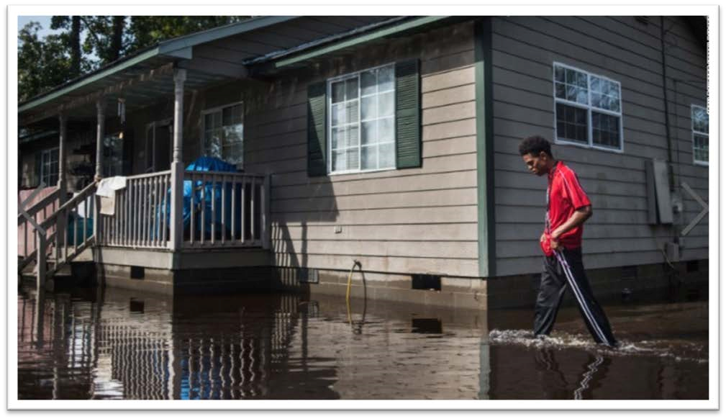

(http://www.cnn.com/2016/11/18/us/north-carolina-lumberton-hurricane-matthew-stormrecovery-holidays/ )
In addition to Lumberton, Greenville and Rocky Mount had damages with a combined total of $16,000, and Rocky Mount still has $3,980 costs remaining. In Greenville, 105 Public Housing families were displaced; however, all of the units have since been repaired and all families have moved back. Wilmington did not have any damage from Hurricane Matthew and data is still being gathered regarding Pembroke Housing Authority.
The housing programs within this Action Plan will address remaining unmet needs, after taking into account funds available from insurance and other sources, to restore public housing and return families to their homes.
Other Subsidized Housing
Similar to the Public Housing Authorities, the State sent a survey to the NC Housing Finance Agency (NCHFA), USDA, and other housing providers in impacted communities, to assess damages and unmet needs due to Hurricane Matthew. According to the NCHFA, 397 were damaged and still remain in an unrepaired state. The agency believes they have sufficient funds to make the needed repairs using insurance proceeds. However, if there are instances where subsidized affordable rental housing has remaining unmet needs, their recovery will be given priority in the rental housing programs outlined in this Action Plan.
Table 11: NC Housing Finance Agency Properties Damaged by Hurricane Matthew
Name | City | County | Units
Prince Court Apartments | Princeville | Edgecombe | 30
Asbury Park Apartments | Princeville | Edgecombe | 48
Holly Ridge Apartments | Lumberton | Robeson | 110
Mount Sinai Homes | Fayetteville | Cumberland | 99
ARC/HDS Northampton Co GH | Woodland | Northampton | 6
First Baptist Homes | Lumberton | Robeson | 40
Cypress Village | Fair Bluff | Columbus | 40
Glen Bridge | Princeville | Edgecombe | 24
Source: North Carolina Housing Finance Agency, effective 3/10/17
The State also sent surveys to CDBG Entitlement Communities in the impacted areas, and received responses back from Fayetteville and Rocky Mount. In Fayetteville, a reported 952 rental properties were severely damaged, and 671 remain unrepaired. The City cited a need for substantial mitigation and resiliency measures, as many damaged properties were severely damaged exceeding 50% value. The city is currently determining the costs of repair and unmet needs, after factoring in other federal assistance and insurance proceeds. Rocky Mount reported 340 rental homes damaged, and are currently determining repair costs and unmet needs.
Permanent Supportive Housing
The State contacted North Carolina’s Department of Health and Human Services to understand the impact Hurricane Matthew had on homeless shelters, transition housing facilities, or any housing facilities that serve those with disabilities or supportive housing damages. They were asked what the total damaged properties were and how many people were displaced and if they are still displaced.
The Department of Health and Human Services (DHHS) manages the delivery of health- and human-related services for all North Carolinians, especially our most vulnerable citizens – children, elderly, disabled and low-income families. DHHS has not yet reported damage to any permanent supportive housing or service facilities, while the State is currently assessing unmet needs.
In addition to restoring existing permanent supportive housing and services, the disaster event likely calls for new services to families and residents who have not historically been served by DHHS. For many very low income owners and renters, older adults, and persons with disabilities, the impact of severe flooding can lead to a variety of needs. For many families, the loss of their homes, losing wages for a period of time due to job interruption, having limited access to transportation, and the stress associated with living in overcrowded or unsafe conditions due to “doubling up” or remaining in their damaged homes out of necessity, warrants additional services in the form of emergency housing assistance, mental health support services, homeless prevention services, health and transportation assistance. The State will address these needs, working closely with local communities, with emphasis on assisting families currently displaced or at risk of displacement.

Housing Unmet Need Summary
The State of North Carolina has taken multiple steps in estimating the unmet housing needs as a result of Hurricane Matthew. This includes conducting field inspections of damaged homes; analyzing FEMA IA data, SBA loan information, and insurance information; initiating county-led planning efforts; and surveying public housing authorities and other housing providers, to determine what our remaining financial needs are to restore our homes and neighborhoods.
This estimate accounts for the costs to repair damaged homes, and providing required mitigation for these homes to avoid future losses ($360,707,485).
There are additional needs beyond repairing damaged homes. The State has been proactive in initiating outreach with the most impacted communities to determine the cost benefit of repairing homes that experience repetitive flood loss and/or are located in flood-prone areas versus the cost of acquiring these properties and relocating these families to safer ground. This is an ongoing effort, and as of March 15, 2017, the State estimates an additional need of $457,000,000 to elevate homes, or acquire and demolish homes, and then relocate families to new housing. Additionally, the State will require all new construction and repair of substantially damaged homes meet Advisory Base Flood Elevations, where the lowest floor is at least 2 feet above the 100-Year Floodplain elevation.
The estimate also accounts for the repair of the public housing units severely damage in Lumberton ($5,200,000); an estimated need for support services, including assistance to the homeless, families living in poverty, persons needing medical or mobility assistance due to disabilities, permanent supportive housing needs, persons who are currently displaced and need additional housing assistance, and services to older residents especially challenged by displacement ($17,371,361).
Finally, the unmet needs factors in a preliminary estimate of subsidies needed for low and moderate income homeowners who will expect to see their insurance premiums increase, and who will not be able to afford flood insurance once their homes are rebuilt ($8,800,000).
These estimates are based existing data; as the State and local planning efforts continue to work with the most impacted communities, these figures may be adjusted based on better data and feedback.

Table 12: Housing Unmet Needs
Owner - Repair Damages | $260,565,781
Renter - Repair Damages | $100,141,704
Elevation/Buyout | $457,000,000
Public Housing | $5,200,000
Supportive Services | $17,371,361
Insurance Subsidies for LMI Owners | $8,800,000
TOTAL | $849,078,846
Source(s): FEMA Individual Assistance data dated 1/16/17; Small Business home loan data effective 2/28/17; survey responses from State and local housing providers and agencies effective 3/10/17; analysis effective 3/15/17.

Vulnerability of the Most Impacted Communities

As previously stated, North Carolina’s approach to recovering its homes and neighborhoods after Hurricane Matthew is to strategically examine where the damage occurred, and then focus its recovery efforts in those areas, paying special attention to the housing types, household types, and special needs of these unique communities.
In particular, families and individuals with social vulnerabilities oftentimes face greater challenges in evacuating during a disaster event, including finding suitable and affordable housing if displaced, and being able to afford making the repairs needed so that they can return to their homes. To address this issue, North Carolina analyzed individual assistance applications to determine which neighborhoods withstood the brunt of Hurricane Matthew’s impact, and then examined the socio-economic and demographic profiles of these neighborhoods.
For the purpose of this study, we consider a neighborhood to be “most impacted,” if at least 25 homes experienced major to severe damage (i.e. homes with a category 3, 4 and 5 damage level, or Major-Low, Major-High and Severe damage), or where at least 5% of all homes had major to severe damage. The analysis defines vulnerable populations as older residents (65 years old or older), persons with disabilities, neighborhoods where at least 51% of households earn less than 80% AMI (Low and Moderate Income neighborhoods), households with English language barriers, and households who do not own personal vehicles. This data is publicly available using the 2010 - 2014 American Community Survey (ACS), and is collected at the Census Tract-level (aligned with our definition of a neighborhood). To determine if a Census Tract has a disproportionate number of residents or families with social vulnerability, we compare the figures to state averages, or use HUD-standard benchmarks (i.e. majority of households are low income, for example).
Based on this analysis, there are five neighborhoods located in Lumberton, Princeville, Fayetteville, and Fair Bluff that were severely impacted (where at least 100 homes experienced major to severe damage.) Of these five neighborhoods, an impacted family is more likely to be low income, minority, and without a family car than what is typical in the state. Among the other impacted neighborhoods, there are pockets of damage where residents have English language barriers, disability, and are also low income and minority neighborhoods. There are no substantially impacted neighborhoods with a disproportionate number of older residents. Even so, North Carolina understands that many older households have substantial rebuilding challenges, and their needs will be addressed through local outreach efforts and prioritization among programs.
Additionally, North Carolina is committed to rebuilding damaged communities in a manner that furthers fair housing opportunities to all residents. For this reason, the analysis identifies which impacted neighborhoods have a disproportionate concentration of minority populations. As these communities rebuild, the State will focus its planning and outreach efforts to ensure that rebuilding is equitable across all neighborhoods, which may include providing affordable housing in low-poverty, non-minority areas where appropriate and in response to natural hazard-related impacts.
Table 13: Most Impacted Neighborhoods and Social Vulnerability [Y = Disproportionate Social

Vulnerability]
Town | County | Neighborhood | Owner | Renter | Total | Disability | Language Barriers | No  Access to  Vehicle | Minority | LMI
Lumberton | ROBESON | 37155960801 | 150 | 320 | 470 | N | N | Y | Y | Y
Princeville | EDGECOMBE | 37065020900 | 156 | 211 | 367 | N | N | Y | Y | Y
Lumberton | ROBESON | 37155960802 | 125 | 144 | 269 | Y | N | Y | Y | Y
Fayetteville | CUMBERLAND | 37051003203 | 26 | 107 | 133 | N | N | N | Y | N
Fair Bluff | COLUMBUS | 37047930600 | 50 | 59 | 109 | Y | N | Y | N | N
Fayetteville | CUMBERLAND | 37051000200 | 53 | 40 | 93 | Y | N | Y | Y | Y
Rural | WAYNE | 37191000901 | 44 | 48 | 92 | N | Y | N | N | N
Goldsboro | WAYNE | 37191001500 | 24 | 61 | 85 | Y | N | Y | Y | Y
Rural | ROBESON | 37155961802 | 16 | 61 | 77 | Y | N | N | Y | Y
Town | County | Neighborhood | Owner | Renter | Total | Disability | Language Barriers | No  Access to  Vehicle | Minority | LMI
Rural | DARE | 37055970502 | 47 | 28 | 75 | N | N | N | N | Y
Rural | CUMBERLAND | 37051003001 | 52 | 16 | 68 | N | N | N | N | N
Rural | PENDER | 37141920502 | 41 | 24 | 65 | N | N | N | N | N
Kinston | LENOIR | 37107010800 | 2 | 62 | 64 | Y | N | N | Y | N
Rural | ROBESON | 37155961500 | 47 | 14 | 61 | N | N | N | N | N
Hope Mills | CUMBERLAND | 37051001601 | 32 | 17 | 49 | N | N | N | N | N
Fayetteville | CUMBERLAND | 37051003800 | 4 | 42 | 46 | Y | N | Y | Y | Y
Lumberton | ROBESON | 37155961302 | 23 | 23 | 46 | N | Y | N | Y | N
Rural | ROBESON | 37155961601 | 35 | 10 | 45 | N | N | N | Y | N
Goldsboro | WAYNE | 37191001400 | 12 | 31 | 43 | N | N | Y | Y | Y
Rural | EDGECOMBE | 37065021500 | 34 | 8 | 42 | N | N | N | N | N
Fayetteville | CUMBERLAND | 37051001400 | 22 | 20 | 42 | Y | N | N | Y | Y
Goldsboro | WAYNE | 37191002000 | 13 | 27 | 40 | N | N | Y | Y | Y
Rural | WAYNE | 37191001101 | 27 | 13 | 40 | N | N | N | N | N
Rural | PENDER | 37141920501 | 31 | 8 | 39 | N | Y | N | Y | N
Rural | BLADEN | 37017950100 | 34 | 4 | 38 | Y | N | N | N | N
Seven Springs | WAYNE | 37191000602 | 22 | 12 | 34 | N | Y | N | Y | N
Kinston | LENOIR | 37107010200 | 7 | 26 | 33 | Y | N | Y | Y | Y
Rural | SAMPSON | 37163971000 | 30 | 3 | 33 | N | Y | Y | Y | N
Whiteville | COLUMBUS | 37047930900 | 6 | 26 | 32 | Y | N | Y | Y | Y
Lumberton | ROBESON | 37155960701 | 29 | 2 | 31 | N | Y | N | Y | Y
Kinston | LENOIR | 37107011300 | 23 | 7 | 30 | Y | N | N | N | N
Windsor | BERTIE | 37015960400 | 18 | 12 | 30 | Y | N | Y | Y | N
Rural | CUMBERLAND | 37051001903 | 0 | 29 | 29 | N | N | N | N | N
Tarboro | EDGECOMBE | 37065021000 | 10 | 19 | 29 | N | N | Y | Y | Y
Rural | CRAVEN | 37049960200 | 24 | 3 | 27 | Y | N | N | N | N
Rural | LENOIR | 37107011300 | 15 | 12 | 27 | Y | N | N | N | N
Rocky Mount | EDGECOMBE | 37065020400 | 0 | 27 | 27 | N | N | Y | Y | Y
Rural | WAYNE | 37191001000 | 24 | 3 | 27 | N | Y | N | N | N
Fayetteville | CUMBERLAND | 37051000800 | 0 | 26 | 26 | N | N | N | N | N
Rural | CUMBERLAND | 37051001400 | 6 | 19 | 25 | Y | N | N | Y | Y
Rural | GREENE | 37079950102 | 20 | 5 | 25 | Y | N | N | Y | Y
Rural | MOORE | 37125950501 | 14 | 11 | 25 | N | N | N | N | N
Source: Source(s): FEMA Individual Assistance data dated 1/16/17; American Community Survey 2010-2014; analysis effective 3/15/17.
The challenges associated with vulnerable populations can be categorized as follows:
Evacuation Needs – Many low-income families lack the financial capacity to evacuate during a storm event, with limited resources to pay for alternative lodging. Many do not own a vehicle and simply cannot evacuate without assistance. Similarly, older residents and persons with disabilities may not be able to evacuate due to mobility challenges and needing to be near their existing medical care. There are also residents who are unaware of impending disasters due to language barriers and social isolation due to lack of technology. These individuals and families often risk their safety, and even their lives, due to their inability to get out of harms way when a storm approaches. Although the storm has since passed, North Carolina acknowledges that many impacted neighborhoods are at continued risk of flooding in the event of a future storm, and are using this flood event to understand what the evacuation needs may be for the neighborhoods hit hardest by flooding.
Displacement and Temporary Housing Needs – The greatest challenge most low income families face immediately after evacuation is finding suitable temporary housing that is affordable and located near their jobs and basic services. Many are not able to pay for two homes (a mortgage on their damaged home and renting a new home) leading to severe debt or households “doubling up” with other family members. Even more challenging, many older adults and persons with disabilities have mobility challenges and medical needs, and moving far from their existing support network can lead to a sedentary, unhealthy living environment, or worse, a medical crisis. Very low income residents, persons with disabilities, and many older adults impacted by Hurricane Matthew have supportive service needs like medical care, access to medicine, transportation assistance, and financial support during the rebuilding process.
Rebuilding Needs – The long-term goal of North Carolina is to safely return families and individuals to their communities and homes. The cost of repair is a major issue for low income homeowners, particularly for those whose homes were devastated by flooding and whose insurance did not cover the damages. Many low-income residents cannot afford to move and cannot afford to rebuild. What often happens is that they remain in their damaged home, living in an environment that poses health risks like mold and structural damage. Renters may face even greater challenges, since it is up to the landlord to rebuild or not, and if the rental income was insufficient to encourage rebuilding, the landlord may choose to keep the insurance payout and not rebuild. This leads to long-term displacement of renters, which can be particularly challenging in smaller communities where there is a limited supply of rental units.
North Carolina will address these challenges by tailoring its housing recovery programs to the communities most impacted while providing a suite of supportive services and financial assistance to low income families vulnerable populations struggling to rebuild their lives.
Figure 5: Most Impacted Neighborhoods that are Low and Moderate Income
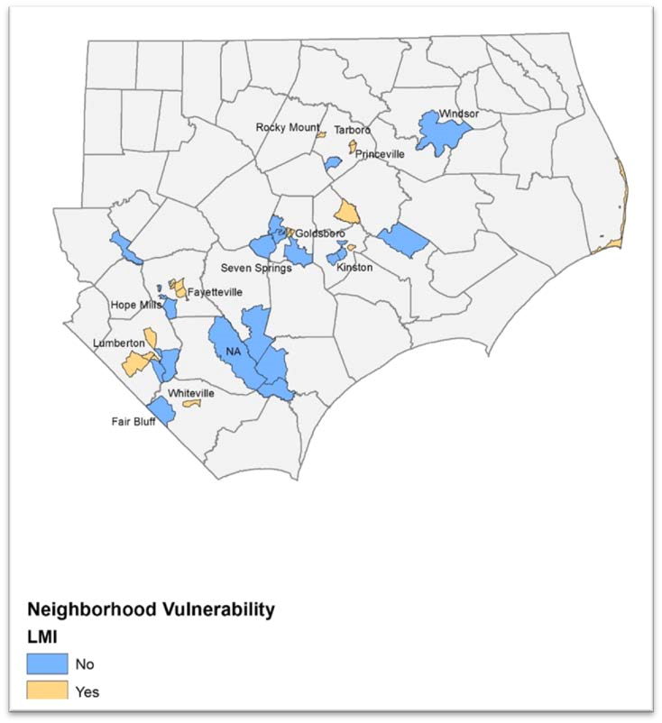
Figure 6: Most Impacted Neighborhoods with a Disproportionate Concentrate of Households

without a Car
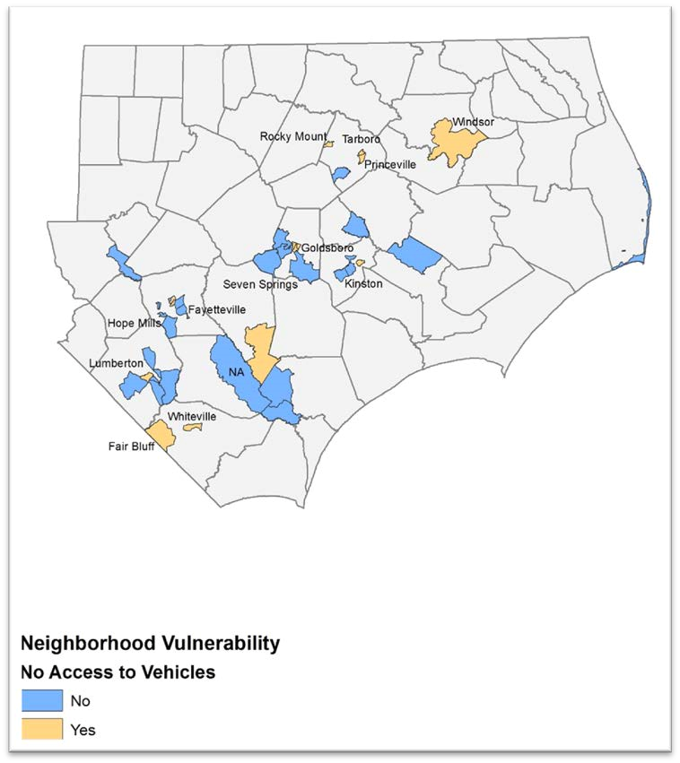

Figure 7: Most Impacted Neighborhoods with a Disproportionate Concentration of Residents

who maintain language barriers
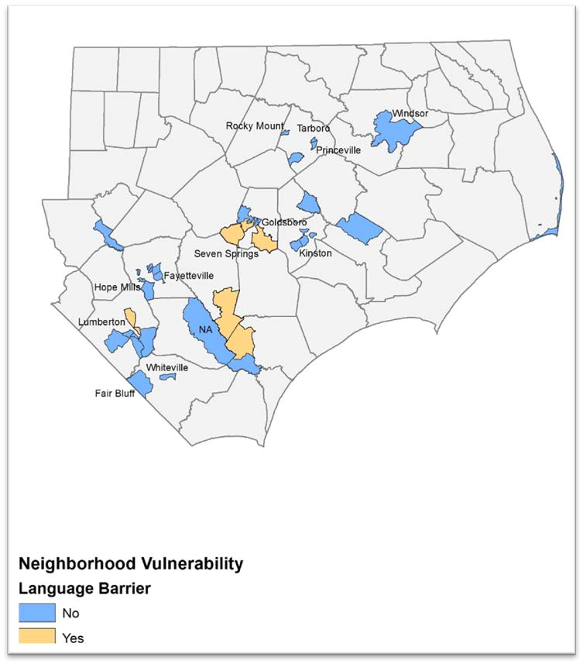

Figure 8: Most Impacted Neighborhoods with a Disproportionate Number of Residents with Disabilities
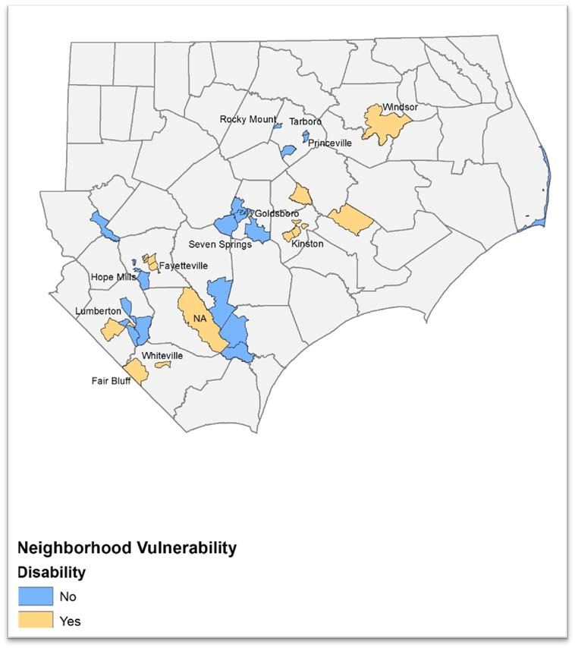

Figure 9: Most Impacted Neighborhoods with a Disproportionate Concentration of Minority Populations
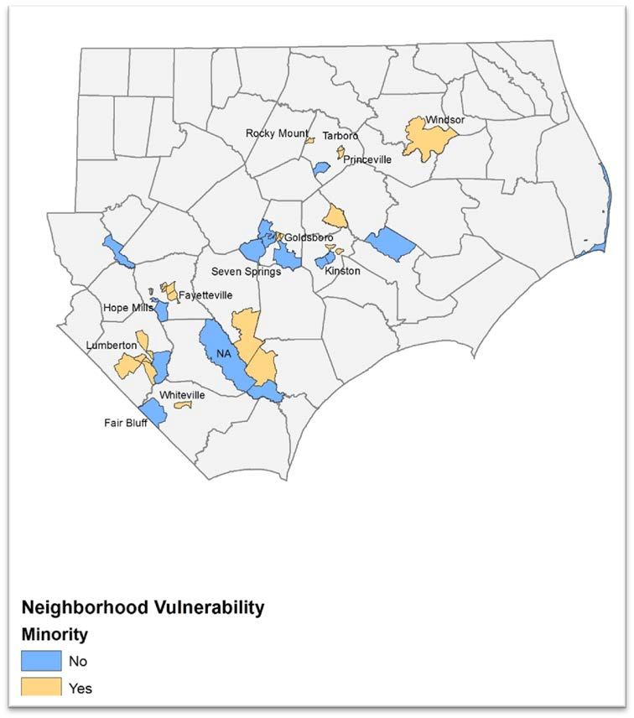

Economic Recovery

Hurricane Matthew was indiscriminate with the damage inflicted on North Carolina’s economy, incurring extensive damage in the same areas as housing as well as in more rural counties serving as the heart of the state’s agriculture-driven economy.
Dunn & Bradstreet (D&B), an economic development and business research company, assessed the potential impact from Matthew in the five hardest hit states, projecting as many as 98,178 businesses could have been affected in North Carolina. D&B projects that up to 43% of businesses affected by Hurricane Matthew are at risk of falling into arrears, not paying their creditors in full over a 12-month period, or failing. D&B estimates the businesses most impacted fall into the services category at 42% and retail trades at 12.9%.
This can provide an explanation for the SBA report on its Disaster Loans approved in North Carolina as of the end of February, 2017 with an almost 2 to 1 ratio between loans denied and loans approved. There are 376 applications approved for business loans with 675 not approved. SBA further reports 100 applications for Economic Injury Disaster Loans (EIDL) (which is working capital) with 30 approved. This means that for every three businesses that apply for SBA assistance, two are denied.
The applicants denied SBA loans are typically denied due to creditworthiness, inability to supply the required financial information (most likely because of financial hardship) and/or inability for financial reasons to meet asset pledge requirements. Finally, from prior disaster experience, for businesses that are approved an SBA loan, the approved amount does not cover all unmet needs, but rather reflects all that the business could afford as a loan.
In addition to the businesses who were denied an SBA loan, there were 7,740 businesses who were referred to the program but never applied for a loan. Many of these businesses likely have unmet needs but did not submit the loan because they knew from the SBA language requirements that they would not qualify.
While there can be several explanations for the disparity in FEMA referrals and disaster business loan applications, and the ratio of SBA disaster loan approvals to denials (i.e. SBA’s tightened credit rules and documentation requirements), given that the preponderance of businesses affected by Hurricane Matthew are in sectors traditionally vulnerable to business interruptions due to natural disasters (i.e. small, independently owned retail and service sector businesses that serve the local community), we can assume a strong subset of those not applying and those denied SBA disaster loans reflect a substantial unmet need to be addressed.

Based on the above, the estimated unmet need for businesses is $263,435,519. The assessment is based on a conservative approach of 1) 10% of the businesses referred to FEMA but did not submit an application for an SBA loan have unmet needs, 2) all businesses that applied for a SBA loan but were denied have unmet needs, and 3) SBA business loans cover 80% of unmet needs.
As noted at the outset of this section, there is a solid connection between promoting the recovery of affected businesses, and addressing the housing needs. For example, the four counties identified in the allocation as being the recipient of 80% of the CDBG-DR funds, Robeson, Edgecombe, Cumberland, and Wayne, had the highest number of per county applications for SBA disaster loan assistance.
The D&B analytics report states that almost 60% of affected businesses are in the service and retail trades which are primarily situated in residential areas (mixed use downtowns) or adjacent to residential areas. The study found that 99% of the businesses affected in the most impacted cities are small businesses with less than 100 employees. From local accounts, the communities most impacted by Hurricane Matthew also experienced tremendous damage to their commercial districts, particularly Lumberton, Kinston and Fayetteville. Additionally, the US Office of Advocacy for the SBA reports that in 2016, 44.8% of the state’s workforce was employed in small businesses, which is a relatively consistent level from prior year reports.
Another primary component of North Carolina’s economic strength is agriculture, which was also hard hit by Hurricane Matthew. The USDA declared 79 of North Carolina’s 100 counties as having significant agricultural damage. The North Carolina Department of Agriculture & Consumer Services reported as early as a week after Hurricane Matthew that 48 counties (of which the 42 are also the USDA designated disaster impact counties) were seriously impacted and that these counties (for the last full reporting year of 2014) accounted for $9.6 billion of the $13.5 billion in farm cash receipts.
The Department has undertaken a thumbnail initial assessment reporting $400 million impact to major field crops, $20 million impact to landscape and nursery crops, and $1.8 million in poultry lost. Because agriculture is seasonal, and ranges throughout the year depending on the types of crops produced, the State is still analyzing the full impact and will continue to assess recovery throughout the next year, but based on current accounts, there is substantial evidence that small agricultural businesses were substantially impacted, losing their anticipated 2017 earnings in the floodwaters.
This data highlights that the most vulnerable businesses in North Carolina, small businesses, within the service, agriculture and retail industries have been disproportionately impacted by Hurricane Matthew mainly within or connected to the residential areas in the hardest hit counties amplifying the importance of initiating measures to begin to address unmet needs. Assuring the services, employment, and stability provided by these small businesses are critical factors in sustaining successful overall recovery efforts.

Table 14: Unmet Business Needs
 | Business  Loans  Denied | Business Loans  Approved | Referrals only | Average Loan  Amount | Estimated Damages | Amount Received | Estimated Unmet Need
Total | 675 | 376 | 25,064 | $65,826 | $288,186,019 | $24,750,500 | $263,435,519
Source: US Small Business Administration, 1/20/16

Public Infrastructure and Facilities

Families who lost their homes also lost a part of their community, with local schools, parks and Main Streets in disrepair. For housing recovery to be effective, all aspects of a damaged community must be addressed, including community facilities and services. Therefore, the State gives priority for this Action Plan to restore damaged community facilities that do not have sufficient resources from FEMA, private insurance, or other public funds to rebuild. This includes restoring basic services and rebuilding community buildings like daycare centers, schools, community centers, and other community-oriented buildings that serve families in the impacted areas, and are cornerstones of healthy neighborhoods. The State is working with counties and the towns that experienced the greatest damage to assess what the unmet needs are for restoring these buildings and services, after taking into account funds available through FEMA Public Assistance, other public funds, and private insurance.
Additionally, the State acknowledges that Hurricane Matthew caused extensive damage to North Carolina’s infrastructure, including roads, dams, levees, water treatment facilities, and the National Guard’s facilities and equipment. For example, the hurricane caused 635 roads to be closed, which included a section of I-40 West and I-95 North and South in Robeson and Cumberland Counties. The closures lasted for 7-days and 10-days, respectively.
FEMA, through its Public Assistance (PA) program, will assist communities to rebuild many of these infrastructure projects. Because the storm occurred relatively recently (October 2016), the FEMA PA program is still assessing needs. As of February 21, 2017, there were $13,527,665 in obligated funds (including approximately $10.3 million in federal obligations and $3.3 million in State obligations). These figures are incomplete; the State estimates that once all FEMA PA projects are accounted for, the FEMA PA program will include approximately $400 million in projects, with $80 million in local match requirements. In addition, the state has identified $100M in Hazard Mitigation Grant Program funding with a $75M Federal share and a $25M state share.
The following section provides a more descriptive overview of the unmet needs of the State’s public infrastructure and facilities. As part of the State’s Resilience and Redevelopment Planning efforts, public meetings have occurred in 50 counties and provided information from the front-line on building damages and public service needs
Strategies to address HUD Infrastructure Activities will be addressed through the State’s Resilient Redevelopment Planning effort involving all 50 impacted counties. This effort is described in detail later in this Action Plan and will:
- Identify mitigation measures to be integrated into rebuilding activities and establish the framework for how infrastructure activities will achieve the regional objectives identified through this planning effort.
- Detail the cost benefit analysis for any infrastructure efforts
- Detail how planning strategies will seek to ensure that infrastructure activities will avoid disproportionate impact on vulnerable communities and create opportunities to address economic inequities facing local communities.
- Detail how the State will align investments with other planned state or local capital improvements and infrastructure development efforts, and will work to foster the potential for additional infrastructure funding from multiple sources to include other federal funding. The state is also exploring a partnership with the University of North Carolina School of Government’s Development Finance Initiative to leverage private investment. A strategy is currently under development for the state to leverage these funds.
- In conjunction with Action Plan strategies, the NCRRP will detail the extent to which the State will employ adaptable and reliable technologies to guard against premature obsolescence of infrastructure.
All infrastructure related projects will refer to the Federal Resource Guide for Infrastructure Planning and Design: (http://portal.hud.gov/ hudportal/documents/huddoc?id=BAInfra ResGuideMay2015.pdf)

Community and Supportive Facilities
Many public facilities have been damaged and need to be retrofitted to prevent future damage. The State estimates approximately $400 million in damages to public facilities and infrastructure that will likely be partially paid for with FEMA Public Assistance, leaving $80 million in local match requirements. The needs of these facilities include enhancing and expanding the carrying capacity of culverts, curbs, storm water drains, and pipes, and relocating utility poles and underwater sewer lines. Debris removal in open channels and public lands is also necessary.
Additionally, the storm impacted the State of North Carolina’s facilities that provide social, community and health (including mental health) services. Through local outreach and needs assessments, the State estimates an additional unmet need of $69,485,443 to address unmet needs to repair these facilities.

Dams and Levees
North Carolina has 3,000 dams, which is the largest number of dams under State jurisdiction of any state in the nation. Inclusive of the total number of dams, the State has 1,200 high hazard dams that would potentially endanger lives and property if they failed. According to the North Carolina’s Division of Energy, Mineral, and Land Resources, 20 dams were breached and 46 additional dams were damaged as a result of Hurricane Matthew. The levee protecting the Town of Princeville was damaged again after repair was done after Hurricane Floyd. Millions of dollars in damage occurred as a result of the partial or total failure of dams, and some dams threaten more than 500 structures and residences downstream.
North Carolina’s dam/levee work will include registration with the USACE Levee Database or Dam Inventory and North Carolina will ensure the structure is admitted under the USACE P.L. 84-99; ensure the structure is accredited under the FEMA National Flood Insurance Program; will upload the location of the structure and area served and protected into DRGR. The State will maintain file documentation of a risk assessment prior to flooding the flood control structure and that the investment includes risk reduction measures.

DOT/HUD/FHWA Transportation Facilities and Infrastructure
North Carolina Department of Transportation’s (DOT) recovery efforts consisted of debris removal, emergency protective measures, and specific site repairs. Debris removal consisted of removing and disposing of vegetative and sand debris deposited by Hurricane Matthew along approximate 42,000 miles of State-maintained rights-of-way throughout the declared counties. Emergency protective measures included operations performed before, during, and after Hurricane Matthew and involved pre-positioning resources, providing emergency access, temporary slope stabilization, road closures, evacuations, detours, and safety inspections. Specific site repairs consisted of temporary and permanent work to restore the state’s highway system and transportation connectivity. Repairs included pavement washouts, pavement undermining, shoulder washouts, pipe washouts, culvert washouts, bridge approach slab washouts, bridge washouts, traffic signal and signal box damage, damage to signage, equipment damage, and facility damage.

USDA - Emergency Watershed and Conservation Protection
Hurricane Matthew caused substantial damage to North Carolina’s rural areas, including causing the loss of livestock in the floodwaters which has caused environmental hazards within the streams, ponds and other water bodies. North Carolina, working with the USDA, estimates a need for $63,319,035 for soil and water conservation, including clean-up efforts.

EPA - Drinking Water and Waste Water Repair and Mitigation
Working with the Environmental Protection Agency, North Carolina estimates substantial unmet needs for the repair and mitigation of the water systems, after taking into account FEMA Public Assistance. This includes structural and drainage improvements, such as force mains, dike walls, manholes; repair of severely damaged inflow, infiltration, and WWTPs, aerial line and sewer line replacement; slip lining and pump station capacity upgrades; repair of outfalls and polishing ponds; and extensive repairs to wastewater collection systems.

National Guard Facilities and Equipment
The facilities and equipment of the National Guard was damaged by the storm. As a result, the State’s unmet needs include the repair and restoration of damaged facilities equipment at the Benson Readiness Center, Mount Olive Readiness Center, Goldsboro Readiness Center, and Goldsboro Field Maintenance Shop.

Table 15: Infrastructure Unmet Need
 | Unmet Need
FEMA PA Local Match (estimate) | $80,000,000
Repair health care, daycare, and other supportive facilities with remaining unmet needs (after subtracting FEMA and insurance) | $69,485,443
Other Federal Agencies
USACE - Levee and Dam Repair Safety | $38,132,675
DOT/HUD/FHWA - pavement, storm pipes, highway embankment | $52,586,192
USDA - Emergency Watershed and Conservation Protection | $76,198,588
EPA - Drinking Water and Waste Water Repair and Mitigation | $274,481,000
National Guard | $734,000
TOTAL | $675,078,162

The State recognizes that the data collection and documentation of community infrastructure and public facilities needs are ongoing. In addition, community planning efforts will continue and provide more information about the unmet needs for the impacted counties. As a result, the funding levels for the unmet needs and CDBG-DR allocation may change.

Planning, Coordination, and Community Outreach Needs
In December 2016, the North Carolina General Assembly established the North Carolina Resilient Redevelopment Planning (NCRRP) program as part of the 2016 Disaster Recovery Act (Session Law 2016-124). This effort is funded by the State and does not currently use CDBG-DR funds.
The purpose of the program is to provide a roadmap for community rebuilding and revitalization assistance for the communities that were damaged by the hurricane. The program empowers communities to prepare locally driven recovery plans to identify redevelopment strategies, innovative reconstruction projects, and other needed actions to allow each community not only to survive but also to thrive in an era when natural hazards are increasing in severity and frequency. This effort will also assist the state in promoting sound, sustainable long-term recovery planning informed by a post-disaster evaluation of hazard risk, especially land-use decisions that reflect responsible flood plain management and take into account possible sea level rise.
The NCRRP consists of planning and implementation phases, is managed through North Carolina Emergency Management and serves as the coordinating body to develop regional planning strategies that ensure consistency across the State. The planning effort was initiated in February of 2017 and will result in a road map on May of 2017.
This document will represent a snapshot of the current needs of the impacted counties regarding holistic recovery and redevelopment. The plan will evolve as the counties analyze the risk to its assets, identifies needs and opportunities, determines the potential costs and benefits of projects, and prioritizes projects. As projects are more fully defined, the potential impact on neighboring communities and the region may lead to modifications.
The State has identified needs at the local level to increase the capacity of individuals and communities to rebuild quickly and sustainably. This includes improving the capacity of local governments to implement recovery; providing legal services to low and moderate income families in need of legal aid as a result of damage from Hurricane Matthew; and to provide data and information to local governments and counties to aid in their long-term resiliency and recovery plans, so that the proposed future development activities are informed of long-term risks.
Implementation of the proposed projects and actions described in this plan is subject to applicable federal, state, and local laws and regulations. Proposed projects or actions may be eligible for state or federal funding, or could be accomplished with municipal, nonprofit, or private investments. However, inclusion of a project or action in this plan does not guarantee that it will be eligible for recovery funding. Strategies will be integrated with the State’s Action Plan to ensure long term resilience is incorporated into Action Plan programs.

Nexus Between Unmet Need and Allocation of Resources
The State of North Carolina gives priority to the communities that experienced the most significant damage from Hurricane Matthew as described in the Unmet Needs Assessment. Based on local and county planning efforts and community outreach, combined with a thorough research of available data, the following unmet needs are the main priorities for this Action Plan as reflected in the proposed recovery activities: Rebuilding homes with major to severe damage
Ensuring an adequate supply of rental housing that is safe, sustainable and affordable in the most impacted areas
Providing assistance to low and moderate income families, and other persons with supportive service needs
Providing assistance to small businesses damaged in the storm that serve fundamental community, employment, and retail needs, notably the Main Streets and commercial corridors within impacted communities which are a priority in succeeding in sustaining recovery efforts' primary focus on residences to re-establish the critical services, goods, and amenities necessary to preserve the identity and integrity of neighborhoods.
Providing assistance to impacted cities and towns to restore basic community operations and services strategically necessary to support recovery efforts with residences to assure that residents received needed benefits by restoring all the public infrastructure and services key to meeting their needs.
All proposed activities and uses described in the following programs are authorized under Title I of the Housing and Community Development Act of 1974 or allowed by waiver or alternative requirement and will be located in a Presidentially declared county eligible for assistance.

Method of Distribution
The State of North Carolina prioritizes the first allocation of CDBG-DR funds, in the amount of $198,553,000, for rebuilding homes and restoring the lives of families most impacted by Hurricane Matthew. For this reason, 84.7% of available funds are dedicated to housing recovery, and providing supportive services to families with the greatest needs.
Additionally, the State recognizes that exclusively rebuilding homes neglects other aspects of recovery, like jobs and neighborhood services, that families need to survive. Because Hurricane Matthew concentrated its damages within select towns and communities, the shops, daycare centers, schools, and local job centers families rely upon were also flooded.
To promote a more holistic recovery, the State includes 5.9% of available funds to assist small businesses, and 9.4% of available funds to restore necessary community facilities, to aid in the recovery of neighborhoods most impacted.
Table 16: Distribution of CDBG-DR Funds by Program
Category | Unmet Need | % Unmet Need | Allocation | % of Total  Allocation (minus Planning and Admin) | % of Unmet  Need  Addressed in this Allocation | To Most  Impacted  Counties | LMI Benefit
Housing | $ 849,078,846 | 45.5% | $142,886,811 | 84.7% | 17% | $114,309,449 | 100%
Homeowners | $ 260,565,781 | 14.0% | $93,977,299 |  | 36%
Renters | $ 100,141,704 | 5.4% | $36,409,512 |  | 36%
Elevation/Buyout | $ 457,000,000 | 24.5% | $0 |  | 0%
Public Housing | $ 5,200,000 | 0.3% | $5,000,000 |  | 96%
Supportive Services | $ 17,371,361 | 0.9% | $7,500,000 |  | 43%
Insurance Subsidies for LMI Owners | $ 8,800,000 | 0.5% | $0
Economic Development | $ 278,907,901 | 15.0% | $10,000,000 | 5.9% | 4% | $8,000,000 | 25%
Infrastructure | $ 655,078,162 | 35.1% | $15,883,239 | 9.4% | 2% | $12,706,591 | 75%
Resiliency | $ 16,168,000 | 0.9% | $0 | 0.0%
Planning and Capacity (10%) | $ 65,896,989 | NA | $19,855,300 |  | 30%
Administration (5%) | NA | NA | $9,927,650
Total | $ 1,865,129,898 | 100.0% | $198,553,000 |  | 10% | $158,842,400 | 93%
*$8.8M in Insurance Subsidies for LMI Owners unmet need will be addressed in Housing allocation.
Housing Repair and Replacement programs will be run by the State. The State reserves the option of sub-allocating funds to CDBG Entitlement communities with capacity to manage housing programs.
Criterion for allocating funds to Units of General Local Government (UGLGs) will be based on capacity, performance, and unmet need. The first and most important criterion is capacity including current staffing levels and existing financial controls. The next criterion is the UGLGs past performance in managing similar programs and funds. The final criterion is to determine the allocation to the UGLG is percentage of unmet need compared to the other communities. will be determined based on past performance managing CDBG funds, staffing capacity, and internal controls. A cap of $1,000,000 will be applied for any allocation of funds to the counties not identified as the most heavily impacted communities with the ability to review funding allocation at a later date if the UGLG is able to provide further justification for additional funds.

Recovery Programs

Program Name: Homeowner Recovery Program

The Homeowner Recovery Program will provide assistance to low and moderate income homeowners who experienced major to severe damage to their homes and have remaining unmet needs, after subtracting other benefits received from FEMA, SBA, private insurance, and charitable organizations. The program will include reconstruction activities, acquisition and construction of new homes, and insurance subsidies to eligible low and moderate income homeowners.
Rehabilitation: For homeowners who wish to remain in their homes, the program will provide reconstruction grants for the rebuilding and mitigation of damaged structures.
Acquisition and/or New Construction: Where cost-benefit analysis indicates it is not feasible to rebuild, the program will provide homeowners with the option to purchase another home in a sustainable area. This may include acquiring an existing home, or acquiring vacant land and constructing a new home. It is anticipated that any such purchase will be done through an acquisition program versus the alternative of a buyout which while not foreseen to be employed would only occur as a last option and only if it was clear the site would not be conducive for building or restoring a structure. The State may also begin to purchase property through an acquisition program following HUD guidelines for acquisition in advance of the HUD grant agreement to ensure that projects are ready to go when funds become available. The State will ensure that any activity intended to be reimbursed by CDBG-DR will have environmental clearance before a choice limiting action is taken.
Reimbursement: Low and moderate income homeowners who expended private funds to make necessary repairs may be eligible for a reimbursement grant.
Insurance Subsidies: Low and moderate income homeowners whose flood insurance premiums increase substantially due to revised Advisory Base Flood Elevations may be eligible for insurance subsidies for up to two years. Application Process
North Carolina citizens who were directly impacted by the disaster will have an opportunity to apply to the Housing Recovery Programs through one application into the program. As the State continues to develop Standard Operating Procedures to support the Action Plan Programs further guidance will be provided on how citizens will apply, where they will apply, and to whom they will apply. The application will allow the applicant to list their housing recovery needs. Applicants may have unmet needs in more than one eligible category of assistance listed above. For example, an applicant may be still be displaced from their residence and have already used FEMA temporary rental assistance. Their home is still uninhabitable and they require assistance with the repairs or replacement of the damaged home. The home is substantially damaged and in a 100 year floodplain and will require elevations to meet Federal floodplain requirements.
The applicant will list their needs which will be confirmed by the State’s damage inspectors. After an inspection of unmet need, an analysis of prior assistance received for the same purposes will be undertaken to determine an award amount. In the example above, it may be determined that the damage estimate indicates $60,000 needed in repairs. The home is valued at $110,000 and therefore the damages are more than 50% of the home’s value. Because the home is in a floodplain, Federal regulations require that it be elevated to at least 1 foot base flood elevation (BFE). It is estimated that it will take approximately 6 months to complete the construction. Based on this scenario, the applicant would be eligible for the $60,000 in repairs and up to $75,000 additionally to cover the required elevation. Because the applicant is still displaced, they will be eligible to receive the 6 months of rental assistance until they can move back into their home.
Similarly, an applicant who used their own personal funds in addition to FEMA, SBA, insurance or other sources of disaster assistance to begin clean and repair of their home may be eligible for reimbursement of their personal funds up to $25,000. Again, this information would be entered into the application and a damage inspection would be conducted by the State. The first step would be to verify and quantify repairs completed and also to assess whether health or safety code violations were still remaining on the structure. If it is determined that the home is still in need or additional repairs, the applicant could be eligible for reimbursement of out-ofpocket expenses and additional repairs to the home.
Once an applicant enters the Housing Recovery Program, they will be assessed for all eligible assistance including supportive services. Receiving assistance for one program does not preclude an applicant from receiving additional assistance or services if they are eligible. The State will provide experienced Case Managers and Housing Counselors to assist applicants through the decision-making process during the application and implementation phase of the program(s). Applicants will be kept informed of their progress through the programs until they are back into their homes.
The program will be administered by North Carolina Emergency Management and is estimated to benefit 1,000 to 1,200 homeowners.
Allocation for Housing Activities: $93,977,299
Maximum Award: Single-Family Homeowner Rehabilitation: up to $75,000 per applicant for homes with damages totaling less than 75% of its pre-disaster value; additional $50,000 available on a case-by-case basis due to extraordinary costs.
Single-Family Homeowner Reconstruction: up to $150,000 per
applicant to rebuild homes with damages totaling 75% or more of the homes pre-disaster value, when all other options have been exhausted.
Mobile Home Repair: $15,000 per applicant for homes with damages totaling less than 51% of its pre-disaster value. The Mobile Home must have a minimum unmet need of at least $2,000. It must be determined through the inspection that after repairs the home will meet HUD’s requirements for decent, safe, and sanitary.
Mobile Home Replacement: up to $60,000 per applicant for mobile home replacement when damages total 51% or more of the predisaster value of the home. HUD has determined that it is not cost effective to invest repair funds into a significantly damaged mobile home as the overall soundness of the structure is likely compromised. Where a mobile home is determined to have significant damage (more than 51% pre-disaster value), than the home will be replaced to provide a safer and more sustainable solution for the household.
Home Buyout: At this time, the State will address the need to buyout flood-prone properties through the FEMA Hazard Mitigation Grant Program (HMGP) and State funds. Although an eligible activity for the CDBG-DR funds, the State is not intending to use CDBG-DR for the matching portion of the grant. Acquisition of homes for the purpose of a flood mitigation buyout will base the purchase value on the appraised pre-disaster value of the home. Homes purchased for this purpose must remain open space with no further development other than the limited uses allowed by HUD in compliance with the Federal Register Notice.
Acquisition for Redevelopment: up to $80,000. No CDBG-DR funds obligated at this time. However, the State reserves the right to allocate funds through future amendments if determined to be an unmet need. Acquisition of homes for redevelopment will allow
impacted homeowners to sell their properties and relocate to a more resilient housing solution. Homes will be purchased at the post-disaster fair market rate based on appraisals. The purpose is to allow purchased properties to be redeveloped and made more resilient before being put back into the market for additional affordable housing.
Acquisition for New Construction: up to $1,000,000. There is also a need to develop affordable housing outside of flood prone areas. Property will be purchased and used to develop new affordable housing units. The State may begin to purchase property in advance of the HUD grant agreement to ensure that projects are ready to go when funds become available. The State will ensure that any activity intended to be reimbursed by CDBG-DR will have environmental clearance before a choice limiting action is taken.
Temporary Rental Assistance: up to $10,000 per applicant. Will be provided to households who are not able to re-enter their homes. Any units occupied and paid for with CDBG-DR funds would be subject to Housing Quality Standards inspection.
Eligible Applicants: | Homeowners who experienced major to severe damage to their primary residence (where FEMA determined the Full Verified Loss of at least $8,000) and who are low to moderate income according to HUD Income Guidelines.
Priorities: | 75% of funds are set aside for households residing within a town or city where at least 100 homes sustained major to severe damage, or in a Census Tract where at least 50 homes sustained major to severe damage, and under one or more of the following conditions: a) the householder is 65 years of age and older; b) a member of the household receives Social Security Disability Income or Supplemental Security Income; and/or c) the household earns less than 60% of Area Median Income.
Eligible Activities: | Rehabilitation; Acquisition; Residential Construction; Homeowner Assistance
National Objective: | Low and Moderate Income
Eligible Activity: | Housing Repair Reimbursement; up to $25,000 to reimburse homeowners for out-of-pocket expenses to clean and repair their
homes following the disaster but prior to applying to the Homeowner Recovery Program. The reimbursement of out-ofpocket funds will be paid to homeowners who have had their disaster repairs verified by receipts, inspections, or other sources, and that exceed funding that may have been received from FEMA, SBA, insurance, or other charitable organizations following the disaster. These costs are only reimbursable if expended within one year of the disaster incident (i.e., October 8, 2017) or prior to application for assistance – whichever comes first.
To exercise the reimbursement option, owners must stop making repairs to their homes while an inspection and site specific environmental review are completed, owners must comply with all Program requirements, and if there are any remaining code or lifesafety issues to be addressed, the owner must commit to completion of the remaining work through the Housing Recovery Program. Reimbursable costs must be reasonable and necessary as determined by the State inspection and cost estimates. All reimbursements will be in the form of grants to the homeowner.
Eligible Applicants: | Homeowners who were directly impacted by the disaster may apply for reimbursement up to $25,000. 75% of funds will be reimbursed to low and moderate income households and 25% will be available for households up to 120% of area medium income.
Priorities: | The funds will be distributed on a first-come-first-serve basis as this is for repairs already completed in the home and therefore do not require a particular priority.
National Objective: | Low and Moderate Income (75%); Urgent Need (25%)
Eligible Activity: | Flood Insurance Assistance; $2,000 per household for a maximum of two years for low and moderate income homeowners that are located in the 100-year flood plain. Homeowners residing in the flood plain and who receive CDBG-DR assistance for their homes, must maintain flood insurance into perpetuity on the property. To assist low and moderate income homeowners still struggling to get their lives back on track and lessen burdens of recovery, the State will fund the first two years on flood insurance.
Priorities: All low and moderate income households receiving CDBG-DR
rehabilitation or replacement assistance and who reside in a 100year flood plain will have equal priority.
National Objective: Low and Moderate Income

Program Name: Small Rental Repair Program

The Small Rental Repair Program will provide assistance to landlords whose rental units experienced major to severe damage and have not been repaired. The program is reserved for small rental structures, including single family rental units, duplexes, triplexes, and buildings with less than 10 units. The program will be administered by North Carolina Emergency Management and is estimated to develop 500 to 750 units serving Low and Moderate Income renters.
Allocation for Activity: $18,204,756
Maximum Award: | Up to $30,000 per unit
Eligible Applicants: | Rental units in structures with less than 10 units that experienced major to severe damage and have remaining unmet needs. Units must be affordable to renters earning less than 80% AMI for five years.
Priorities: | 60% of funds are set aside for damaged rental units located in a town or city where at least 100 homes sustained major to severe damage, or in a Census Tract where at least 50 homes sustained major to severe damage.
Eligible Activity: | Rehabilitation
National Objective: | Low and Moderate Income

Program Name: Multi-Family Rental Housing

The Multi-Family Rental Housing Program will provide gap financing to repair majorly to severely damaged rental housing in the most impacted communities, and to create new multifamily housing affordable to low to moderate income renters in the most impacted communities.
The program will be administered by North Carolina Emergency Management and is estimated to help create 300 to 500 units.
Allocation for Activity: | $18,204,756
Maximum Award: | Up to $50,000 per unit
Eligible Applicants: | Developers building rental housing reserved for households earning less than 80% of Area Median Income for a minimum of 5 years. Projects must be multi-family new construction or substantial rehabilitation, consisting of at least 10 units, and located in the most impacted counties.
Priorities: | Priority will be given to projects that leverage other resources and produce new housing that is sustainable, integrated with neighborhood services and jobs, and provides deeper affordability.  Projects will be selected through a competitive application process.
Eligible Activity: | Construction of Housing
National Objective: | Low and Moderate Income

Program Name: Supportive Housing and Services Grant

North Carolina Emergency Management will provide grants to state, local and non-profit agencies to provide supportive services to families and individuals in need of assistance; to repair permanent supportive housing and housing for the homeless that was damaged from Hurricane Matthew; and to increase the supply of permanent supportive housing and housing for the homeless in the most impacted areas. Assistance may include homeless services, repair or construction of permanent supportive housing, mental health services, child services, and financial assistance to very low and extremely low income families. Allocation for Activity: $7,500,000
Maximum Award: $500,000 for non-construction supportive services; $2,000,000 for construction-related projects. Needs-based award based on a competitive application process. For individual services, a $5,000 cap will be applied. For household services, a $10,000 cap will be applied.
Eligible Applicants: | State, county, local and non-profit organizations who provide supportive services in storm-impacted counties
Priorities: | Applicants will be selected based on a competitive application process that will consider applicant capacity and target group served. 80% of funds are set aside for services within the most impacted counties.
Eligible Activity: | Public Facilities/Public Service
National Objective: | Low and Moderate Income

Program Name: Public Housing Restoration Fund

Deeply affordable rental units managed by Public Housing Authorities (PHAs) in impacted areas experienced severe damage due to Hurricane Matthew. Based on surveys administered to PHAs in March 2017, the Lumberton PHA identified substantial remaining unmet needs, estimated at $5 million. The Public Housing Restoration Fund will be administered by North Carolina Emergency Management and will be available to rebuild Lumberton public housing units that have not yet been repaired.
Allocation for Activity: $5,000,000
Maximum Award: | $50,000 per unit
Eligible Applicant: | Public Housing Authorities
Priorities: | $5 million is set aside for the Lumberton Public Housing Authority to address unmet need, after subtracting FEMA, insurance, and other public funds received.
Eligible Activity: | Rehabilitation
National Objective: | Low and Moderate Income

Program Name: Small Business Recovery Assistance

Approximately two-thirds of businesses that apply for an SBA business loan are denied, due to SBA’s tightened credit requirements, reporting requirements, and repayment stipulations. The vast majority of these businesses are located in the most impacted areas, where flooding devastated commercial main streets and local business districts. Many of these businesses are small businesses working in the agriculture, service and retail industries, and have limited resources to withstand long-term business interruption or rebuild damages not covered by insurance. These businesses are at risk of collapse, which will have a negative impact on overall recovery of the communities severely flooded by Hurricane Matthew. Therefore, NCEM will administer a small business assistance loan program to restore commercial activity in the most impacted areas. This will be a very low interest revolving loan program aimed to establish an ongoing source of funding to further address unmet needs with small businesses through replenishment of the program through loan repayments as program income. Standard, uniform underwriting procedures will be followed in determining both capacity and amount of loan per business. North Carolina Department of Commerce has extensive experience in supporting small businesses with resources, technical assistance, and relationships with key partners including SBA Small Business Development Centers and Community Development Financial Institutions. This experience and the relationships will inform the setup, implementation, and management of the revolving loan fund.
Allocation for Activity: $10,000,000
Maximum Award: | $75,000 per business
Eligible Applicants: | Small Businesses who have documented unmet needs to recover their business operations due to costs already incurred (reimbursement for the repair and/or replacement of damaged structures and equipment) or remaining repair costs
Priorities: | The first funding round will be available to micro-businesses (<10 employees) and DBEs located within a substantially damaged, town, city, or neighborhood.  The second funding round will be available to all small businesses located within the most impacted counties.
Eligible Activities: | Special Economic Development Activity; Microenterprise Assistance
National Objective: | Low and Moderate Income; Urgent Need

Program Name: Community Recovery Program

Through county planning efforts and outreach, local communities have identified more than $60 million in unmet needs to restore basic services and provide healthy, safe neighborhoods. This includes repairing health clinics, day care centers, senior centers, libraries, and supportive service facilities; blight remediation; and implementing community recovery plans. North Carolina Emergency Management will provide grant assistance to local jurisdictions and counties to repair these facilities with remaining unmet needs, after factoring in FEMA, other public assistance, and private insurance funds available for repair and recovery.

Allocation for Activity: | $15,883,239
Maximum Award: | Up to $2,000,000 per project. This maximum award will be subject to review when additional information becomes available.
Eligible Applicants: | Local and county government and non-profit organizations that clearly document a) the facility was substantially damaged in Hurricane Matthew; b) the facility is needed for the immediate functioning and support of residents living in the community; and c) the owner of the facility has exhausted all other resources for repair, including FEMA and private insurance, and has remaining unmet needs.
Priorities: | 75% of funds are set aside for community facility projects that serve older adults, children, persons with disabilities, and/or families living in poverty, and located within a substantially damaged, town, city, or neighborhood
Eligible Activity: | Public Facilities and Improvements
National Objective: | Low and Moderate Income; Urgent Need

General Eligibility Requirements
According to federal regulations mandated under the National Flood Insurance Reform Act (NFIRA) of 1994, buildings and property which utilized financial assistance from the Federal Government following a Presidentially declared disaster may have been required to have and maintain flood insurance coverage. In the event that flood insurance lapsed or was no longer in effect at the time of Hurricane Matthew’s impact, the owner of the building and/or property may not be eligible for additional federal assistance.

Leveraging
Given limited resources and an estimated unmet need exceeding $1.8 billion, the State of North Carolina is committed to maximizing the impact of CDBG-DR funds. This will be accomplished by first ensuring that all other available funds available for recovery are utilized; and then, where feasible, combining CDBG-DR funds with other public and private investment as a means to increase the overall benefit to impacted residents, families, businesses and communities. This includes close coordination with other local and federal agencies, including the North Carolina Housing Finance Agency, USDA, Department of Transportation, Small Business Administration, FEMA, and the HMGP Program.

Program Income
The State of North Carolina will redeploy program income within the program category in which it is generated - Housing, Economic Development, or Infrastructure. In the cases of Housing and Infrastructure, redeployment of program income will be based on existing program priorities and remaining unmet needs not addressed with the initial CDBG-DR funding. The program income for Economic Development will be from small business recovery assistance through the planned revolving loan program. Program income generated through this program will be redeployed to the revolving loan fund for future generations of loans to address remaining unmet needs consistent with the policies and procedures of the activity.
Within the program categories, North Carolina will retain up to 5% to address unanticipated administrative costs resulting from the program income. The maximum 5% administrative cap will be maintained for the overall total of CDBG-DR fund including the program income. Should there be program income generated through an activity through a subrecipient, the program income will remain with the subrecipient providing the activity or activities in the subrecipient agreement continues to have unmet need. In the case of a subrecipient with no remaining unmet needs, North Carolina shall retain it and redeploy it within the program category based on priority unmet needs not yet addressed. Program income, once received, will be redeployed first within the activity from which it has been generated before any draw downs of CDBG-DR funds, and this requirement will be included in all subrecipient agreements.

Schedule of Expenditures and Outcomes
The State of North Carolina will expend funds within six years of HUD’s grant execution date, proposing the following expenditure schedule and anticipated outcomes.

Table 17: Expenditure Schedule
Program | Allocation Amount | Year 1 | Year 2 | Year 3
Homeowner Recovery | $93,977,299 | $9,397,730 | $32,892,055 | $23,494,325
Small Rental Repair | $18,204,756 | $910,238 | $3,640,951 | $4,551,189
Multi-Family Rental Housing | $18,204,756 | $- | $1,820,476 | $12,743,329
Supportive Housing and Services | $7,500,000 | $1,500,000 | $1,500,000 | $1,500,000
Public Housing Restoration | $5,000,000 | $3,750,000 | $1,250,000 | $-
Small Business Recovery | $10,000,000 | $3,000,000 | $4,000,000 | $2,000,000
Community Recovery | $15,884,240 | $1,588,424 | $4,765,272 | $4,765,272
Program (cont.) | Year 4 | Year 5 | Year 6 | Outcome
Homeowner Recovery | $14,096,595 | $9,397,730 | $4,698,865 | 1,000 - 1,200 homeowners served
Small Rental Repair | $4,551,189 | $3,640,951 | $910,238 | 500 - 750 rental units repaired
Multi-Family Rental Housing | $3,640,951 | $- | $- | 300 - 500 rental units constructed
Supportive Housing and Services | $1,500,000 | $1,500,000 | $- | 200 - 300 individuals served
Public Housing Restoration | $- | $- | $- | 250 units repaired
Small Business Recovery | $1,000,000 | $- | $- | 130 - 200 businesses assisted
Community Recovery | $4,765,272 | $- | $- | 10 - 20 public facilities
 |  |  |  | repaired/replaced

Table 18: Expenditure Schedule by Percentage
 | Year 1 | Year 2 | Year 3 | Year 4 | Year 5 | Year 6
Homeowner Recovery | 10% | 35% | 25% | 15% | 10% | 5%
Small Rental Repair | 5% | 20% | 25% | 25% | 20% | 5%
Multi-Family Rental Housing | 0% | 10% | 70% | 20% | 0% | 0%
Supportive Housing and Services | 20% | 20% | 20% | 20% | 20% | 0%
Public Housing Restoration | 75% | 25% | 0% | 0% | 0% | 0%
Small Business Recovery | 30% | 40% | 20% | 10% | 0% | 0%
Community Recovery | 10% | 30% | 30% | 30% | 0% | 0%

Minimum Threshold for Substantial Amendment
The thresholds which will trigger the requirement for a substantial amendment will be a) a change in program benefit or eligibility criteria, b) the addition or deletion of an activity or c) allocation or reallocation of $5 million within the approved Action Plan activity allocations.

State of North Carolina Green Building Standards for Construction and Contractor Oversight
The State will follow best practices such as those provided by the U.S. Department of Energy's Guidelines for Home Energy Professionals—Professional Certifications and Standard Work Specifications for homes where repair costs exceed 50% of replacement cost. New construction and replacement construction activities that include changes to structural elements such as flooring systems, columns, or load bearing interior or exterior walls must fully incorporate Green Building standards.
For homes where repair costs do not exceed 50% of homes value, rehabilitation construction will incorporate Green Building materials to the extent feasible according to specific project scope. Materials must meet established industry-recognized standard that have achieved certification under at least one of the following programs:
- ENERGY STAR (Certified Homes or Multifamily High-Rise),
- Enterprise Green Communities;
- LEED (New Construction, Homes, Midrise, Existing Buildings Operations and Maintenance, or Neighborhood Development),
- ICC-700 National Green Building Standard, (v) EPA Indoor AirPlus (ENERGY STAR a prerequisite), or
- any other equivalent comprehensive green building program.
North Carolina will implement and monitor construction results to ensure the safety of residents and the quality of homes assisted through the program. All Single Family, Rental and Mobile Home repaired must comply with the current HUD Housing Quality Standards (HQS). In addition, North Carolina Emergency Management, responsible for implementation, will ensure applicants are aware of the risks associated with mold and take steps to limit the impact of any mold issues that may arise.
Contractor compliance will be maintained through the review and approval of monthly project performance reports, financial status reports, and documented requests for reimbursement throughout the contract period. The State will utilize the HUD- provided contract reporting template (for PL 113-2) for upload to the DRGR on a quarterly basis: https://www.hudexchange.info/resource/3898/public-law-113-2-contract-reporting-template/.
All program activities will meet HUD requirements for national objectives, which will be supported by documentation in the program file system of record. North Carolina is dedicated to prioritizing assistance toward residents that face the most financial barriers to recovery and fully intends to comply with the HUD Low-to-Moderate Income (LMI) national objective requirement of 75% of the total grant.
Residents will be required to provide household income information and supporting documentation at the time of application for processing and verification. North Carolina will apply a methodical approach to applicant assistance that assigns priority to program applicants based on household income and other social vulnerability factors. Applicants will be required to provide information regarding all assistance received for the recovery purposes as required by the HUD’s Certification of Duplication of Benefits Requirements Under the Stafford Act for Community Development Block Grant (CDBG) Disaster Recovery Grantees (76 FR 71060, November 16, 2011). Any funds found to be duplicative will be deducted from the CDBG-DR award.
The State will review files and test for compliance with financial standards and procedures including procurement practices and adherence to cost reasonableness for all operating costs and grant-funded activities. All program expenditures will be evaluated to ensure they are:
- Necessary and reasonable;
- Allocable according to the CDBG contract;
- Authorized or not prohibited under state/local laws and regulations;
- Conform to limitations or exclusions (laws, terms, conditions of award, etc.);
- Consistent with policies, regulations and procedures;
- Adequately documented; and
- Compliant with all Cross Cutting Federal Requirement including Uniform Administrative Requirements at 2 CFR 200.
The FR allows individuals, businesses, and non-profits to be reimbursed for out of pocket repair cost that would have been covered under a CDBG-DR program repair program if the program had existed at the time. This type of reimbursement is eligible for repairs made up to one year after the disaster, although an extension can be granted by HUD if requested by the Grantee on a case-by-case basis, or until application to the CDBG-DR repair program (whichever comes first). Before making these reimbursements, a retroactive environmental review must be done by the program. This is when SHPO, FWS, and NMFS will be contacted. These steps will be followed before any reimbursement for repairs is made by the State.

Monitoring Standards and Procedures
Beginning shortly after commencement of contracted activities, risk-based on-site monitoring will occur as appropriate to contracted activities and award amounts. At least one on-site monitoring visit will occur prior to project completion, to verify funds were expended appropriately.
The State of North Carolina will implement policies and guidance in that are designed to be consistent with the U.S. Department of Housing Urban Development monitoring policies as defined in the HUD Monitoring Desk Guide: Policies and Procedures for Program Oversight. The Desk Guide is located at: http://portal.hud.gov/hudportal/documents/huddoc?id=DOC_35339.pdf.

Summary of Monitoring Objectives
To determine if an entity is carrying out its grant-funded program, and its individual activities, as described in the Grant Agreement between the State of North Carolina and sub-recipients.
To determine if an entity is carrying out its activities in a timely manner, in accordance with the schedule included in the Agreement. To determine if an entity is charging costs to the project which are eligible under applicable laws and federal regulations and reasonable in light of the services or products delivered.
To determine if an entity is conducting its activities with adequate control over program and financial performance, and in a way that minimizes opportunities for waste, mismanagement, fraud and abuse.
To assess if the entity has continuing capacity to carry out the approved project, as well as other grants for which it may apply.
To identify potential problem areas and to assist the entity in complying with applicable laws and regulations.
To assist entities in resolving compliance problems through discussion, negotiation, and the provision of technical assistance and training.
To provide adequate follow-up measures to ensure that performance and compliance deficiencies are corrected by entities, and not repeated.
To determine if any conflicts of interest exist in the operation of the federally funded program.
To ensure that required records are maintained to demonstrate compliance with applicable regulations, such as rent, occupancy, household income, meeting property standards, Fair Housing, Affirmative Action and Davis-Bacon wage rates.
To conduct site visits/inspections of CDBG-R assisted units to ensure that units are in full compliance with all applicable regulations, codes and ordinances.

Risk Analysis
At the beginning of each calendar year (January to December), a monitoring Risk Analysis is completed for all recipients of Community Development Block Grant – Disaster Recovery (CDBG-DR) funding. The Risk Analysis identifies risk criteria and establishes a base line level of risk for each recipient. The Risk Analysis is used to determine which recipients receive an onsite monitoring visit during the funding year, the frequency of visits, and if additional reporting and monitoring requirements are necessary. Each criterion is weighted based on the level of risk indicated by each item.
All recipients are assigned levels of monitoring based on the outcome of the above Risk Analysis criteria. A preliminary schedule of on-site monitoring visits is established at the beginning of the calendar year. The level of monitoring can be adjusted during the contract period for reasons such as non-compliance with contract provisions, failure to meet performance objectives, failure to submit accurate and timely reports, findings identified from on-site monitoring, staff turnover in key positions of the organization, and other identified changes that increase the risk of administering grant funds. Non-compliance by the recipients can result in suspension of funds, termination of the contract, and request for repayment of all funds provided under the contract. The following is a description of monitoring levels.

On-Site Agency Monitoring
Prior to notifying organizations of an on-site monitoring, the monitoring staff will read the grant agreements, notes any late and/or incorrect submissions of invoices and performance reports, and reviews any previous monitoring letters, regardless of the funding source. The purpose of this review is to determine the scope of the monitoring visit prior to sending a letter notifying the organization of the visit.
Two weeks prior to conducting an on-site monitoring visit, a letter is sent to the organization. The letter confirms the dates and scope of the monitoring and indicates the information and/or documentation that will be reviewed.
Within 45 days of the monitoring visit, staff issues a monitoring letter noting any findings, concerns, and any resolutions discovered during the review. The letter is addressed to the appropriate staff member/s. Organizations will be given 30 days to respond to monitoring letters.

Contractor Performance Standards and Appeals Process
Construction contractors performing work funded with CDBG-DR funds shall be required to be a licensed contractor with the State of North Carolina and to possess all applicable licenses and permits from applicable jurisdictions where work will be performed, prior to incurring any costs to be CDBG-DR reimbursed. Licenses will confirm the required standards set forth by the applicable county, city and/or town code to conduct work within the jurisdiction and the reflected scope of work in the construction contract. Permits will be the required registration and documentation of county, city, and/or town code to be secured prior to any construction work commences. It will be the obligation of the contractor to secure all such permits, provide copies to the state agency or subrecipient administering the contract prior to commencing work.
This requirement will be included as a standard in any applicable subrecipient agreement to be enforced by the subrecipient involving housing or small business activities. All CDBG-DR funded contracts involving construction contractors performing work for homeowners and small business shall be required to have in the contract work pertaining to an individual homeowner and small business owner a 1-year warranty on all work performed. The contractor is required to provide notice 6 months and one month prior to the end of the 1-year warranty to the homeowner and small business owner with a copy of each notice to the state agency and/or subrecipient administering the applicable activity.
Each homeowner and small business shall be provided prior to the commencement of any work involved through such contracts, a written notice of their right to appeal the work being performed when it is not to the standards set forth or the scope established. The homeowner and small business owner shall be provided an appeal contact person within the state agency or subrecipient responsible for managing the activity. Policies and procedures will be established as part of the activity setting forth timelines and step by step process for resolving appeals and said policies and procedures shall be provided to each homeowner and small business prior to the start of any work, and shall be included in the contract with each participating contractor as an enforceable part of the contract.

Broadband
All recipients receiving CDBG-DR funds for the substantial rehabilitation or new construction of residential units, with four or more units per structure, must include broadband infrastructure in accordance with program requirements.

Citizen Participation Plan
The State of North Carolina is in receipt of a U.S. Department of Housing and Community Development Block Grant-Disaster Recovery (CDBG-DR) appropriation in accordance with the Disaster Relief Appropriations Act, 2016 (Public Law 114-223). The Act describes the applicable waivers and alternative requirements, relevant statutory and regulatory requirements, the grant award process, criteria for the action plan approval, and eligible disaster recovery activities. These funds are being made available to assist disaster recovery efforts in response to Hurricane Matthew as described in Federal Register Notice published Wednesday January 18, 2017, at 82 FR 5591.
The primary goal of this Citizen Participation Plan is to provide all North Carolina citizens with an opportunity to participate in the planning, implementation, and assessment of all the State’s recovery programs. The plan sets forth policies and procedures for citizen participation, which are designed to maximize the opportunity for involvement in the community recovery process from citizens, property owners, renters, business owners, developers as well as federal, state, local stakes holders.

Public Notice

Unlike the Citizen Participation Plan for the Consolidated Plan process, there is no requirement for a public hearing relative to the CDBG-DR Action Plan. The Federal Register published on November 21, 2016 contains a list of waivers which permits changes to the State of North Carolina’s Consolidated Plan Citizen Participation Plan process. While the requirement that the CDBG-DR be consistent with the Consolidated Plan was waived, the State will up-date its Consolidated Plan Citizen Participation process in accordance with the Federal Register instructions as applicable. The State’s disaster recovery needs will be incorporated into the next required up-date of the State Consolidated Plan. In addition, the State will ensure that all grantees adhere to fair housing requirements and will capture, review and maintain records of its status.
Contact Information: Interested parties may make comments or request information regarding the Citizen Participation Planning process by mail, telephone, facsimile transmission, or email to the Consolidated Planning Coordinator, N.C. Department of Commerce.
Comments and complaints may be submitted as follows:
• Electronically to the NC Department of Commerce CDBG-DR website http://www.nccommerce.com/rd.
Written comments may be mailed to:
North Carolina Department of Commerce
Consolidated Planning Coordinator
4346 Mail Service Center, Raleigh, NC 27699-4346 By email: compliance@nccommerce.com.
By telephone: (919) 814-4600, TDD 1-800-735-2962 or Fax (919) 715-0096

Encouragement of Citizen Participation and Outreach

The State will invite and encourage citizen participation in the Action Plan process with a focus on outreach to low- and moderate-income persons, racial/ethnic minorities, persons with disabilities, and persons with Limited English Proficiency.
Strategy: The State will advertise opportunities for public participation in The Action Plan process through stated, federal, local governments, tribal communities, public housing, housingrelated service providers, for-profit developers, professional organizations, other known constituency groups, and citizens who have requested notification. Additionally, the State will advertise through:
Groups, organizations, agencies, and churches providing services to or advocating for low- and moderate-income persons, racial/ethnic minorities, persons with disabilities, and persons with Limited English Proficiency (see Appendix 1 for a list of identified organizations and contact information for each); and
Media sources that have direct contact with low- and moderate-income persons, racial/ethnic minorities, persons with disabilities, and persons with Limited English Proficiency (see Appendix 2 for a list of identified media sources and contact information for each).
The Department of Commerce is committed to ensuring that all populations impacted by the storm are aware of the programs to assist in the recovery from Hurricane Matthew. Through in persons meeting, outreach events, online and traditional media, the State has publicized the programs and conducted outreach efforts throughout the storm impacted areas. In addition, the Governor’s Office, has engaged a grass-roots community driven process that engages the public as a key stakeholder in the planning and rebuilding process.

Public Notice, Comment Period and Website

A comment period of at least fourteen (14) days, as required by HUD, shall be provided for citizens, affected local governments, and other interested parties an opportunity to comment on substantial amendments to the Action Plan.
In accordance with CDBG-DR requirements, the State of North Carolina has developed and will maintain a comprehensive website regarding all disaster recovery activities assisted with these funds. The State will post all Action Plans and amendments on the State’s CDBG-DR website at http://www.nccommerce.com/rd and www.rebuild.nc.gov to give citizens an opportunity to read the plan and to submit comment(s). This website is featured prominently on, and is easily navigable from, the State’s homepage www.nc.gov. The State will maintain the following information on its website: actions plan, any substantial amendments, all performance reports, citizen participation requirements, and activities/program information that are described in the action plan, including details on contracts and ongoing procurement policies. Paper copies of the Action Plan will be available in both English (including large, 18pt type) and Spanish.
After the conclusion of the required comment period, all comments shall be reviewed and the State will provide responses to the comments as best as information currently available allows. The State’s consideration on all public comments can be reviewed in Attachment #2 (pg. 80). HUD has an expedited 60 day period to review and approve the Action Plan. That review period will begin upon submission of the Action Plan and public comments to HUD, the State estimates that Action Plan will be submitted to HUD on or before April 24th, 2017. The State also estimates that HUD’s 60 day period shall conclude on or before June 23, 2017.
Upon approval of the State’s Action Plan, HUD will provide the state an action plan approval letter, grant terms and conditions, and grant agreement. Upon receipt of the grant agreement, the State will review and begin the process to execute the grant agreement with HUD. Upon execution of the grant agreement the CDBG-DR funds will be accessible to the State. In compliance with the terms of rules of the grant, the State will begin drawdown of funds by July 22, 2017.

Individuals with Limited English Proficiency (LEP)

Based on LEP data within the impacted areas collected by the State, both the instructions for commenting on, and access to, the Action Plan will be translated into Spanish. Comments will be accepted through the online commenting form in English and Spanish. The State will make every possible effort to translate and consider comments submitted in any other language within the timeframe.

Persons with Disabilities

As noted above, hard copies of Action Plans will be available in large print format (18pt font size) at the location listed above. The online materials will also be accessible for the visually impaired. For more information on how people with disabilities can access and comment on the Action Plan, dial (800) 735-2962.

Response to Citizen Complaints and Appeals

The State of North Carolina shall provide a written response to every complaint relative to the CDBG-DR Plan within fifteen (15) working days of receipt if practicable. The state will execute its Appeals Process in response to complaints and will require grantees to adopt a similar process that weighs complaints through an unbiased process of the citizen’s peers. The process will be tiered whereby applicants will be able to appeal a decision and received further review from another level.
All sub-contractors and local government grantees will be required to develop an appeals complaint procedure to handle all complaints or appeals from individuals who have applied for CDBG-DR housing, infrastructure and business programs or other programs that may be included through subsequent amendments. A written appeal may be filed when dissatisfied with program policies, eligibility, level of service or other complaints by including the individual facts and circumstances as well as supporting documentation to justify the appeal.
Generally, the appeal should be filed with the administrating entity or sub-contractor. The appeal will be reviewed by the administrating entity with notification to the Division of Emergency Management, the CDBG-DR state implementation agency, for the purpose of securing technical assistance. If the appeal is denied or the applicant is dissatisfied with the decision, an appeal can be made to the Department of Commerce (DOC). If DOC denies the appeal, the final step in the internal appeals process is to appeal to the Secretary of the Department of Commerce. If the Secretary denies the appeal, the applicant will be notified regarding the process to appeal to the North Carolina Office of Administrative Hearings.
Applicants to the State’s Recovery Programs may appeal their award determinations or denials that are determined based on Program policies. However, it should be noted that an applicant is unable to appeal a federal statutory requirement.

Performance Review

The requirements for submission of a Performance Evaluation Report (PER) are waived for the CDBG-DR program. As an alternative, the State’s Action Plan must be entered into HUD’s Disaster Recovery Grant Reporting (DRGR) system. The State will submit a performance report in a form to be prescribed by HUD no later than thirty days following the end of each quarter, beginning after the first full calendar quarter after grants award and continuing until all funds have been expended. The quarterly reports shall use the DRGR system and be posted on the State’s website within three days of submission.

Action Plan Amendments

In the case of amendments, the State of North Carolina will follow two alternative citizen participation processes. In the cases of a substantial amendment, the procedures detailed above will be followed.
A substantial amendment shall be defined as: a change in program benefit, beneficiary or eligibility criteria, the allocation or re-allocation of more than $5 million, or the addition or deletion of an activity.
For amendments considered to be non-substantial, the State shall notify HUD, but public comment is not required. The State will notify HUD at least 5 days prior to the amendment becoming effective. Every amendment, substantial or not, shall be numbered sequentially and posted on the website.

Applicant Status:
The usual methods of notifying citizen of their application status regarding CDBG-DR programs involves communicating through interviews, telephone, email and written correspondences. In addition to these very effective methods, the North Carolina CDBG-DR program will include a data management system where applicants will be able to access their status online.

The Final HUD-Approved Action Plan

Following HUD approval of the Action Plan, it will be posted on the State’s CDBG-DR website. Copies of the Final Action Plan will be available upon request.

Attachment 1: Uniform Relocation Act
Action Plan #39 URA: Grantees must define” demonstrable hardship” and “not suitable for rehabilitation” in the Action Plan or in its policies. These items will also be included in policies when a final decision regarding maximum allowable cost.
Demonstrable Hardship is defined as:
Demonstrable-proved or shown, by objective evidence (not subjective feelings).
- Hardship-an economic impact which is burdensome or very difficult to bear, causing economic distress well beyond mere inconvenience.
- A demonstrable hardship is a substantial change in an owner’s or renter’s financial situation that will prohibit or severely affect their ability to provide a minimal standard of living or the necessities of life including food, housing, clothing and transportation without causing economic distress well beyond mere inconvenience as shown by objective evidence. A demonstrable hardship must be occurring after the 2016 flood event. The term is not necessarily a definable term of fixed and inflexible content or meaning.

- The demonstrable hardship must be of a severe, involuntary and unexpected nature. It must not be one that is generally shared by other property owners affected by the 2016 flood event or within the disaster area. Examples of a demonstrable hardships may include job loss, failure of a business, divorce, severe medical illness, injury, death of a family member or spouse, unexpected and extraordinary medical bills, disability, substantial income reduction, unusual and excessive amount of debt due to a natural disaster, etc. None of the listed examples above, individually or taken together, automatically establish a demonstrable hardship nor is the listing above exhaustive as there may be other relevant factors relating to a hardship case.
Definition of Not Suitable for Rehabilitation:
Not Suitable for Rehabilitation – storm damage sustained to more than 75 percent of a home or 50 percent for manufactured home as determined by the valuation obtained from pre-flood County property tax records unless a third-party appraisal was conducted no more than six months prior to the flood.
Determining Whether a Home is Eligible for Rehabilitation
Pre-Flood Value:
The County Assessor’s Office will provide the pre-flood appraised value of the property which will be used to determine the value of the home.
The State, UGLG, or grantee will estimate the cost of repairs. The Estimated Cost of Repair (ECR) incorporates costs necessary to ensure that the property meets minimum Housing Quality Standards (HQS). An ECR does not provide an evaluation that considers an exact replacement of an applicant’s original home. The ECR evaluation is based on basic livability standards and on costs developed by the construction industry in North Carolina.
All property improvements must be for unmet housing needs resulting from the September 2016 flood, code violations, energy efficiency improvements, HQS violations and resiliency.
If the mobile home repairs exceed 50% of a County’s pre-flood assessed value, the mobile home may be replaced with a decent, safe and sanitary, HUD-certified mobile home.
Assistance to individual homeowners is determined after determining the eligibility criteria has been met, subtracting DOB that must be paid by the applicant, and then factoring in the funding caps for the required rehabilitation activity. The calculation follows a three-prong test:
- Does the estimated cost of repairs exceed 75% or 50 of the pre-flood assessed value? If no, then rehabilitation assistance may be approved.
- Does the homeowner have other resources (other than personal savings) to help pay for the rehabilitation? If yes, subtract from estimated cost of repairs and the remaining balance is the CDBG-DR award amount, up to the cap.
- If the remaining balance exceeds the maximum available from CDBG-DR, the homeowner will need to identify other sources of funds and/or volunteer labor to cover the total cost.
Relocation:
Alternatively, URA requires that applicants who are displaced received relocation assistance in accordance with the Stafford Act and HUD waivers. This assistance can be provided to renters displaced as a result of a buyout, temporarily for repairs to rental units, homeowner properties or for interim rental payments when the applicant has to relocate because a unit will not be replaced. Relocation assistance will be made available after a DOB analysis of all other disaster assistance received from federal, state, local and other organizations for the same purpose.
The amount of temporary housing assistance must be necessary and reasonable. An approved CDBG-DR interim housing benefit amount cannot exceed the maximum amount assistance available to the applicant. A fixed time will be imposed on these projects with an exception being made on a case-by-case basis.
The sub-grantee must insure that all temporary and interim housing meet HUD Housing Quality Standards.

 | NC CDBG-DR Action Plan Comment Disposition Form
No. | Reference | Section | Comment | Disp. Response Ver.
1. | Adam T. Short (Planning  Director, City of  Kinston) | Recovery Programs –  Construction and Repair | Please review your thresholds for construction/repair, because this will raise a lot of red flags with flood plain admins. Your numbers are in conflict with the 50% threshold for substantial improvement. It should be clear that all improvements and payments will be made with consideration to bringing homes into compliance with local flood regs. In other words, we're not going to spend over 50% of a homes value on repairs without bringing it into compliance. | C | Pg. 50 Now addressed in  Application Process | C
2. | Kathie Byrd  (Fayetteville  Citizen) | Public Comment | Our family enjoyed the bountiful wildlife and calming effect of the lake at Mount Vernon (Gray's Creek area) for 23 years until the breach during Hurricane Matthew. Our property has lost value, and our home has lost its beauty. | D | NA
3. | Anonymous | Public Comment | It is important that funds be given to small cities to administer and treat their needs & not given to counties to distribute. | D | Pg. 48 Criterion for allocating funds to Units of General Local Government (UGLGs) will be based on capacity, performance, and unmet need.  A $1M cap was also identified.
4. | Tyler W.  Thomas (Town Manager, Town of Pembroke) | Comment for Future Funding | Generally, I think the structure of the proposed allocations align well with individual needs on the local level. As further funding is allocated, it would be good to channel that funding to infrastructure needs (water, sewer, storm water, roads, etc.) as the initial State appropriation (Disaster Recovery Act) will not be adequate to address all State locality infrastructure needs. If data warrants further need for multifamily housing (beyond the projected 3-400 beds) this is something that might be adjusted to allow for more multifamily housing. Finally, the Town is interested in longer-term resiliency measures such as downtown (Main Street) revitalization and Waste Water  Infrastructure repair and upgrades. If initial CDBG-DR funding does not lend itself to being able to support resiliency efforts such as these, we are hopeful subsequent funding mechanisms will address endeavors such as these. | D | NA

Attachment 2: Consideration of Public Comments

5. | Upper Coastal Plain Council of  Governments | Housing Program Administration | There is very little detail regarding administration of housing recovery programs. There is no indication that Emergency Management intends to hire staff or professional services skilled and experienced in administering construction and housing development activities, or that there will be adequate staffing to monitor and enforce all the civil rights and other compliance requirements that accompany CDBG funds. | C | The State of North Carolina has reviewed its staffing capacity for administering and implementing its CDBG-DR allocation from HUD. The State has identified positions to be filled to ensure capacity to administer, implement, and advise the use of CDBG-DR funds. Until sufficient support staff can be hired, DOC will augment staff capacity with experienced contracted CDBGDR personnel for a period of time. EM will fill capacity immediately through contracted support for a period of time and will determine when to transition to internal staffing. | C
6 | Upper Coastal Plain Council of  Governments | Housing Program Administration | The total number of public housing units damaged or destroyed in the storm are not included in the document. The number of missing units may be large enough to change the dollar amount proposed for public housing units. | C | The State does have the ability to amend the Action Plan and distribution of CDBG-DR funds by program based on additional needs discovered during program implementation. | C
7 | Upper Coastal Plain Council of  Governments | Housing Program Administration | In the discussion of the State’s duty to affirmatively further fair housing, it is unclear how the State will balance the mandate to not use CDBG funds to reinforce residential patterns of segregation with historic housing patterns in the impacted area. This information should be more detailed to inform recipient communities, and the public, of the fair housing considerations required in programming and spending these federal funds. | C | The State is committed to adhering to all Fair Housing Requirements. The State’s Monitoring Standards and Procedures of contracted activities include the identification of problem areas and to assist in the compliance of applicable laws and regulations. In addition, citizens will have the opportunity to submit complaints to the State. The State will review and respond to all complaints. | C

8 | Upper Coastal Plain Council of  Governments | Housing Program Administration | UCPCOG encourages the state to develop a specialized unit to administer housing recovery programs, staffed by persons experienced in all facets of housing development. | C | The State will staff positions with qualified individuals and provide ongoing trainings for the CDBG-DR programs. The State of North Carolina’s Department of Commerce  (DOC) is the Lead Agency for administering the CDBG-DR allocation from HUD. DOC currently administers the State’s CDBG program. The North Carolina Department of Public Safety - Emergency Management (NCEM) will be responsible for implementation of the CDBG-DR funded programs and activities. The Governor’s Office will approve and provide oversight of the State’s Action Plan and identified staffing positions. An organization to support this Action Plan was included in the State’s Risk Assessment and includes the desired expertise. | C
9 | Upper Coastal Plain Council of  Governments | Method of Distribution | The criteria for allocating funds to Units of General Local Government (UGLGs) is proposed to be based upon “past performance in managing CDBG funds, staffing capacity, and internal controls” in addition to the percentage of unmet needs compared to other communities. These criteria will disadvantage some of the hardest hit communities, where the local government has not had experience administering CDBG funds, or has had past deficiencies in fiscal management or financial controls. There is no mention of possible remedies for these communities, which include administering funds through a third party, such as a Council of Governments, consulting firm, nonprofit housing corporation, or cooperating UGLG. UCPCOG encourages the State to consider the need for capacity at the local government level, as mentioned on page 43, as it considers where to allocate recovery funds. | C | Per the Action Plan, the State reserves the option to allocate funds to UGLGs to manage housing programs. | C

10 | Upper Coastal Plain Council of  Governments | Program Income | In the Housing program category, it is unclear what funds would be program income requiring remittance to the State. For instance, will net income from rental units be considered program income? Will the designation of program income depend on the nature of the entity receiving the CDBG-DR funds?  UCPCOG recommends that the State clearly identify what income from housing activities would require remittance to the State before it solicits interest from housing developers, and that the State allow retention of earnings by not for profit developers to the greatest extent possible, to support the capacity of these organizations to continue to produce housing after these funds have been expended. | C | The State will comply with HUD requirements found in 24 CFR 570.489. In the event the State’s activities generate program income, those funds, to the maximum extent feasible, shall be distributed before the State makes additional withdrawals from the Treasury. | C
11 | Upper Coastal Plain Council of  Governments | Minimal Threshold for  Substantial  Amendment | On page 56, the threshold for a substantial amendment is $ 5 million. On page 67, the threshold for a substantial amendment is $ 1 million. UCPCOG recommends that the State set the threshold for a substantial amendment higher than $ 1 million and lower than $ 5 million. | C | The threshold for a substantial amendment is $5M. The Action Plan was revised to reflect the correct amount. | C
12 | Upper Coastal Plain Council of  Governments | Building Standards and Contractor Oversight | This section does not clearly explain whether contractors will need to prove certification in a nationally recognized green building standard and/or HUD Housing Quality Standards (HQS). UCPCOG encourages the State to support both the incorporation of green building standards, and the opportunity for workers and small businesses in the region to participate in rebuilding projects. UCPCOG recommends that the State allocate funds to increase the training in green building practices available in the impacted counties. | C | The State supports the incorporation of green building standards as mentioned in the Building Standards for Construction and Contractor Oversight Section of the Action Plan. In addition, the State encourages opportunities for workers and small businesses in the region to participate in rebuilding projects and will assess the training needs for green building practices in the impacted counties. | C
13 | Upper Coastal Plain Council of  Governments | Applicant Status | The State proposes to utilize a data management system that applicants will be able to access online. There are no details about whether this system currently exists, and if not, how long it will take for the system to be operational. UCPCOG encourages the State to provide more detail to the public on this data system, including when it will be available. | C | The State plans to utilize a data management system currently used by other State programs.  Additional information regarding the data system and operational timeline will be made available to the public. In addition, all program information will be available via the state’s recovery website. | C

14. | David Nolan | Mt. Vernon Dam | Since Hurricane Matthew devastated our area it seems like we live in a third world country. America has always been a place where we take a hit and immediately get back on our feet. The dam on Fire Department Road was breached during the storm and is still in disrepair. For the following reasons the county must help repair this breach:  - Our property values have dropped, which affects the amount of taxes collected by Cumberland County. Not just the property values of those on the lake, but in the entire community  - dam failure affects more than the people around the lake; it affects the entire community.  - dam failure affects the environment, including the Cape Fear River and puts strain on other dams in the area  - our health and safety is at risk (disease/mosquitoborne illnesses, vermin, snakes, etc.)  - the dam provided flood protection; without that dam, everything changes  - loss of wildlife, including some threatened/endangered species | D | Thank you for the comments.  We have designed the Action Plan in a manner to maximize the assistance to the State.
15. | Kittie Elrod | Mt. Vernon Dam | We retired to a home on a lake in Mt Vernon Estates. My husband, a disabled Army Vet, served 29 yrs. We bought this specific home so he could enjoy his 1 passion, fishing. Due to Matthew our dam was breached & the lake lost. This is devastating personally & has far more local affects: "Reverse economic development" because of lost tax revenue (property taxes were lowered), huge health & safety issues, water flow & retention benefits were lost (future floods downstream), & endangering wildlife | D | Thank you for the comments.  We have designed the Action Plan in a manner to maximize the assistance to the State.
16. | Ron Elrod | Mt. Vernon Dam | The repair to the Mount Vernon dam will not only benefit the Mount Vernon neighborhood, but will prevent future damage to many privates houses and public roads. If this damn is not repaired, future storms will likely cause the same damage we all encountered during Hurricane Mathew. If the damn is repaired and proper drains are installed, this damn can assist in controlling the flooding downstream. The repair is a fraction of what it could save the county and state for future storms and flooding. If the damn would have had the much needed drains, it would have been possible to drain the lake and prevent the dam from breaching. | D | The state has identified an unmet need for dams.

17. | Marti Forbes | Mt. Vernon Dam | Infrastructure  General Comments  Community Recovery  The dam at Mt. Vernon Estates which broke during Hurricane Matthew is devastating. The geese, ducks, frogs and turtles are gone. They will soon be replaced by mosquitoes as the water remaining is turning stagnant. Not only have the property values gone down, but this is where we have taught our grand kids to fish. We must preserve this lake for future generations. I hope the state of NC will be able to help repair our dam. | D | The state has identified an unmet need for dams.
18. | Mark and Robin Jones | Mt. Vernon Dam | Mathew brought a lot of rain in a 24 hr. period as we know. There was and still is a lot of damage done. I live in Mt. Vernon Estates with our property on what use to be a lake. The dam that made our lake failed. All property value in the neighborhood has gone down. There is constant marshy/muddy smell with water that seeps out of the ground keeping a muddy/marshy terrible looking mess where there use to be a lake. Also, a lot of wildlife that use to have a home, no longer do. We need financial help to rebuild dam. | D | The state has identified an unmet need for dams.
19. | Reed Whitesell | Operating Procedures | - Make sure to allow communities to address both wind and flood damage.  - Develop a flow chart to assist localities in identifying the most cost-effective treatment for a specific owneroccupied unit. Reconstruction is likely a more viable alternative to elevation (whether financed with HMGP or CDBG-DR funds) when substantial rehab of the superstructure is required.  - Limit rental rehab assistance to units outside of the 100-year floodplain -- Rehab of rental units in the special flood hazard area should not be a priority given limited funds. If HMGP funds are utilized to elevate a rental structure in the 100-yr. area, the owner should have insurance or should make superstructure repairs at his own expense.  - Encourage bidding/award of HMGP/CDBG-DR units (elevation/rehab) as a single contract. | D | Further guidance on program operating procedures will be provided following approval of the Action Plan by Housing and Urban Development.

20. | North Carolina Association of  Community  Development  Corporations | Housing General Comment | We forcefully support the State’s number one priority as declared in the AP which is to allow families, who experienced major to severe damage in the most impacted communities, to return to their homes, and to ensure those homes are in safe and sanitary conditions. NCACDC and its affiliates are committed to the fundamental notion that decent homes in neighborhoods are the building blocks of healthy and vibrant communities and towns. We also understand that housing links to other aspects of community life which must also be restored such as schools, parks, Main Streets, community facilities and infrastructure, and community businesses and services, etc. Healthy neighborhoods foster positive community spirit and pride that can in turn help mend shattered dreams, as well as remake and restore the tattered fabric of the community following the storm’s destruction. | C | Thank you for the comments.  We have designed the Action Plan in a manner to maximize the assistance to the State
21. | North Carolina Association of  Community  Development  Corporations | Housing General Comment | We also strongly endorse the State’s goal of “rebuilding damaged communities in a manner that furthers fair housing opportunities to all residents,” as stated on page 28 of the AP. We recognize that people in the United States largely live in neighborhoods segregated by race and income. Early models of neighborhood change present processes of succession and segregation as inevitable, underemphasizing the role of the state. For example, see the 2015 report, Gentrification, Displacement and Role of Public Investment. As North Carolina moves forward to deploy significant federal and state resources to rebuild housing in a hurricane ravaged region of the state, we encourage State officials to fully enforce the Fair Housing Act by carefully monitoring the role of this public investment and subsequent public policy actions in reducing residential segregation patterns and enhancing “geographies of opportunity” as a means of further fostering future regional prosperity. See also the 2017 report, The Cost of Segregation, National Trends and the Case of Chicago, 1990-2010. | C | Thank you for the comments.  We have designed the Action Plan in a manner to maximize the assistance to the State

22. | North Carolina Association of  Community  Development  Corporations | Housing General Comment | From a fair housing perspective and based upon NCACDC’s knowledge gained through participation in the Hurricane Matthew Inclusion Collaborative, often hosted at the NC Rural Center offices, we fear that insufficient public attention and resources, including state and federal hurricane recovery resources, are being devoted to the equitable participation and recovery of national origin (non-English speaking) populations residing in the flood impacted region.  For example, we call to your attention to Table 13 on page 28 of the AP which relates to a discussion of residents or families with social vulnerability. The federal Fair Housing Act includes national origin as a protected class category. Surprisingly, Table 13 includes few impacted neighborhoods where the language barrier category includes a “Y” response, even though the AP notes on page 28 there are impacted neighborhoods that include “pockets of damage where residents have English language  barriers...”  We caution the State to take all necessary steps, including targeted community engagement, outreach meetings and other appropriate actions, to identify and ensure that the housing recovery needs of eligible individuals and their families included in the national origin protected class category are addressed, and not overlooked, during implementation of the AP. | C | Further guidance on program operating procedures will be provided following approval of the Action Plan by Housing and Urban Development.
23. | North Carolina Association of  Community  Development  Corporations | Housing General Comment | NCACDC has identified a critical housing recovery need that does not appear to be addressed in the AP. NCACDC’s post-storm housing recovery experience after Hurricane Floyd informs us that there is a definite need for a pool of pre-development funds. Such funding would aid local governments, non-profit agencies and public housing authorities buy land for new low income housing development and reduce barriers to financing other early stage housing development activities, thereby increasing the ability of these entities to undertake rebuilding efforts. An appropriation of $7.5 million earmarked for such pre-development activities was included in the State’s hurricane relief and recovery legislation enacted by the NC General Assembly in 1999. We strongly recommend that the State include a similar pre-development funding category in its AP. | C | Thank you for the comments.  We have designed the Action Plan in a manner to maximize the assistance to the State.  We will take every consideration to address these concerns through technical amendments.

24. | North Carolina Association of  Community  Development  Corporations | Housing General Comment | Another critical housing recovery need that is also omitted from the AP involves capacity building funding to facilitate the rebuilding efforts of nonprofit housing developers located in or near the in various flood impacted counties. In the Introduction section of the AP, the State highlighted various communities severely impacted by Hurricane Matthew noting “these communities...are disproportionately minority and low income.” NCACDC’s post-storm housing recovery experience after Hurricane Floyd informs us that locallybased nonprofit housing developers can and must play a key role in addressing the unique housing recovery needs of such populations.  However, in recent years, nonprofit community development corporations with housing construction capabilities have been struggling to secure sufficient operational funds to function at maximum efficiency. To stimulate the effective participation of such non-profit housing developers in the rebuilding phase of storm recovery, NCACDC proposes to serve as an intermediary funding agency for the distribution of such capacity building funds to locally qualified nonprofits, especially those located in the most severely impacted counties. Given the scope of housing unmet needs referenced in the AP, the wisdom and cost effectiveness of mobilizing such an experienced cadre of affordable housing developers as outlined in NCACDC’s recommendation is apparent. | C | Thank you for the comments.  We have designed the Action Plan in a manner to maximize the assistance to the State.
25. | North Carolina Association of  Community  Development  Corporations | Housing General Comment | NCACDC also recommends that the State consider adding a provision to the AP to fund housing counseling services to assist homeowners and renters in NC counties identified as suffering the most catastrophic damage as a result of Hurricane Matthew. Housing counselors employed by NCACDC’s affiliates and working with any federal HUD program must be and already are HUD-Certified Housing Counselors. According to HUD, knowledgeable housing counselors lead to better identification of housing issues, more knowledgeable referrals and resolution of barriers, and a greater ability to avoid scams. | C | An application process has been added to the Housing Recovery Program to include counseling. | C
26. | North Carolina Association of  Community  Development  Corporations | Housing General Comment | As NCACDC reviewed the sizable housing unmet need summary beginning at page 26 of the AP, we anticipate the on-going need for additional resources beyond the HUD appropriated CDBG-DR funding allocation as new information later further clarifies the full scope of housing unmet need. Therefore, NCACDC strongly recommends that the State revise its approach to formulation of its annual Small Cities CDBG expenditure plan for the foreseeable future to include housing services. Failure to make this proposed adjustment would likely result in a denial of needed assistance to low and moderate income families who experienced flooding to rebuild their lives. | C | Thank you for the comments.  We have designed the Action Plan in a manner to maximize the assistance to the State.  We will take every consideration to address these concerns through technical amendments.
27. | North Carolina Association of  Community  Development  Corporations | Homeowner Recovery  Program/ Single  Family Housing | NCACDC agrees with the State’s decision to provide assistance to low and moderate income homeowners who experienced major to severe damage to their homes and have remaining unmet need. We know from our experience after Hurricane Floyd that federal disaster relief initiatives are not intended to make individuals whole after a loss. Further, some people in damaged homes will either not qualify for federal housing assistance or do not have the resources to take advantage of federal housing assistance. Many who do qualify later discover that the federal assistance provided is insufficient to enable them to secure replacement housing. | C | Thank you for the comments.  We have designed the Action Plan in a manner to maximize the assistance to the State
28. | North Carolina Association of  Community  Development  Corporations | Homeowner Recovery  Program/ Single  Family Housing | The Homeowner Recovery Program will allow for acquisition and new construction as well as mitigation. After Hurricane Floyd, the State’s housing crisis assistance initiative included what we believe was a similar program called SARF. The State’s Homeowner Recovery Program expenditure categories appear to have been adjusted upwards, when compared with the old SARF program funding categories. We assume these upward adjustments to the maximum award levels reflected in this section of the AP were made in recognition of the rising cost of housing units since 1999, and NCACDC fully supports this approach. | C | Thank you for the comments.  We have designed the Action Plan in a manner to maximize the assistance to the State

NOTES:
INITIAL DISPOSITION CODES: C = Will Comply D = Delete Comment F = Further Clarify | FINAL DISPOSITION CODES:  C D | Ver: Incorporation of C (Initials)

Attachment 3: Certifications, Waiver, and Alternative Requirements
Certifications, Waiver, and Alternative Requirements (81 FR 83274)
(24 CFR 91.325 is waived.)
The State of North Carolina makes the following certifications with its action plan:
- The grantee certifies that it has in effect and is following a residential anti-displacement and relocation assistance plan in connection with any activity assisted with funding under the CDBG-DR program.
- The grantee certifies its compliance with restrictions on lobbying required by 24 CFR part 87, together with disclosure forms, if required by part 87.
- The grantee certifies that the action plan for disaster recovery is authorized under State and local law (as applicable) and that the grantee, and any entity or entities designated by the grantee, and any contractor, subrecipient, or designated public agency carrying out an activity with CDBG–DR funds, possess(es) the legal authority to carry out the program for which it is seeking funding, in accordance with applicable HUD regulations and this Notice. The grantee certifies that activities to be undertaken with funds under this Notice are consistent with its Action Plan.
- The grantee certifies that it will comply with the acquisition and relocation requirements of the URA, as amended, and implementing regulations at 49 CFR part 24, except where waivers or alternative requirements are provided for in this Notice.
- The grantee certifies that it will comply with section 3 of the Housing and Urban Development Act of 1968 (12 U.S.C. 1701u), and implementing regulations at 24 CFR part 135.
- The grantee certifies that it is following a detailed citizen participation plan that satisfies the requirements of 24 CFR 91.105 or 91.115, as applicable (except as provided for in notices providing waivers and alternative requirements for this grant). Also, each UGLG receiving assistance from a State grantee must follow a detailed citizen participation plan that satisfies the requirements of 24 CFR 570.486 (except as provided for in notices providing waivers and alternative requirements for this grant).
- The grantee certifies that it has consulted with affected UGLGs in counties designated in covered major disaster declarations in the non-entitlement, entitlement, and tribal areas of the State in determining the uses of funds, including the method of distribution of funding, or activities carried out directly by the State.
- The grantee certifies that it is complying with each of the following criteria:
  - Funds will be used solely for necessary expenses related to disaster relief, long-term recovery, restoration of infrastructure and housing, and economic revitalization in the most impacted and distressed areas for which the President declared a major disaster in 2016 pursuant to the Robert T. Stafford Disaster Relief and Emergency Assistance Act of 1974 (42 U.S.C. 5121 et seq.) but prior to October 10, 2016.
  - With respect to activities expected to be assisted with CDBG–DR funds, the Action Plan has been developed so as to give the maximum feasible priority to activities that will benefit low- and moderate-income families.
  - The aggregate use of CDBG–DR funds shall principally benefit low- and moderate-income families in a manner that ensures that at least 70 percent (or another percentage permitted by HUD in a waiver published in an applicable Federal Register notice) of the grant amount is expended for activities that benefit such persons.
  - The grantee will not attempt to recover any capital costs of public improvements assisted with CDBG–DR grant funds, by assessing any amount against properties owned and occupied by persons of low- and moderate income, including any fee charged or assessment made as a condition of obtaining access to such public improvements, unless: (a) Disaster recovery grant funds are used to pay the proportion of such fee or assessment that relates to the capital costs of such public improvements that are financed from revenue sources other than under this title; or (b) For purposes of assessing any amount against properties owned and occupied by persons of moderate income, the grantee certifies to the Secretary that it lacks sufficient CDBG funds (in any form) to comply with the requirements of clause (a).
- The grantee certifies that the grant will be conducted and administered in conformity with title VI of the Civil Rights Act of 1964 (42 U.S.C. 2000d) and the Fair Housing Act (42 U.S.C. 3601–3619) and implementing regulations, and that it will affirmatively further fair housing.

- The grantee certifies that the grant will be conducted and administered in conformity with the Fair Housing Act (42 U.S.C. 3601–3619) and implementing regulations, and that it will affirmatively further fair housing, which means that it will take meaningful actions to further the goals identified in an AFH conducted in accordance with the requirements of 24CFR 5.150 through 5.180, and that it will take no action that is materially inconsistent with its obligation to affirmatively further fair housing.
- The grantee certifies that it has adopted and is enforcing the following policies, and, in addition, States receiving a direct award must certify that they will require UGLGs that receive grant funds to certify that they have adopted and are enforcing:
  - A policy prohibiting the use of excessive force by law enforcement agencies within its jurisdiction against any individuals engaged in nonviolent civil rights demonstrations; and
  - A policy of enforcing applicable State and local laws against physically barring entrance to or exit from a facility or location that is the subject of such nonviolent civil rights demonstrations within its jurisdiction.
- The grantee certifies that it (and any subrecipient or administering entity) currently has or will develop and maintain the capacity to carry out disaster recovery activities in a timely manner and that the grantee has reviewed the requirements of this notice and requirements of the Appropriations Act applicable to funds allocated by this notice, and certifies to the accuracy of its certification documentation referenced at A.1.a. under section VI and its risk analysis document referenced at A.1.b. under section VI.
- The grantee certifies that it will not use CDBG–DR funds for any activity in an area identified as flood prone for land use or hazard mitigation planning purposes by the State, local, or Tribal government or delineated as a Special Flood Hazard Area in FEMA’s most current flood advisory maps, unless it also ensures that the action is designed or modified to minimize harm to or within the floodplain, in accordance with Executive Order 11988 and 24 CFR part 55. The relevant data source for this provision is the State, local, and Tribal government land use regulations and hazard mitigation plans and the latest issued FEMA data or guidance, which includes advisory data (such as Advisory Base Flood Elevations) or preliminary and final Flood Insurance Rate Maps.
- The grantee certifies that its activities concerning lead-based paint will comply with the requirements of 24 CFR part 35, subparts A, B, J, K, and R.

- The grantee certifies that it will comply with environmental requirements at 24 CFR part 58.
- The grantee certifies that it will comply with applicable laws.

__________________________________________________________
Anthony M. Copeland Date

____________________________________________________ Secretary of Commerce

Major and Severe Damage is defined using HUD’s definition within FR-6012-N-01, where an owneroccupied home is considered majorly or severely damaged if it incurs at least $8,000 in real property loss according to FEMA Individual Assistance inspections. Similarly, a renter-occupied home is considered majorly or severely damaged if it incurs at least $2,000 in personal property loss.
For this analysis, a neighborhood is defined as a Census Tract, which is a geographic area defined by the U.S. Census that on average contains 2,000 to 4,000 residents.

